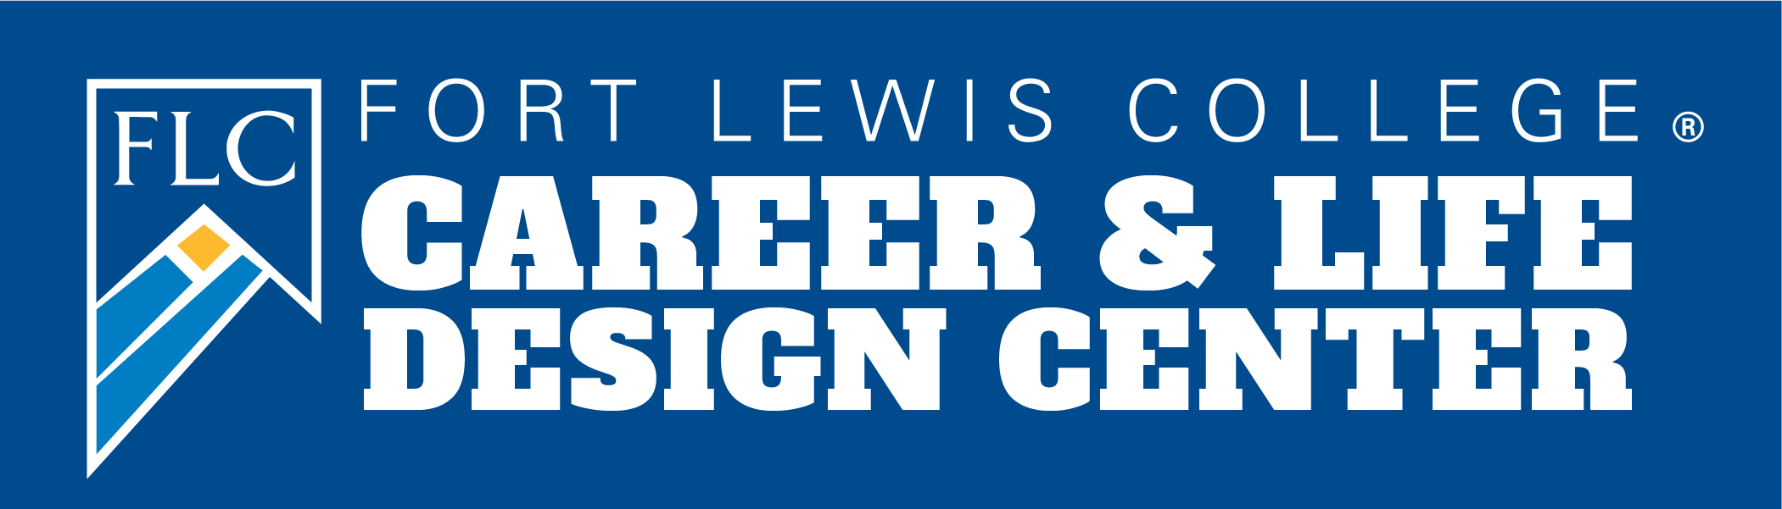

Career & Life Design Center Resume and Cover Letter Development Kit

Due to a high demand for our services, we have implemented a resume review process to ensure you get the time and attention needed to create a professional resume. To do this, we ask that you use this kit to create a resume as much as you can and then we will be happy to review it and provide feedback

Next steps:
- Review the information in this kit to create/improve your resume and cover letter.
- A resume template can be found at the end of this document.
- Complete one of the following:
  - Submit your resume/cover letter to our DropBox—A member of our team will review it and email you a video with feedback.
  - Stop by Reed 145 during our drop-in hours to have a Career Coach review your resume/cover letter.
  - Schedule a review with a Career Coach by visiting careers.fortlewis.edu and clicking Schedule an Appointment.

If you have any questions, please stop by our office in Reed 145 or email askcareerservices@fortlewis.edu. We look forward to seeing your resume!

First Name Last Name
City, State
(XXX) XXX-XXXX | Email@gmail.com | www.linkedin.com/in

Summary (optional)
Write 3-4 lines giving an overview of your resume. Highlight major accomplishments and why you are interested in a particular company or industry. Talk about what value you can provide them.

Education
Name of University, ABC school May 2012
Bachelor of Science/Arts in Major GPA: 3.5
Minor: XXXXX
Societies listed here
**do not use bullet points in education section

Professional Experience
Organization Name City, State
Position Title Month year–Present
- Write your main highlighted accomplishments.
- Think about how your task/project helped the company do better and how you added value to the company.
- Follow the format “Performed X by doing Y resulting in Z”
- Start with strong action verbs and avoid using responsible, helped, researched, or assisted. Showcase your essential and technical skills here.

Organization Name City, State
Position Title Month year–Present
- Write your main highlighted accomplishments.
- Think about how your task/project helped the company do better and how you added value to the company.
- Follow the format “Performed X by doing Y resulting in Z”
- Start with strong action verbs and avoid using responsible, helped, researched, or assisted. Showcase your essential and technical skills here.

Activities
Organization Name, Institution Name City, State
Title Month year–Present
Brief description of the organization and your role (1-2 lines).
- This might be activities related to a specific class, organization on campus or volunteer work experience.
- Try to show essential and technical skills you gained through this organization. Focus on leadership, teamwork and management skills here.

Certifications
Name of Certification Expiration or attainment date

Skills
Skill, skill, skill, skill, skill (ex. PowerPoint, sales, negotiation, time management, networking)

References
Name
Job Title
Employer
Phone: (XXX) XXX-XXXX
Email: person@gmail.com

First Name Last Name
City, State
(XXX) XXX-XXXX | Email@gmail.com | www.linkedin.com/in

Today’s date

Recipient’s name and Title
Name of company
Company mailing address
City, State, Zip

Dear Mr./Ms./Dr. (recipients name),

Paragraph 1 – Tell the reader of the letter which position you are applying for. Give a brief description as to why you would be a quality candidate for this role.

Paragraph 2 – The second paragraph of your cover letter should respond directly to the job description. Describe how your previous job experiences, skills, and abilities will help you meet the company’s needs. To make that easier, you should include exact words and phrases from the job descriptions in your cover letter. This section should answer why they should hire you.

Paragraph 3 – The third paragraph is the call-to-action portion of your cover letter. Summarize your cover letter and inform the hiring manager that you would love the opportunity to interview. Provide your email address or other contact information. Thank them for spending their time reading your cover letter.

Sincerely,

(Your name)

First Name Last Name
City, State
(XXX) XXX-XXXX | Email@gmail.com | www.linkedin.com/in

Todays date

Recipient’s name and Title
Name of company
Company mailing address
City, State, Zip

Dear Ms. Doe,

I was excited to see your job listing for the Senior Digital Marketing position at Westward Strategies on Indeed.com. As a dynamic email marketing specialist with over two years of professional experience executing market research, analyzing consumer data, and running A/B tests to drive successful marketing campaigns, I’m confident that I would be a valuable asset to the team at Westward.

Your job listing mentions a need for someone who is experienced in email segmentation and campaign development, both of which are areas I have extensive experience in. I’m currently employed at Marketed Inc., where I’ve honed my skills by running numerous successful email marketing campaigns. While employed here, I’ve spearheaded a digital promotion campaign for the company’s new line of sandals that successfully raised our total online engagement by an impressive 13% over the course of six months, contributing substantially to the department’s annual goals.

I’m confident that my proven track record of excellent work ethic, unparalleled attention to detail, and high-performing email marketing campaigns will make me an immediate asset at Westward Strategies and allow me to contribute to the team’s success.

I look forward to discussing the Senior Digital Marketing position and my qualifications with you in more detail and I look forward to the opportunity to interview. I can be reached at (phone) or (email).

Thank you so much for your time and consideration.

Sincerely,

(Your Name)

First Name Last Name
City, State
(XXX) XXX-XXXX | Email@gmail.com | www.linkedin.com/in

Todays date

Recipient’s name and Title
Name of company
Company mailing address
City, State, Zip

Dear Mr. Doe,

I was pleased to see your recent job listing for an account manager role. As an experienced and highly-qualified account manager, I've used my analytical and communication skills to identify clients' goals and implement campaigns that exceeded each milestone. I'd love to provide the same positive results to your company and clients.

I have three years of account management experience in my current role at Communications Solutions, Inc. During my time there, I've collaborated with several businesses in a wide variety of industries to bring in successful results for both our clients and the company. Some notable achievements I've accomplished during my time at the company include:

- Increased client retention rate by 60% in three years
- Maintained a steady clientele of 30 clients
- Negotiated and renewed contracts with current clients, increasing the company's revenue by 20%

Thank you for taking the time to consider my application for your account manager position. I'd love to use my customer service, team-building and negotiation skills to help you attract and retain clients for your business. I look forward to the opportunity to interview. I can be reached at (phone) and (email)

Thank you again for your consideration.

Sincerely,

(Your Name)

Additional Tips

Project Experience
Graphic Resumes
Quantifying Experience
How to Check Margins and Indentation
Font Sizes in a Resume
Font Types in a Resume
How to Check Font Type
How to Check Font Size
Resume Sections
Using Images on a Resume
Applicant Tracking Systems (ATS) Explained
Using Abbreviations on a Resume
Margins on a Resume
PDF vs. Word
Using Columns on a Resume
Should I Include High School Information?
Why You Should Avoid Blank Space
Cover Letter information

Action Verbs

Administrative Skills
Approved
Arranged
Classified
Compiled
Executed
Generated
Implemented
Operated
Organized
Prepared

Educating Skills
Advised
Coached
Communicated
Demonstrated
Encouraged
Facilitated
Instructed
Trained
Guided
Corrected

Management Skills
Administered
Assigned
Coordinated
Delegated
Developed
Strengthened
Improved
Increased
Monitored
Scheduled

Communication Skills
Addressed
Composed
Edited
Explained
Negotiated
Interpreted
Persuaded
Clarified
Authored
Marketed

Financial Skills
Allocated
Analyzed
Balanced
Calculated
Estimated
Forecasted
Quantified
Tracked
Reconciled
Purchased

Research Skills
Classified
Collected
Evaluated
Interpreted
Reviewed
Summarized
Surveyed
Critiqued
Examined
Tallied

Creative Skills
Conceptualized
Designed
Directed
Exhibited
Initiated
Performed
Revitalized
Shaped
Transformed
Integrated

Helping Skills
Assessed
Assisted
Educated
Led
Mediated
Referred
Validated
Volunteered
Counseled
Rehabilitated

Technical Skills
Assembled
Engineered
Fabricated
Operated
Programmed
Recorded
Repaired
Solved
Upgraded
Remodeled

Transferrable Skills

Meet deadlines
Ability to delegate and plan
Customer service
Increase sales or efficiency
Time management
Problem solving
Manage money/budgets
Public speaking
Organization
Written communication
Computer skills
Persuasive
Collaborative
Critical thinking
Decision making
Flexibility
Dependable
Developing rapport
Result oriented
Supervising
Defining needs
Patience
Persistence
Quick learner
Leadership
Responsible
Advising/counseling
Mentoring
Diligence
Conflict management
Interview skills
Active listening
Negotiation
Adaptable
Event planning
Led meetings
Self-motivated
Analyze data
Take inventory
Research and find information/answers
Classify data
Compare, inspect or record data
Detail oriented
Logical
Convey complex information
Design
Edit
Cultural sensitivity
Focus on diversity, equity, and inclusion
Troubleshoot
Teaching
Facilitated group discussions

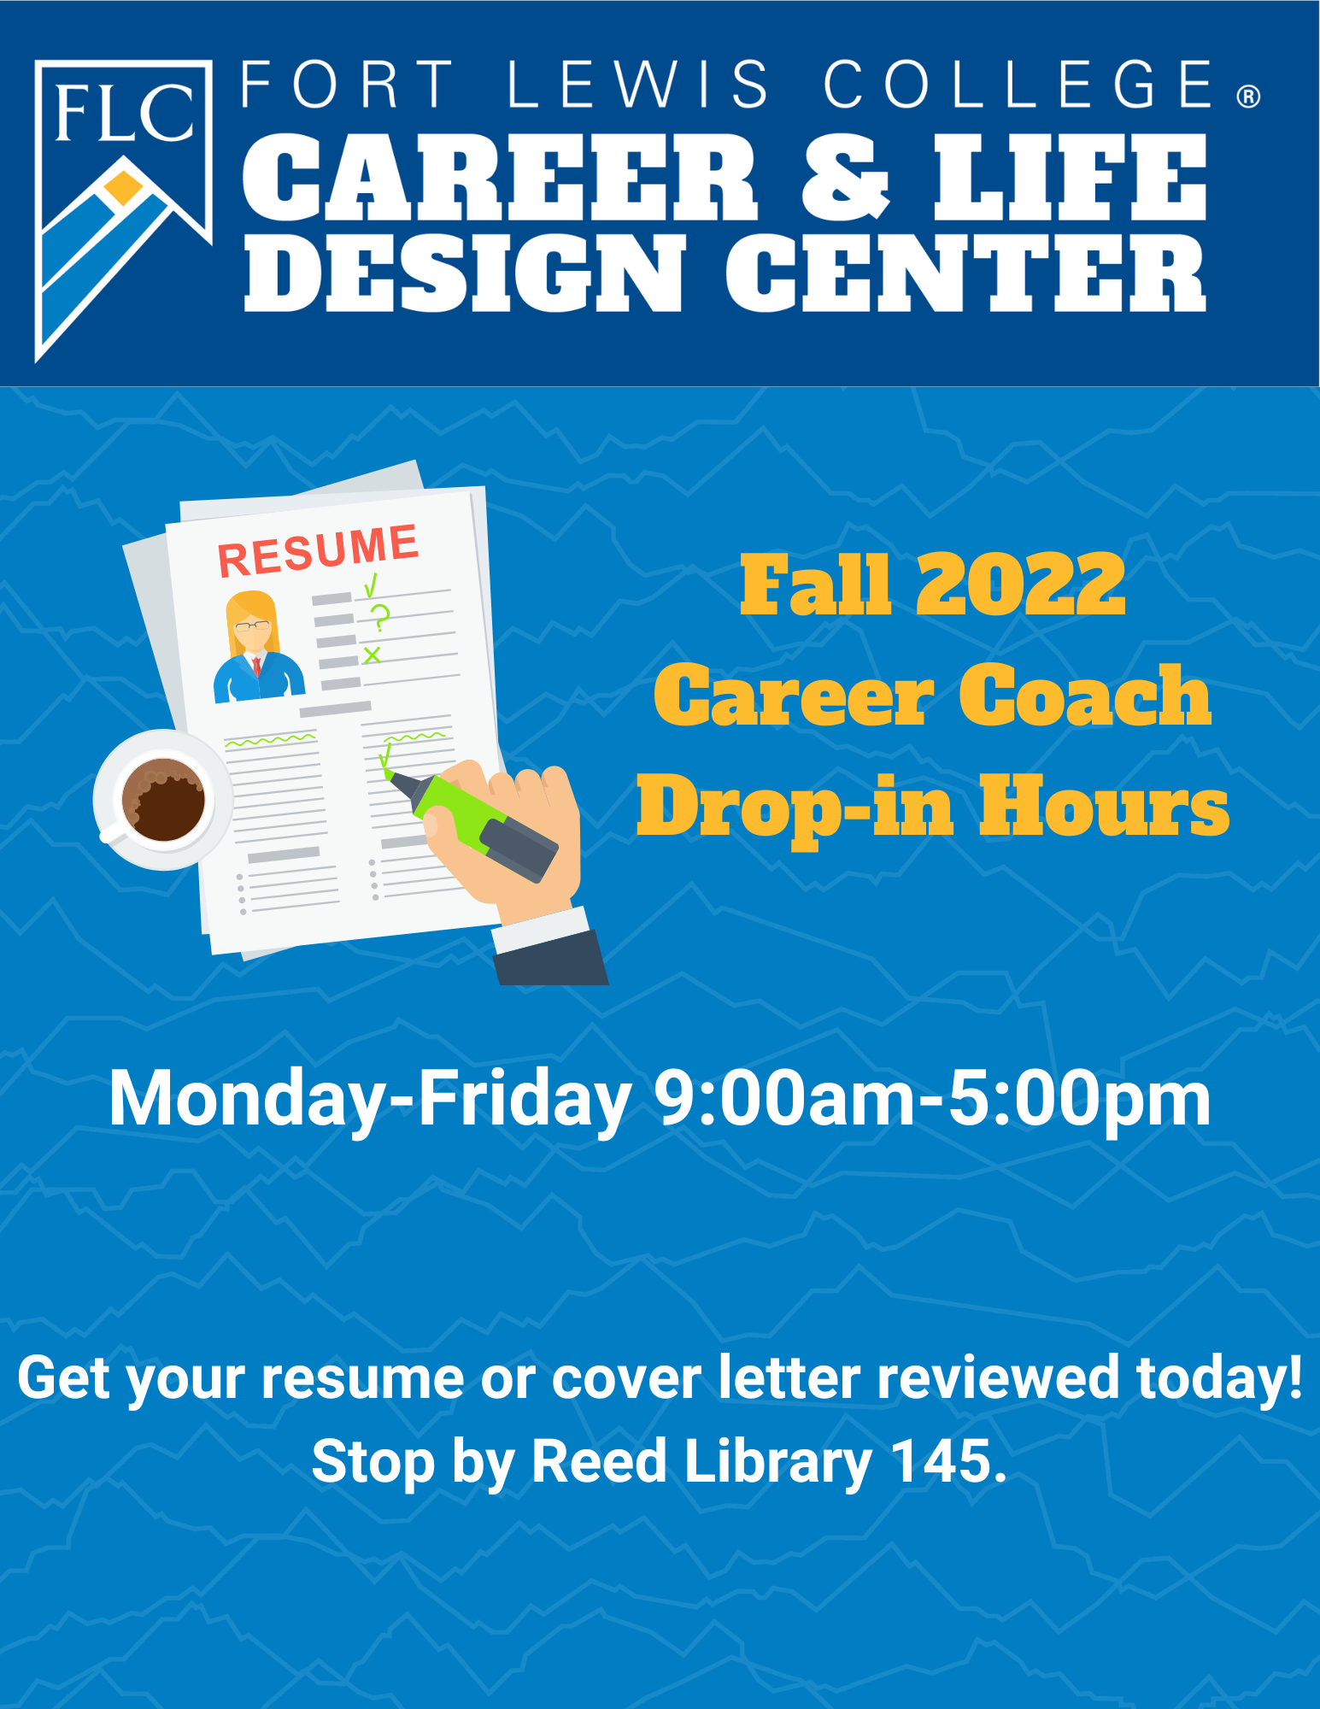
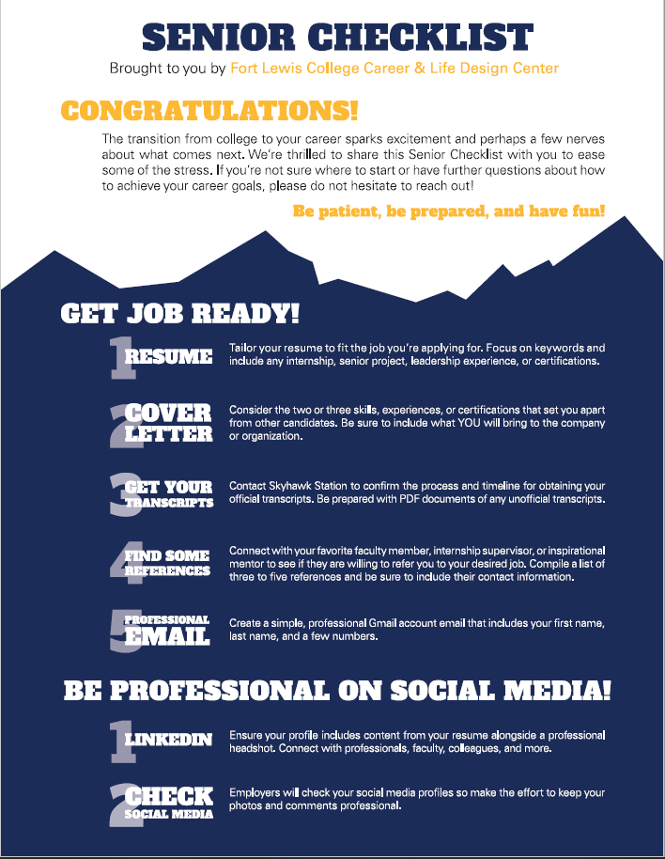
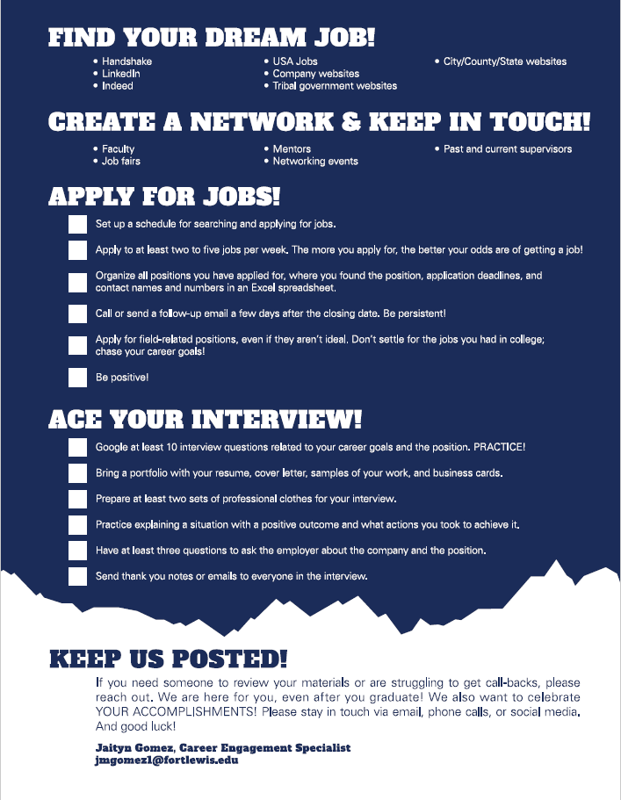
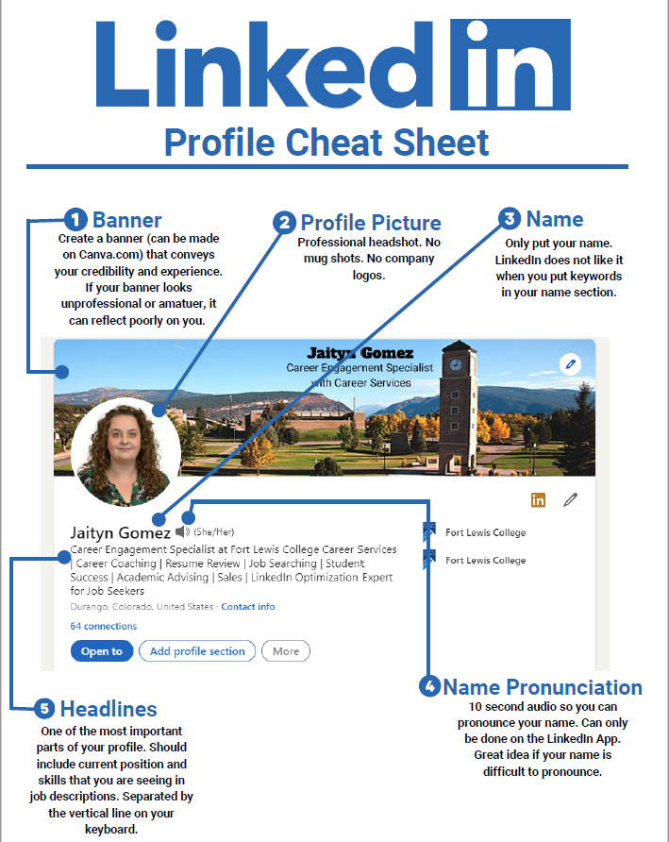
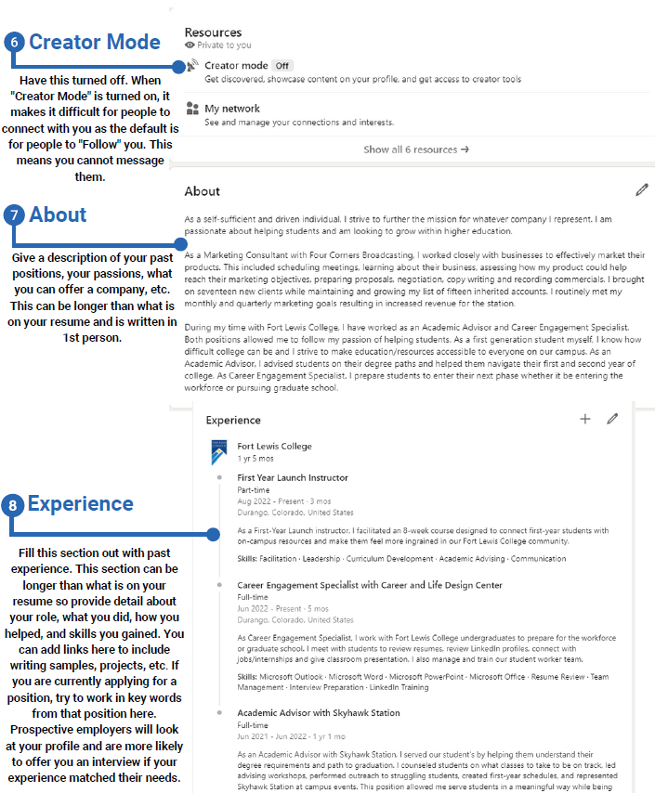
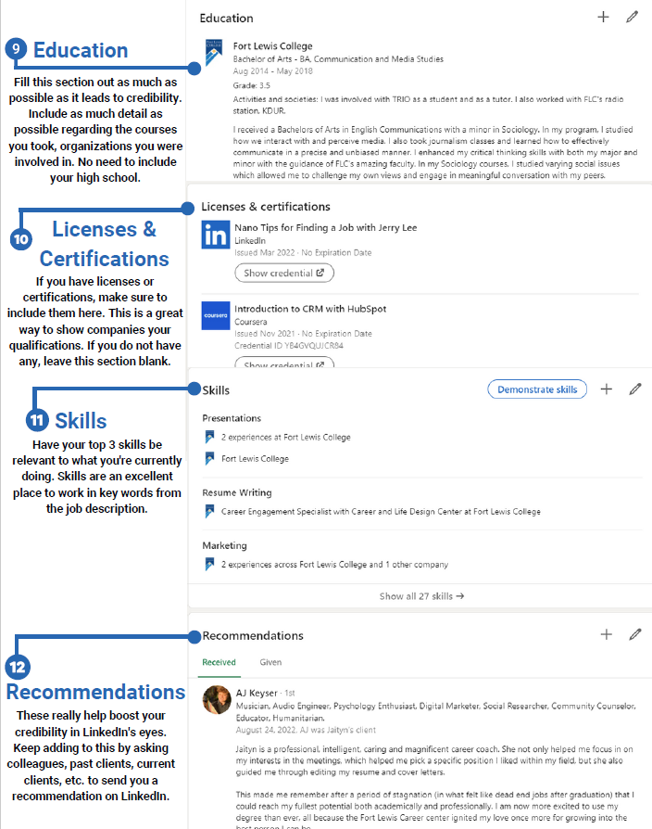
TEMPLATE (COPY AND PASTE INTO NEW DOCUMENT)
First Name Last Name
City, State
(XXX) XXX-XXXX | Email@gmail.com | www.linkedin.com/in

Summary (optional)
Write 3-4 lines giving an overview of your resume. Highlight major accomplishments and why you are interested in a particular company or industry. Talk about what value you can provide them.

Education
Name of University, ABC school May 2012
Bachelor of Science/Arts in Major GPA: 3.5
Minor: XXXXX
Societies listed here
**do not use bullet points in education section

Professional Experience
Organization Name City, State
Position Title Month year–Present
- Write your main highlighted accomplishments.
- Think about how your task/project helped the company do better and how you added value to the company.
- Follow the format “Performed X by doing Y resulting in Z”
- Start with strong action verbs and avoid using responsible, helped, researched, or assisted. Showcase your essential and technical skills here.

Organization Name City, State
Position Title Month year–Present
- Write your main highlighted accomplishments.
- Think about how your task/project helped the company do better and how you added value to the company.
- Follow the format “Performed X by doing Y resulting in Z”
- Start with strong action verbs and avoid using responsible, helped, researched, or assisted. Showcase your essential and technical skills here.

Activities
Organization Name, Institution Name City, State
Title Month year–Present
Brief description of the organization and your role (1-2 lines).
- This might be activities related to a specific class, organization on campus or volunteer work experience.
- Try to show essential and technical skills you gained through this organization. Focus on leadership, teamwork and management skills here.

Certifications
Name of Certification Expiration or attainment date

Skills
Skill, skill, skill, skill, skill (ex. PowerPoint, sales, negotiation, time management, networking)

References
Name
Job Title
Employer
Phone: (XXX) XXX-XXXX
Email: person@gmail.com

