Cover Letter Tips and Samples
Business Career Center | 114 Business Building | careerconnections.smeal.psu.edu

What is a cover letter?
» Acquaints the employer with your unique talents, experiences, and skills
» Highlights your resume by identifying how you are qualified for the position and the reasons why it will be to the employer’s advantage to hire you

Your cover letter should build rapport with the reader, express your enthusiasm for the job, and motivate the reader to carefully consider your resume.

Follow these tips:
» Address it by name and title of the individual with the power to hire you, if possible
» Use ‘Dear Hiring Manager’ or ‘Dear Hiring Committee’ if name is unknown
» Adapt the letter to specific details of the job opportunity
» DON’T use the same letter for every posting
» Open with an idea that captures the attention of the employer
» Highlight points in your resume that uniquely qualify you for the position
» Focus on the needs of the prospective employer
» Use the job description to help identify what their needs are
» Display your knowledge of the company
» Show you understand the company, the product, their needs, and the competition
» Don’t send the same cover letter for every job; the employer will know it is a template
» Adapt the letter to the specific condition of each position you are applying to
» Avoid jargon and trite language
» Pay attention to grammar, spelling, and neatness
» Have multiple people review it and do not rely on spell check
» The cover letter should be as concise and targeted as possible and limited to one page

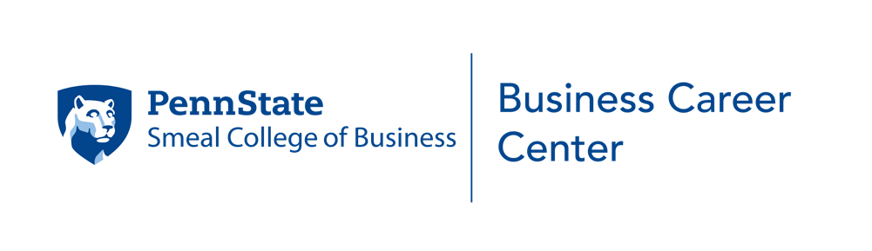
Tips from recruiters:
» Write resumes and cover letters tailored toward the job you are applying for
» Include evidence in the body of the cover letter which indicates you researched the company and the types of jobs they offer
» Clearly state why you are interested in the company and the position

Your present address City, State, ZIP
Date

Person’s Name Title
Company Address

Dear Ms. :

FIRST PARAGRAPH:
Attract the employer’s interest by briefly touching on your specific interest in the company and/or position. If you have been referred by someone, here is where you mention it. You want to convince the reader that you are interested in them by specifically outlining why you want to work for them and how you would contribute to the organization.

MIDDLE PARAGRAPH:
Describe your interest in the position, in the field of work, or in the organization. If you have a related class, volunteer, student activity, or work experience, be sure to mention pertinent data or accomplishments to show that you have specific qualifications and/or skills for this particular type of position. Refer to key aspects of your resume which relate to the job or employer, but DON’T restate the bullet points of your resume.

CLOSING PARAGRAPH:
Mention your interest in discussing the job in person (i.e., ask for an interview). Express appreciation for being considered and include a statement about your desire to have an interview.

Sincerely,

(handwritten signature) Your typed name

SAMPLE

905 Woodlawn Drive Clifton Park, NJ 07306

Date

Maria Porter, Account Executive Eliot, Zizelman, & Rohn
5962 Martindale Road
Parsippany, NJ 08630 Dear Ms. Porter:
I am currently a Junior at Penn State University majoring in Marketing in the Smeal College of Business. Through this letter I would like to express an interest in the account services internship with Eliot, Zizelman & Rohn. I value how Eliot, Zizelman & Rohn focuses on customer and strives to go above and beyond their needs. Through my customer service experience, creativity, and drive to succeed I feel I have the potential to be a valuable employee.

I have enclosed a resume for your review which outlines my experience in the field of advertising and promotion. As an advertising salesperson for the Daily Collegian, I worked successfully with a variety of clients and with the media to design and arrange advertisements. My responsibilities in this position enhanced my skills in writing, design, promotion, marketing, and follow-through. I
quickly learned to identify appropriate markets and to promote the Daily Collegian as an effective medium to reach those markets. Much of my success is due to my customer orientation, my skills in identifying client needs, and in marketing the services of my employer. I am a self-starter, persistent, and possess the ability to learn quickly. I feel these skills and experiences would be a strong addition to your firm and am excited about the prospect of putting them to work for you.

I would appreciate the opportunity to discuss my background and qualifications and how they can be of benefit to Eliot, Zizelman & Rohn. I would appreciate your consideration for an interview and look forward to hearing for you. If you have any questions in the meantime, please feel free to contact me at 555-555-5555 or abc123@gmail.com. Thank you for your time and attention.

Sincerely, Mark Smith

