Professional Dress Tips
Business Career Center | 114 Business Building | careerconnections.smeal.psu.edu

Clothing:

Business Professional Attire

- Wear a professional pant or skirt suit in a plain solid neutral color (black, blue, or gray).
- Make sure your suit is clean and pressed.
- Proper fit is key! Get your suit tailored so it’s not too big or too snug.
- If wearing a skirted suit, the skirt should not be shorter than knee-length.
- Button down, woven, and printed tops look professional while allowing you to showcase your personality.
- Be careful that your blouse is not low cut.
- Ties pull the entire look together while allowing you to showcase your personality.
- As a general rule, don’t wear anything too flashy.

Socks, Shoes, and Accessories:
- Mid-calf length socks are best so that no skin is visible when you sit down.
- Wear dress socks only!
- Hosiery pulls the entire look together. Don’t go into an interview with bare legs.
- Shoes should be close-toed, in good condition, and polished. If you wear heels, they should be no more than 2-3 inches high. Professional flats are great for interviews and can be more comfortable in situations where you are walking a lot, such as career fairs.
- If you are wearing jewelry, keep it simple. Wear no more than one ring per hand and one earring in each ear.
- Be sure your accessories aren’t flashy and distracting!

General Tips
- Be sure that your nails are clean. If they are polished, be sure they are a subtle color.
- Keep your hair styled neatly and pulled away from your face.
- If wearing makeup, be sure it is minimal and not distracting.
- If wearing a fragrance, be sure it is light and not overpowering.

Smart Casual Attire
- Smart casual is less dressy than business professional, but a step up from business casual.
- Suits are not necessary. You can wear separates such as khakis, dress pants, slacks, blazers, blouses/dress shirts, or an appropriate length business dress or skirt.
- Stay away from casual tops. Collared shirts or dressy button down, woven, and printed tops are a better choice.
- Oxfords, loafers, boots, flats, and mid-length heels are appropriate.

Business Casual Attire
- Business casual can be described as what many people normally wear to the office.
- Trousers, slacks, khakis, and dress pants are all appropriate.
- Casual dresses and skirts that are at or below the knee are acceptable. You want to be able to sit comfortably in public.
- Casual shirts, dress shirts, sweaters, tops, golf-type shirts, and turtlenecks are acceptable attire.
- Conservative loafers, clogs, boots, flats, dress heels, and leather deck-type shoes are acceptable for work.
- Use your discretion when deciding to wear jeans. This is the norm in some offices, but may be seen as too casual in others.

See examples of each type of dress on page 2 of this flyer!

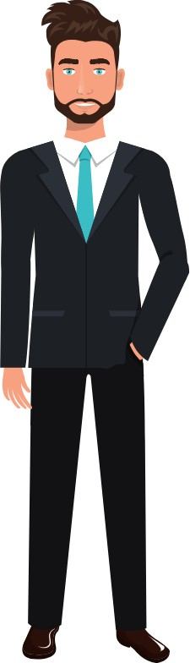
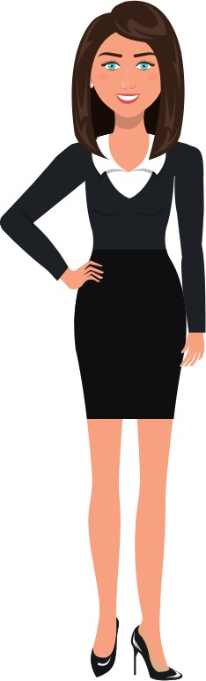
Business Professional Dress

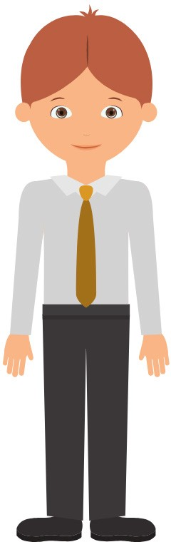
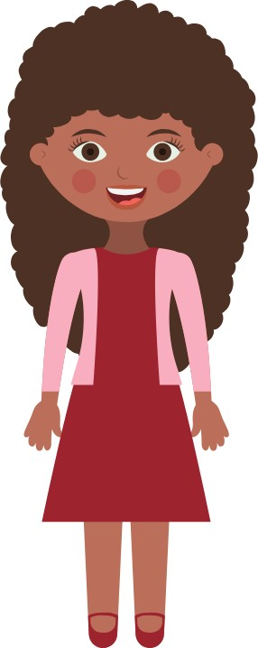
Casual Dress
Smart

Business Casual Dress

