SERVICE- ORIENTED
ASSISTANCE IN TRANSITION TO UNIVERSITY PARK ( ATUP)
Aids Change of Campus business students with
their transition to University Park by providing academic, social, and professional development events and opportunities.

GLOBAL BUSINESS BRIGADES
Brings business skills and a passion for change to developing communities around the world through consulting-based service trips.

DIVERSITY
ASCEND
SMEAL AMBASSADORS
Represents the Smeal College of Business and its integrated community by pioneering new initiatives, improvements, and services.

SMEAL STUDENT MENTORS
Open to students interested in serving as peer mentors to first-year students in the Smeal College of Business. Advisors are assigned to a number of first-year students and are available to answer questions about campus life.

VOLUNTEER INCOME TAX ASSISTANCE ( VITA)
A free tax-preparation service program that allows members to develop basic tax preparation skills and gain professional client interaction experience.

MULTICULTURAL

BUSINESS FRATERNITIES

RECOGNIZED

Promotes development
and leadership skills in Asian and Pacific Islander student interested in pursuing a career in business.

ASSOCIATION OF LATINO PROFESSIONALS FOR AMERICA ( ALPFA)
Increases awareness of the business fields among Hispanic business students and promotes diversity in the workplace.

BLACK MALE LEADERSHIP SYMPOSIUM
Aspires to produce unity and stability among black males, especially in the Smeal College of Business while making an effort to retain and recruit as many of these men it can reach.
WOMEN’ S FORUM
Creates a support network, enhances professional development, and develops leadership skills for multicultural women in, but not limited to, the Smeal College of Business.

NATIONAL ASSOCIATION OF BLACK ACCOUNTANTS ( NABA)
Promotes communication between its members and professionals in the field of accounting.

WOMEN IN BUSINESS ( WIB)
Promotes the advancement of Smeal women by increasing the awareness of workplace trends and connecting members with Smeal/Penn State alumni.
ALPHA KAPPA PSI
Professional fraternity dedicated to fostering the study of business administration and furthering the individual welfare of its members through leadership, scholarship, and service.
DELTA SIGMA PI
International fraternity focused on community service, professional activities, social events, and business goals in order to develop the leadership, professional, and social skills of its members.
PHI BETA LAMBDA
Has the mission of bringing business and education together in a positive working relationship through innovative leadership and career development programs.
PHI CHI THETA
Provides opportunities for business-oriented membership to engage in professional development, philanthropy, and leadership, with the goal of empowering each member to become the best version of themselves, both personally and professionally.
PHI GAMMA NU
Promotes high scholarship, service, leadership, and stresses the interdependence of all university majors in business.

SMEAL STUDENT ORGANIZATIONS

CONTACT

smealorgs@psu.edu careerconnections.smeal.psu.edu

MAJOR-RELATED & GENERAL INTEREST

CORPORATE INNOVATION AND ENTREPRENEURSHIP SOCIETY ( CIES)
Aims to strengthen the academic and professional network of students interested in Corporate Innovation and Entrepreneurship.

COUNCIL FOR SUPPLY CHAIN MANAGEMENT PROFESSIONALS ( CSCMP)
Fosters the advancement of logistics and promotes exchange of information, experience, ideas, and cooperation among its members.

ENTERPRISE RISK MANAGEMENT ASSOCIATION
Facilitates the
advancement of its

MACC PROGRAM STUDENT ASSOCIATION
Provides a voice for the Masters of Accountancy program so that the needs, wants, and concerns of these students be recognized and presented to the administrators for the betterment of the program and the educational benefits received.

MANAGEMENT INFORMATION SYSTEMS ASSOCIATION
Builds academic and career opportunities for Management Science & Information Systems majors and promotes the program among students, the faculty, and corporate recruiters.
PENN STATE INVESTMENT ASSOCIATION/ NITTANY LION FUND
Provides students the chance to make investment decisions regarding the fund's ~$7 million of real investor capital while exploring the intricacies of the financial world.
PENN STATE AMERICAN MARKETING ASSOCIATION ( PSAMA)
Provides its student members with real-world business experience; not just limited to the fundamentals of marketing, but also exploring all professional and rudimentary skills of business. Through personal and professional development, networking and leadership, PSAMA
PROFESSIONAL MANAGEMENT ASSOCIATION
Sponsors tours, speakers, and other activities to fully develop the professional skills of future business leaders.

SMEAL STUDENT COUNCIL ( SSC)
Dedicated to establishing better student-faculty relationships, promoting The Smeal College of Business, and encouraging student interaction through workshops and sessions with speakers.

SPORTS BUSINESS CLUB
Fosters growth of knowledge in sports industry by learning from professionals in the field

ACCOUNTING SOCIETY
Stimulates student interest in the various accounting fields and exposes them to viewpoints from the business world.

ACCOUNTING ANALYSIS & ADVISORY ( AAA)
Aims to help students prepare for careers in the corporate accounting, finance, advisory, and consulting industries while giving opportunities to learn about becoming a Certified Management Accountant (CMA).
ACTUARIAL SCIENCE CLUB
Helps students to learn what it means to be an actuary, develop professionally, pass actuarial exams, and secure jobs and internships through a variety of annual
APICS
Develops professional efficiency in operation management through study, research, and application of scientific methods.
BETA GAMMA SIGMA
Recognizes and honors top performing students from business schools around the world.
BETA ALPHA PSI
An accounting honorary fraternity intended to encourage scholastic and professional excellence through various speakers, programs, and social events.

BUSINESS SOCIETY HOUSE ( BASH)
A residence hall community where business students have an environment where they can prepare
members by holding professional opportunities and community service events as well as providing leadership experience.
INTERNATIONAL BUSINESS ASSOCIATION ( IBA)
Provides guidance, understanding and awareness of international business topics, events, and customs, and to provide opportunities and information about careers inside and outsides of the United States.
LEVERAGED LION CAPITAL ( LLC)
Provides hands-on education in the fixed income markets, preparing members for careers in this profession through the maintenance of a simulated portfolio of loans.
NET IMPACT UNDERGRADUATE CHAPTER
Aims to inspire, educate, and equip students to use business to create a more socially and environmentally sustainable world.

NITTANY LION CONSULTING GROUP ( NLCG)
Inspires, educates, and enables the next generation of business leaders and problem solvers in the consulting community.
PENN STATE FINANCE SOCIETY ( PSFS)
Seeks to expose students to the various fields of finance through education and by providing them with perspectives from experienced students, faculty members, and
offers members the vital
prerequisites needed for any undergraduate to make a comfortable transition to the workforce.
PENN STATE PRIME
Enables students to practice and improve their skills in branding, media marketing, and marketing analytics through real-world industry projects, case competitions, and workshops.
PENN STATE ASSET MANAGEMENT GROUP ( PSAMG)
Equips students with essential industry-related skills by working with a series of derivative instruments across a variety of asset classes, engaging in market research, and managing a simulated sector portfolio.
and provide students with opportunities for internships and future careers in sports.

TAMID
Develops the professional skills of undergraduate students through hands- on interaction with the Israeli economy, training the next generation of business leaders, and instilling in them a strong and lasting connection to Israel.

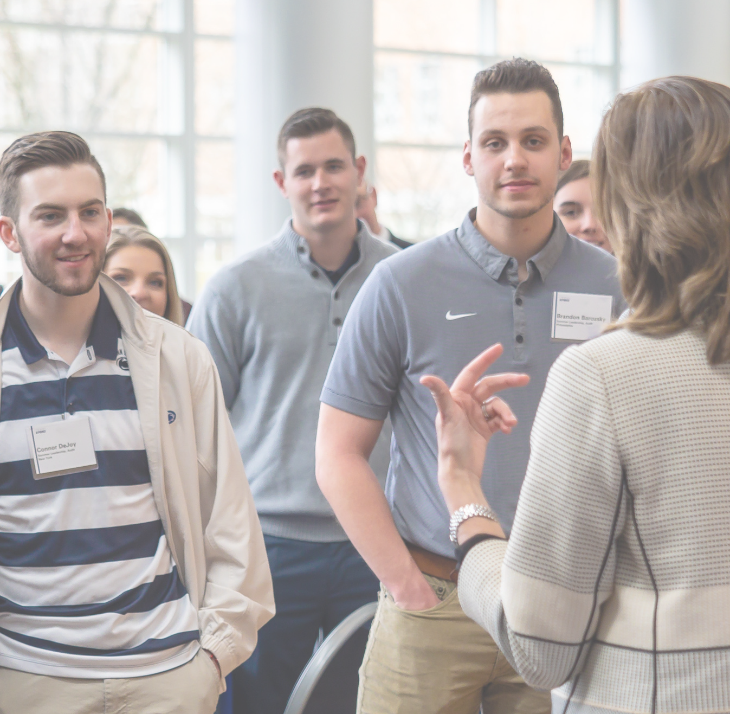events, including an actuarial career fair, company site visits, technical trainings, mock interviews, and funding for
exam resources.
academically and
professionally for their career.
professionals.
Penn State is an equal opportunity, affirmative action employer, and is committed to providing employment opportunities to all qualified applicants without regard to race, color, religion, age, sex, sexual orientation, gender identity, national origin, disability or protected veteran status. U Ed: BUS 20-135

