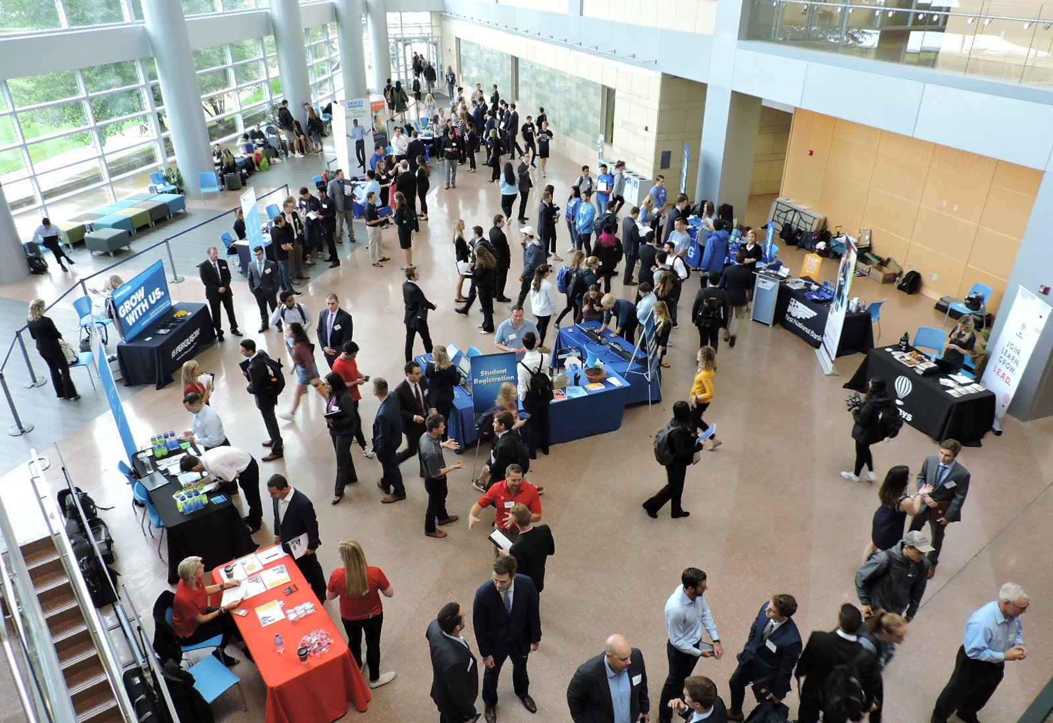Hiring Resources for Smeal Undergraduate International Students
1 Hiring Resources for Smeal Undergraduate International Students

International Student Internship Eligibility
- International students are REQUIRED to meet with the Directorate of International Student & Scholar Advising (DISSA) before applying to an internship and also after accepting the internship. DISSA offers advising, immigration services, and training to support our international students, scholars, and faculty. This is to ensure that all visa requirements are properly met.
- Students MUST enroll in BA395A to earn one credit for a summer internship because CPT, which is not a required part of a degree program, must be credit bearing. Be sure to review the CPT eligibility requirements and steps to authorization.
- Students are REQUIRED to have all necessary paperwork completed by the staff in the Directorate of International Student & Scholar Advising (DISSA).
- Failure to get the appropriate authorizations from DISSA can result in legal issues for the student that could result in deportation in certain cases.
- An internship is NOT a requirement for the curriculum of a Smeal College of Business undergraduate degree program. International students with F-1 or J-1 visas are required to be enrolled in the University with full time status (minimum of 12 credits) in the fall and spring
semesters. Because the internship is not a requirement for Smeal students, there is no exception to the visa requirements. This means that a Smeal international student CANNOT accept the following positions:
  - Fall semester internship
  - Spring semester internship
  - Spring/Summer co-op
  - Summer/Fall co-op
- International students are eligible to participate in SUMMER INTERNSHIPS ONLY.

It is your responsibility to speak with the Directorate of International Student & Scholar Advising (DISSA) if you have any questions regarding these expectations, consequences, or surrounding circumstances. We are committed to assisting all students in the pursuit of their career goals.

Contact university staff if you are unsure what to do or an issue arises.

Contact the Directorate of International Student & Scholar Advising (DISSA)
410 Boucke Building, University Park, PA 16802 Phone: 814-865-6348
Email: dissa-adviser@psu.edu

Contact the Business Career Center
114 Business Building, University Park, PA 16802 Phone: 814-865-3244
Email: smealcareers@smeal.psu.edu

International Student Work Permissions
Employment for F-1 and J-1 students is limited, and working without permission is a violation of status and a deportable offense. F-1 and J-1 students may not work off-campus without permission from the Directorate of International Student & Scholar Advising (DISSA). On-campus employment is permitted with certain restrictions. Students must complete employment paperwork with DISSA in order to work on-campus. A Social Security number is required for anyone receiving payment. DISSA can assist you with this process.

On-Campus Employment | F-1 and J-1 students are allowed to work on-campus up to 20 hours per week while school is in session. If you were registered in spring and are registered for the summer term or will enroll for the following fall, you may work full-time on campus (more than 20 hours per week) during the summer.
F-1 Curricular Practical Training (CPT) | Curricular practical training (CPT), employment which is an integral part of an established curriculum, is available to F-1 students who have been lawfully enrolled on a full-time basis for one academic year. Students in English language programs are ineligible for practical training.
F-1 Optional Practical Training (OPT) | Students who have been in F-1 status for at least one academic year are eligible for Optional Practical Training (OPT) which is temporary employment for twelve months in their field of study for purposes of gaining practical experience.  Students typically use OPT upon completion of program of study.

Finding an Internship or a Job as an International Student

Plan and Research
There are several ways that you can focus your internship and job search as an international student:
- The Business Career Center maintains a list of companies that have hired Smeal students for CPT and OPT.
- Students searching for positions located outside of their country of citizenship should look for positions for which the employer is willing to provide visa sponsorship. Follow the steps on page 6 to search for jobs that can provide visa sponsorship.

Resources
- GoinGlobal has a large database of employers who have applied for a work visa for international students. Penn State Career Services has an account with GoinGlobal so that you can access this resource. To access this resource, log in to Nittany Lion Careers and click the GoinGlobal link under ‘Links’ on the lower right side of the home page.
- MyVisaJobs lists the top 100 visa sponsors by year among other resources.
- Use LinkedIn to connect with Penn State alumni who have worked/worked abroad. Conduct informational interviews to learn more about their job search.
- You may also plan to target corporations and organizations that do business in or with your country of citizenship. Knowing the native language may prove to be a a critical factor when it comes to landing the job!
- If you find an internship that interests you, be sure to reference our Internship Evaluation Database to learn about previous student experiences with that particular company.

Educate and Advocate
Some companies will say that they don’t hire international students simply because they are unfamiliar with hiring policies and the legalities of hiring international students. Be knowledgeable about visa restrictions and your individual eligibility in order to advocate for
yourself. You should also understand why companies may not be able to sponsor you, and know that this does not constitute discrimination.

Communicate
You want to be sure that you practice your conversational English as much as possible if you plan to work in the United States. Joining a student organization is a great opportunity to network, gain leadership experience, and practice your communication skills.

Be sure to enroll in and highlight any English and/or communication courses you’ve enrolled in on your resume as additional evidence of your ability to communicate effectively.

The English for Professional Purposes Intercultural Center (EPPIC) at Penn State University offers English language support services for international students to enhance their skill and confidence in advanced academic and professional English, for career success. Schedule an appointment or find an upcoming workshop here.

Lastly, utilize the Business Career Center to practice your interviewing skills and become more aware of your nonverbal communication. Schedule an appointment through Nittany Lion Careers or visit our website to see when drop-in mock interview hours are.

Differentiate Yourself
You bring a unique global perspective to the workplace as an international student. Be ready to promote your language skills, cultural knowledge, and additional skills to employers in a manner that is appropriate for the country and company that you plan to work in.

Give context to explain your international experiences and be sure to submit a resume that is appropriately formatted depending on the location of the company you want to work at. GoinGlobal gives examples of what your resume should include for different countries.

Have a Plan B
According to recent surveys, approximately 80% percent of international students intend to work in the US after graduating, yet less than 30% obtain an internship or full-time job offer in the US. It is critically important that you network with professionals and research companies in your home country or in other foreign countries.

Smeal International Student Post-Graduation Outcomes, 2017-18
(self-reported data at graduation)
Full-Time Offers (in US and internationally) | 21.8%
Internship | 2.2%
Military | 2.2%
Entrepreneurship | 1.1%
Further Education/Fellowship | 45.8%
Still Seeking (No Offer) | 26.8%
Students Who Had at Least 1 Internship/Co-op (in US and internationally) | 72.1%

Finding Positions for International Students in Nittany Lion Careers

- In Nittany Lion Careers, click on the “Jobs” tab on the left side of the screen, then click “Search”.
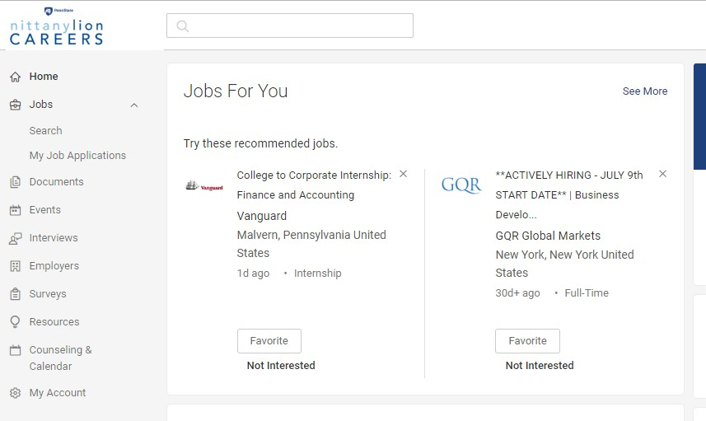

- Then, click “See All Jobs in System”.
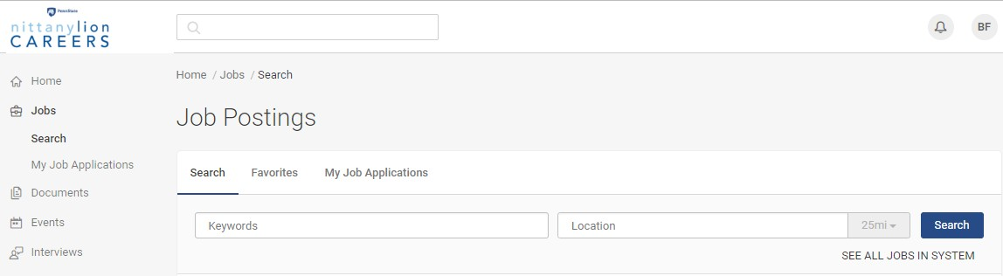

- Click the “More Filters” tab.

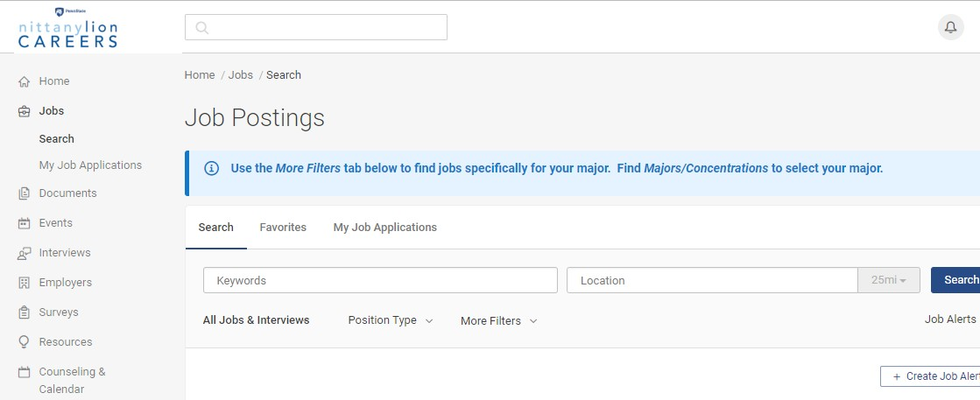

- Under ‘Visa Sponsorship Offered?’, select “Yes”.
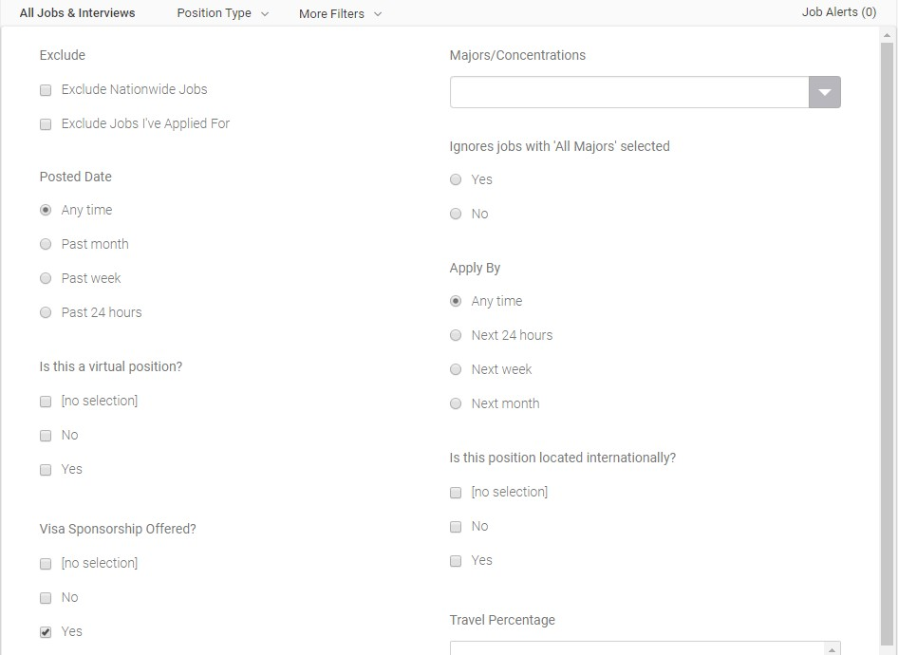
Note: choosing ‘No Selection’ is a possibility, but will require students to do additional research on if the position offers visa sponsorship.

International Internships

Exploring International Internship Opportunities
Students interested in interning abroad will have a challenging, exhilarating cultural experience that includes a chance to build work skills, while learning about the working environment of a different country. Some internships require proficiency in the language of the country. Required credit does not count toward Smeal graduation requirements or the International Business Minor.

Third-party International Internship Providers
Third-party internships are project-based semester or summer experience, and are usually unpaid. Student pays a third party international internship provider to assist with making an internship connection, providing housing, orientation and ongoing support during the internship. Below is a list of Penn State affiliated programs. For students that want to look beyond Penn State options and take responsibility to evaluate other possibilities, there are many internship and service learning providers.

Penn State Affiliated
Summer Internship Programs opportunities include:
- Melbourne, Australia: The Intern Group: Melbourne Internship
- Shanghai, China: CRCC Asia: Shanghai Internship
- Dublin, Ireland: IES: Dublin Internship
Fall & Spring Study Abroad Programs with Internships Available opportunities include:
- Vienna, Austria: IES: Vienna, European Society and Culture
- Seville, Spain: CIEE: Seville
- Buenos Aires, Argentina: IES: Buenos Aires, Latin American Societies and Cultures

Other Options
Third Party International Providers opportunities include:
- Academic Internship Council: work in Boston, New York, San Francisco
- Arcadia University: Australia: Sydney; Italy: Syracuse; Spain: Toledo; UK: Edinburgh
- Dream Careers: China: Hong Kong; France: Paris; Spain: Barcelona; UK: London
- IES Internships: work in Chicago, New York
- The Intern Group: Canada: Toronto; China: Shanghai; Colombia: Medellin; Ireland: Dublin; Japan: Tokyo; Spain: Barcelona, Madrid; UK: London

Service Learning Abroad and More Options
Semester Study Abroad with an Internship or Service Learning Choice
- Students abroad for a full semester usually take 15 credits of classes, 3 credits of which could be a work experience 10-20 hours per week with a local/international employer, NGO, Social Organization, Community Center, etc.
Self Identified Service Learning Abroad
- Students identify opportunities and complete full or part time service work for an NGO or Social/Civic Organization independent of Penn State affiliation.
- Students must carefully review programs to ensure they meet student needs (support, safety, training, etc.) and the community’s needs by work toward a lasting solution to a community problem.community problem.

H1-B Visa Facts

What are my chances of working in the US after graduation?
700
Undergraduate international students in the Smeal College of Business

4,867
Undergraduate international students at Penn State (Univ. Park)

442,800
Undergraduate international students studying in the US

85,000 VISAS ARE AVAILABLE
65,000 (regular cap)

20,000 advanced degrees

Applying for a visa (whether you get one or not) can cost an employer up to

$6,460

The approval rate for H-1B visas has declined from 92% to 75% in the past two years
14.5% of Smeal international graduates reported full time employment in the US in 2017

Working in the US After Graduation

Practical Training
For graduates in F-1 student status, Optional Practical Training allows up to twelve months of employment after graduation (for those holding Science, Technology, Engineering, or Math degrees, may get 24 additional months). The student must obtain permission from the university, and a
work authorization card from the United States Citizenship and Immigration Services (USCIS). The Directorate of International Student & Scholar Advising (DISSA) can help with this process and offers workshops for students to learn more.

H-1B Visas
This is a popular work visa. It is available to foreign nationals who have at least a
US bachelor's degree or foreign equivalent and will be working in a job that requires at least a bachelor's degree. Allows employment for 3 years, or longer with an extension.

H-B Cap: 85,000 new H-1B approvals are issued each year (CIS year - October 1 through September 30). CIS accepts cases beginning April 1 for October 1 H1Bs.

H-1B Exemptions
Each year, CIS exhausts the full quota of 65,000 “bachelor’s degree” H-1B’s and the additional 20,000 quota for U.S. advanced degree holders. As a result, many foreign students and employers seek alternatives to the H-1B. In addition, some employers qualify for an exemption from the H-1B quota. The following is a summary of exempt employers, and alternatives to the H-1B, which may allow a foreign graduate to remain and work in the United States after graduation.

Organizations Exempt from the H-1B Quota
Certain organizations are exempt from the H-1B quota. Exempt organizations can file H-1B applications at any time, regardless of the quota. Exempt organizations include:
- Universities
- Non-profit organizations affiliated with universities (such as research facilities or hospitals)
- Non-profit research organizations, engaged primarily in basic or applied research
- Governmental research organizations

Note that there is no blanket exemption for “non-profits”. To be exempt from the quota, the non- profit either must be affiliated with a university, or must be a non-profit “research organization.”

H-1B Alternatives

H-2A, H-2B, and H-3 Visas: Temporary Workers and Trainees
These visas are for short-term skilled/unskilled workers for temporary positions or training. They may be part-time positions H-2A/2B visas allow for a duration of stay of up to 1 year, and it is generally renewable for up to 3 years. H-3 Trainee visas allow for a duration of stay for 18-24 months.

J-1 Academic Training
You may participate in academic training during your studies or after your studies if the academic training is approved no later than 30 days after completion of studies. However, the period of academic training will begin to count upon the program end date. You are eligible for academic training as long as you meet the following criteria:
- You are primarily in the United States to study rather than engage in academic training;
- You are participating in academic training that is directly related to your major field of study;
- You are in good academic standing;
- You receive written approval in advance from DISSA for the duration and type of academic training.
For exchange, undergraduate, and master’s degree students, academic training cannot exceed the number of months of study or 18 months, whichever is less. For PhD students the limit is 36 months or the number of months of study, whichever is less. No more than 18 months of academic training may be used prior to the completion of studies. A new form DS-2019 must be issued for each 18 month period.

Work Outside the U.S.
A foreign graduate can work for an employer outside the U.S. without a U.S. work visa.

Return to School
Many foreign graduates re-enroll in school in F-1 status if they miss the H-1B quota.

What to Expect in the Job and Internship Search Process

Understanding US Business Culture
- American business culture tends to be individualistic and competitive: people are often focused on their personal success over the success of the group they are in as a whole.
- “Time is money”: projects move at a quick pace and inefficient use of time is seen as a huge loss
- Business professionals are often direct and assertive. They would rather get to the point of a con- versation than cautiously approach a subject.
- Being “on time” means being five minutes early. Show up early to everything!
- Managers are action-oriented. They want quantitative results and processes that will clearly cre- ate a positive impact on the “bottom line” of their company.
- Data is key in making decisions. Everything is quantified and assessed in an attempt to under- stand and improve upon business activities and processes.
- Risk-taking is normal and often encouraged in business practices.
- Work is important to a person’s identity, and hard work is greatly valued and admired.
- Change is constant. Companies are always looking to improve their products to make them bet- ter and to meet customers’ needs.

Understanding the U.S. Communication Style
- Smile! If you don’t smile, you may ome off as unapproachable, dissatisfied, or unpleasant.
- Maintain at least an arm’s length of space when you are speaking with someone.
- Shake hands when you meet someone, but don’t expect more physical contact beyond this.
- Eye contact is key. Be sure to meet the eyes of the person you are talking to frequently.
- Be sure to use greetings and closings when you start and end a conversation.
- Address people you meet as Mr. or Ms. (Last Name) to start, but then use the preferred name if they tell you to.

Understanding U.S. Recruiting Practices
- Think of employers as ‘buyers’ and candidates as ‘sellers’: you have to market yourself to stand out.
- Fairness, diversity, and equal opportunity are emphasized in the recruiting process.
- In the beginning of the screening process, employers look for reasons NOT to hire you before they figure out why they should hire you.
- It is important to be “well-rounded” with your college experiences. Just having good grades most likely will not be enough to get you an interview.
- Networking is key! It is a long-term process that should be personal and mutually beneficial for you and the other person involved.
- Interviews are an important tool for recruiters to assess your level of interest, enthusiasm, and confidence.
- Stick to small talk. Avoid controversial topics such as politics and religion.
- Be prepared to explain the skills you gained through your international work/leadership experience since most recruiters will be unfamiliar.
- While it is important to look for a job that you qualify for as an international applicant, be sure to consider the job itself and not just the fact that they can provide you a visa in your decision.

International Student Hiring Data*

Companies That Hired International Students for a Full-time Position: 2015-2017
Company | Major Hired | Location
Aishi Finance (2016) | Accounting | China
Pin’an Insurance Co. (2015) | Risk Management | China
JWT Worldwide (2017) | Marketing | Ecuador
Quadrum Solutions (2015) | Marketing | India
Lazard Asset Management (2017) | Accounting | Japan
C.J. Miller, LLC. (2015) | Marketing | Korea
Khazanah Nasional (2017) | Finance | Malaysia
Dicarina (2017) | Supply Chain & Information Systems | Panama
Saudi Aramco (2015,2016) | Accounting, MIS, Supply Chain & Information Systems, Finance | Saudi Arabia
Heineken (2017) | Accounting | Singapore
Eurotran (2017) | Supply Chain & Information Systems | Taiwan
General Electric (2015) | Finance | United Kingdom
Adgenics (2015) | Marketing | US
AIG (2015-2017) | Finance, Supply Chain & Information Systems, MIS, Risk Management | US
Altus Group (2015) | Finance | US
Annie International (2015) | Supply Chain & Information Systems | US
BlackRock (2015/2016) | Accounting, Finance | US
Bloomberg L.P. (2015) | Finance | US
Cigna (2016) | Risk Management | US
Cognizant Technology Solutions (2016) | Finance | US
Cummins Inc. (2015, 2017) | Supply Chain & Information Systems | US
Dell (2016) | Accounting | US
Diamond Consulting (2017) | Marketing | US
EY (2015,2016) | Accounting, Finance, Risk Management-Actuarial Science, MIS, Supply Chain, Marketing | US
Freedom Mortgage (2017) | MIS | US
Goldman Sachs (2015) | Finance | US
Habison Walker International (2017) | Supply Chain & Information Systems | US
High Point Solutions (2015,2016) | Supply Chain & Information Systems | US
KMPG (2015-2017) | Accounting, MIS | US
Linde Gas (2017) | Supply Chain & Information Systems | US
Morgan Stanley (2017) | Finance | US
Options Group (2017) | Accounting | US
Solomon Edwards (2017) | Finance | US
TE Connectivity (2017) | Supply Chain & Information Systems | US
Amazon.com (2017) | Supply Chain & Information Systems, Management | US, Costa Rica
Deloitte (2015-2017) | Accounting, Finance, Risk Management, Supply Chain | US, Canada, China
PwC (2015-2017) | Accounting, Finance, Supply Chain, Marketing, Risk Management | US, China, Hong Kong, South Africa
* This list should be used as a reference, but does not guarantee that these employers will be able to sponsor students. This will vary from year to year based on business need. To see more data on where students have found internships, visit

US Companies That Hired International Students for a Internship: 2015-2017
Company | Major Hired
Access Bio (2015) | Accounting
BRT inc. (2017) | Accounting
D & J Construction Consulting (2015) | Accounting
Dell (2016) | Accounting
Franklin Templeton Investments (2015) | Accounting
Fareportal (2017) | Accounting
Harvest Wealth Management (2017) | Accounting
Loreal (2017) | Accounting
Okma Academy (2017) | Accounting
Options Group (2017) | Accounting
ProSci (2017) | Accounting
Roland Berger | Accounting
School Districts Insurance Consortium (2015) | Accounting
Small Business Development Center (2015) | Accounting
Abundance Wealth Counselors (2017) | Accounting
EXR Real Estate Group (2017) | Accounting
Deloitte (2016/2017) | Accounting, Finance
EY (2016/2017) | Accounting, Finance
Morgan Stanley (2017) | Accounting, Finance
PwC (2016/2017) | Accounting, Finance, Marketing, Risk Management-Actuarial Science, Supply Chain and Information Systems
Penn State University (2015/2017) | Accounting, Finance, Risk Management-Actuarial Science
Citibank (2016) | Accounting, Marketing
Accenture (2016) | Accounting, Marketing
KPMG (2016/2017) | Accounting, MIS, Supply Chain & Information Systems
Aon Hewitt (2017) | Accounting, Risk Management-Actuarial Science
Boaz Dvir-Independent Filmmaker (2017) | CIENT
Salvatore Ferragamo (2017) | Finance
Alcoa (2017) | Finance
Archer Daniels Midland (2015) | Finance
Bryant Park Capital (2015) | Finance
CICC US Securities (2015) | Finance
Copper Beech Townhomes (2015) | Finance
Friend Services for Aging (2017) | Finance
GE (2017) | Finance
Grant Thornton (2017) | Finance
Havas Media (2017) | Finance
iA Consulting Group (2017) | Finance
Inter-American Development Bank (IDB) (2017) | Finance
ITC (2015) | Finance
National Securities (2016) | Finance
Science Applications International Corporation (2017) | Finance
Sairong Information Technology Corp (2017) | Finance
Schlumberger (2017) | Finance
Quantum Potential Corp. (2015) | Finance
To see more data on where students have found internships, visit https://careerconnections.smeal.psu.edu/international-students/internationalhires/.

Quantum Potential Corp. (2015) | Finance
Uber Technologies (2017) | Finance
VideoMining (2015) | Finance
Wexford Capital (2017) | Finance
Zoompoint (2017) | Finance
AIG (2016/2017) | Finance, Management Information Systems, Risk Management
BNP Paribas (2017) | Finance, Risk Management-Actuarial Science
McKinsey & Company, Inc. (2017) | Management
NAI Emory Hill (2017) | Management
Pharmaron (2017) | Management
PromoGroup (2016) | Management
Rita Ltd. (2015) | Management
Cox Automotive (2017) | Management Information Systems
Avitron (2015) | Management Information Systems
Conde Nast (2016) | Management Information Systems
Reckitt Benckiser (2016) | Management Information Systems
Accuweather (2016/2017) | Marketing
Bryan Cave Consulting Firm (2015) | Marketing
Colgate-Palmolive (2016) | Marketing
Combus Tech (2017) | Marketing
Face to Face (2017) | Marketing
Saatchi & Saatchi Healthcare (2015) | Marketing
Schoolwires (2015) | Marketing
UniFood Corp (2017) | Marketing
Cigna (2016-2017) | Marketing, Risk Management
Unilever (2016) | Marketing, Supply Chain & Information Systems
Chelsea Hotels (2015) | Risk Management
City of Philadelphia (2015) | Risk Management
Towers Watson (2016) | Risk Management
Falls Lake Insurance (2017) | Risk Management-Actuarial Science
Intersections Insurance Services Inc. (2017) | Risk Management-Actuarial Science
Small Enterprise Assistance Funds (2016) | Supply Chain & Information Systems
American Eagle Outfitters (2017) | Supply Chain & Information Systems
Apex Logistics International (2017) | Supply Chain & Information Systems
ASA Travel (2017) | Supply Chain & Information Systems
Aircraft Shopper Online (2017) | Supply Chain & Information Systems
Bimbo Bakeries (2017) | Supply Chain & Information Systems
Coca Cola Company (2017) | Supply Chain & Information Systems
Cummins, Inc. (2015-2017) | Supply Chain & Information Systems
DHL (2016) | Supply Chain & Information Systems
Global Display Solutions (2015) | Supply Chain & Information Systems
Green Towers LLC. (2015) | Supply Chain & Information Systems
M/C Partners (2015) | Supply Chain & Information Systems
Pro Telecom LLC. (2015) | Supply Chain & Information Systems
TE Connectivity (2017) | Supply Chain & Information Systems
Under Armour (2017) | Supply Chain & Information Systems
To see more data on where students have found internships, visit

Additional Resources

U.S. Citizenship and Immigration Services
- USCIS home page: https://www.uscis.gov/
- Working in the US: https://www.uscis.gov/working-united-states/working-us
- Temporary Worker info: https://www.uscis.gov/working-united-states/temporary-nonimmigrant-workers
- H-1B Visa Information: https://www.uscis.gov/working-united-states/temporary-workers/h-1b-specialty-oc- cupations-dod-cooperative-research-and-development-project-workers-and-fashion-models
- Green Card Information: https://www.uscis.gov/greencard

Department of Homeland Security
- DHS Study in the States info: https://studyinthestates.dhs.gov/

Penn State Career Services
- Penn State Career Services website: https://studentaffairs.psu.edu/career

The National Association of Colleges and Employers
- NACE home page: https://www.naceweb.org/
- Resources and news for international students: https://www.naceweb.org/tag/international-students/

Get in Touch with the Business Career Center

Visit Our Website
- Find career resourcs, event information, and leadership opportunities at https://careerconnections.smeal.psu.edu/

Make an Appointment
- Schedule an appointment with a career coach through Nittany Lion Careers: nittanylioncareers.psu.edu

Contact Us
- Send us an email at smealcareers@smeal.psu.edu
- Drop in our office in 114 Business Building from 8am-5pm, Monday through Friday

