D E V E L O P I N G A N I N T E R N S H I P
P R O G R A M

C O N T E N T S

T H E B E N E F I T O F I N T E R N S H I P S 0 3 I N T E R N S H I P O V E R V I E W 0 4 B E N E F I T F O R E M P L O Y E R S 0 5
C H A R A C T E R I S T I C S O F A N I N T E R N S H I P 0 5 C R I T E R I A F O R A N I N T E R N S H I P 0 6 C O - O P O R I N T E R N S H I P 0 6
C R E A T I N G A N I N T E R N S H I P 0 7 O U T L I N E A P L A N 0 8 I N T E R N S H I P P R O C E S S T I M E L I N E 0 9
I N T E R N S H I P P O S I T I O N D E S C R I P T I O N W O R K S H E E T 1 0
R E C R U I T I N G A T P E N N S T A T E 1 1 F O R - C R E D I T I N T E R N S H I P S 1 2 N O N - C R E D I T I N T E R N S H I P S 1 3 V I R T U A L I N T E R N S H I P S 1 4 I N T E R N S H I P C O M P E N S A T I O N 1 5 P O S T I N G A N I N T E R N S H I P 1 6 I N T E R N S H I P D E S C R I P T I O N S 1 6
S A M P L E I N T E R N S H I P D E S C R I P T I O N 1 7 L E G A L K N O W L E D G E 1 8 P A Y I N G I N T E R N S 1 9
U N P A I D I N T E R N S 1 9 L E G A L A S P E C T S 2 0 I N T E R N A T I O N A L S T U D E N T S 2 1
M A N A G I N G T A L E N T 2 2 O N - B O A R D I N G & F I R S T D A Y 2 3 P R O V I D I N G F E E D B A C K 2 4

Portions of this guide have been borrowed or adapted from ‘Starting and Maintaining A Quality Internship Program’ by Michael True, copyright. https://www.internqube.com
2

THE
BENEFIT OF INTERNSHIPS

Employers and students can experience numerous benefits from participation in an internship experience. Internships and their outcomes have decidedly changed from past decades. Student internships are no longer designed to complete only basic administrative tasks and fetch coffee.

Today's internships are full of experiential learning for students engaging in an experience that supports and expands on their academic goals. This partnership also enhances an organization's pipeline of future talent while supporting their organizational goals through a fresh student perspective.

PLEASE CONTACT:

Ashley Stark
Director of Corporate Relations
Smeal College of Business University Park
als5328@psu.edu 814.863.5827

Thompson Harner
Assistant Director of Corporate Relations
Smeal College of Business University Park
sth121@psu.edu 814.863.8045

If your organization is looking to provide a robust learning experience for a Penn State student, our students are looking forward to contributing to your organization in a meaningful way. The following guide will assist you in preparing an internship program, as well as show you how to engage with Penn State students through an internship experience.

Penn State Employer Engagement professionals or your local campus career services office can assist you with creating an internship, sourcing talent, or building your brand on campus. Contact a Penn State Employer Engagement professional or a local career office for assistance.

EMPLOYER ENGAGEMENT

SUE CHAPPELL
Employer Engagement Manager University Park
sek28@psu.edu 814.865.4624
NICOLE DARLING
Eastern Region Employer Engagement & Career Specialist nss100@psu.edu
570.675.9224

CAREER OFFICES

Find an office at studentaffairs.psu.edu/career/career-offices

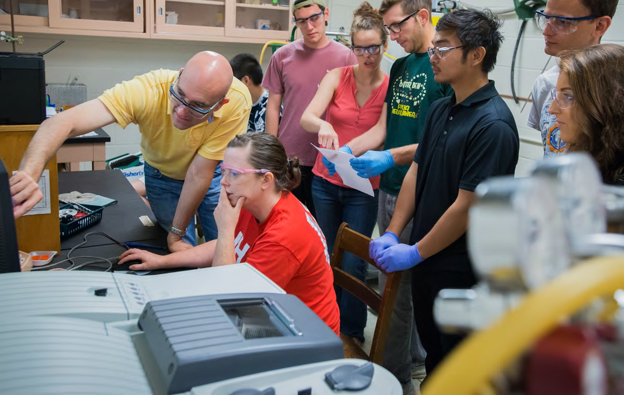

I N T E R N S H I P O V E R V I E W

W H A T I S A N I N T E R N S H I P ?

An internship is a form of experiential learning that integrates | Internships can be completed during the academic year in
knowledge and theory learned in the classroom with practical | conjunction with classes (10-12 hours per week) or as a full-time
application and skills development in a professional setting. | experience (up to 40 hours per week) in the summer.
Internships give students the opportunity to gain valuable
applied experience and make connections in professional fields
they are considering for career paths; and give employers the
opportunity to guide and evaluate talent.

C H A R A C T E R I S T I C S O F A N I N T E R N S H I P

duration typically lasts from three to six months may be either part-time or full-time
may be paid or unpaid

may be part of an educational program that provides careful monitoring and evaluation for academic credit
an intentional learning agenda is structured in to the experience
learning activities include learning objectives, observation, reflection, evaluation, and assessment
effort is made to establish a reasonable balance between intern learning goals and specific work an organization needs completed
promote academic, career, and/or personal development
T H E
B E N E F I T F O R E M P L O Y E R S

Internship experiences offer clear benefits to students. Employers sometimes struggle to see the immense benefits of hosting these experiences in their organizations. While some effort is involved to create an internship program, the opportunities and return on investment for the employer are clear.

F R E S H P E R S P E C T I V E

Internship experiences allow employers to engage in a year- round source of highly motivated pre-professionals. These students bring new perspectives to old problems and a unique combination of involvement and innovation.

ADAPTED FROM THE NATIONAL SOCIETY FOR EXPERIENTIAL EDUCATION

L E G A L I M P L I C A T I O N S
INTERNSHIPS: WHAT THEY ARE & WHY OFFER ONE

Learn the legal implications of hiring interns. Just like other employees, they are subject to legal protections and regulations. Protect yourself and your intern by knowing the laws. What work may or may not be assigned? This is especially important if your company employs a lot of international students, who need special qualifications to work in the U.S.
* LEARN MORE ON PAGE 18

T A L E N T & E X P O S U R E

Investing in an internship program creates a new pipeline of potential employees that have been tested for your culture. Internships allow you to build a proven and cost-effective way to recruit and evaluate potential employees while enhancing your organization’s image in the community and on campus.

E N H A N C E D E F F I C I E N C Y

Offering an internship experience provides you with a flexible, cost-effective workforce without requiring a long-term employer commitment. This expands your existing professional staff’s freedom to pursue more creative projects while interns simultaneously take on real work experiences.

5

C R I T E R I A F O R A N
While both share commonalities, a co-op and internship experience offer very different components. Be aware that the terms co-op and internship may be used by different groups or individuals to mean different things. Academic departments and fellow employers may have their own definitions of each term.

C O - O P
Usually referring to a rotational experience working with one company or organization for two or three semesters. Each rotation typically lasts 12-15 weeks in fall or spring semesters or 10-12 week during the summer. Most co-op experiences include at least one fall or spring semester in addition to summer.

I N T E R N S H I P
Most often used to refer to a one-term work assignment, most often but not always in the summer. Internships can be full-time or part-time and either paid or unpaid depending on the career field. Not all employers use these terms consistently or with consistent meaning.
C O - O P O R I N T E R N S H I P ?
I N T E R N S H I P

NACE, the National Association of Colleges and Employers, is the governing body that sets national standards for internship experiences. To ensure that an experience, either a traditional internship or one conducted virtually, is educational and thus eligible to be considered a legitimate experience certain criteria need to be met.

- The experience must be an extension of the classroom: a learning experience that provides for applying the knowledge gained in the classroom. It must not be simply to advance the operations of the employer or be the work that a regular employee would routinely perform.
- The skills or knowledge learned must be transferable to other employment settings.
- The experience has a defined beginning and end, and a job description with desired qualifications.
- There are clearly defined learning objectives/goals related to the professional goals of the student’s academic coursework.
- There is supervision by a professional with expertise and educational and/or professional background in the field of experience.
INTERNSHIPS: WHAT THEY ARE & WHY OFFER ONE
- There is routine feedback by the experienced supervisor.

- There are resources, equipment, and facilities provided by the host employer that support learning objectives and goals.

If these criteria are followed, it is in the opinion of NACE that the experience can be considered a legitimate internship.
* LEARN MORE ABOUT NACE AT NACEWEB.ORG

T H E I N T E R N S H I P L I F E C Y C L E
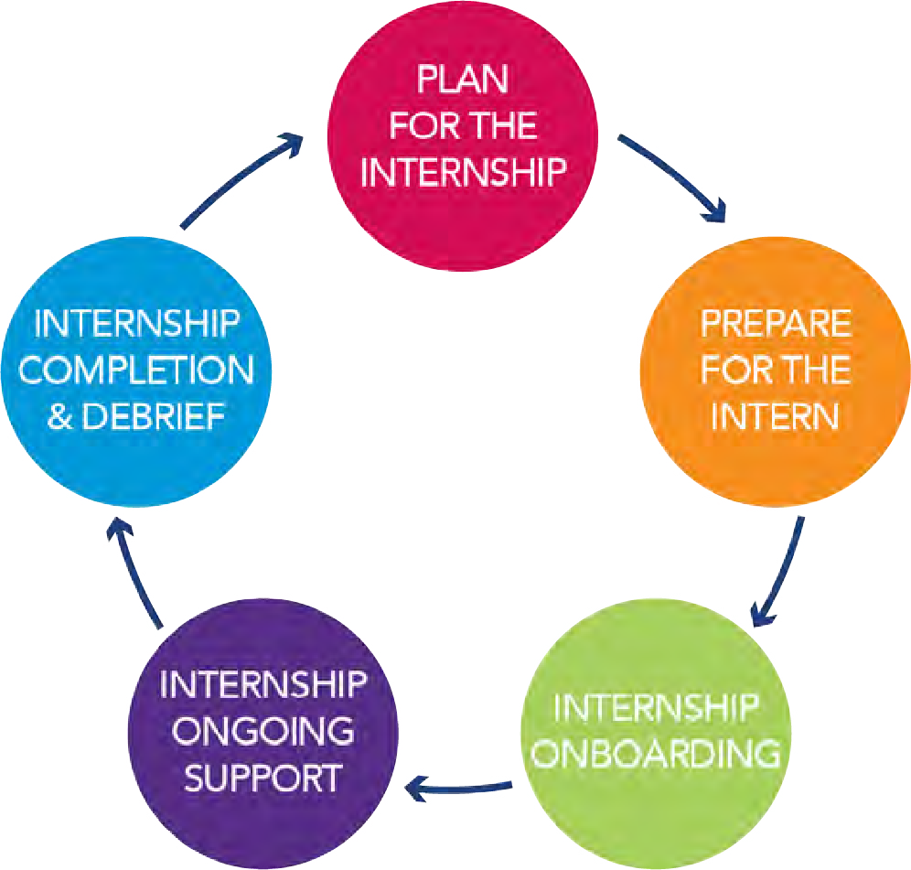

6

C R E A T I N G A N I N T E R N S H I P

S E T Y O U R G O A L S

As varied as organizations are in age, size, industry, and product, so too are their internship activities. How do you know what kind of program will work best for you? Designing an internship goal that meets your needs and achieves your goals can be easy.

Taking time to set specific goals and understand what your organization is looking for can help you define your internship program needs. Having these questions answered will help you set clear expectations of your interns and ensure success for all parties involved.

Q U E S T I O N S T O A S K
- What does your organization hope to achieve from your internship program?
- Are you a small organization searching for additional help on a project?
- Is your organization growing quickly and having difficulty finding motivated new employees?
- Are you a non-profit that struggles to pay workers but can provide an interesting and rewarding experience?
- Is your organization searching for new employees with management potential?

O U T L I N E A P L A N

Carefully plan and write out your internship program and goals. Structure the internship ahead of time so that you can be sure to meet your goals and not find yourself floundering partway through.

Like everything else in your organization, you will want to set the internship up for success. A bad internship, by contrast, can only hurt your chances of attracting good students.

A very important part of your plan should be the assignment of a mentor or supervisor — that is, someone from the intern’s department who will be in charge of the intern. This person should be selected because he or she likes to mentor and has the resources to do it.
*NOT SURE WHERE TO START?
USE THE OUTLINE WORKSHEET ON PAGE 10

T H I N K C R I T I C A L L Y

Once you set your goals, think critically about what your specific resources and needs are regarding an internship experience.
- Do you want someone for a specific project?
- Do you want to give the intern a taste of everything your company or organization does?
- How much will you pay the intern?
Wages vary widely from field to field. Make sure that yours are competitive to attract candidates.
- What sort of academic background or experience are you looking for in an intern?
- Do you have adequate work for the intern? Will you help with parking arrangements or living arrangements?
Take time to think through the tasks that you would assign to a potential intern. Interns are prohibited from participating in
tasks that are off limits to them due to safety, legal, or personnel concerns.
- Performing laboratory tests
- Writing handbooks or manuals
- Designing posters, graphs, and charts
- Generating financial forecast and cost recovery reports
- Performing software and hardware modifications
- Conducting studies and surveys
- Developing presentations
- Compiling technical reports
- Creating social media accounts
- Conducting research
- Generating marketing plans
- Conducting training packages
- Preparing budgets and financial reports
S A M P L E I N T E R N T A S K S
- Who will have the primary supervisory responsibility?
Will this person be a mentor or merely a supervisor?
- What will the intern be doing?
Be as specific as possible. Interns, within an educational process, need structure so they don’t become lost, confused or bored.
Approval for a credit bearing internship is dependent upon a well-developed description.
- Do you want to plan a program beyond the work you give to your interns?
Will there be special training programs, performance reviews, lunches with executives, social events? Keep in mind that your interns are walking advertisements for your company. If they have a good experience working for you, they’re likely to tell their friends — word gets around.

8
OUTLINE A PLAN

I N T E R N S H I P P R O C E S S
T I M E L I N E
Recruiting activity follows a general timeline. Often Fortune 500 companies recruit 3-8 months prior to the internship need so recruiting begins in the fall.

 | S U M M E R  I N T E R N S H I P | F A L L  I N T E R N S H I P | S P R I N G  I N T E R N S H I P
Identify intern needs and type of internship being offered | O C T O B E R | J A N U A R Y | J U N E
Assign internal roles and decide on pay and benefits | N O V E M B E R | F E B R U A R Y | J U L Y
Create an internship job description | D E C E M B E R | M A R C H | A U G U S T
Post internship positions on Nittany Lion Careers | J A N U A R Y | A P R I L | S E P T E M B E R
Recruitment period for most organizations | F E B R U A R Y | M A Y | O C T O B E R
 | M A R C H | J U N E
 |  |  | N O V E M B E R
 | A P R I L | J U L Y
Final candidates determined | M A Y | A U G U S T | D E C E M B E R
Internship begins | M A Y  O R J U N E | A U G U S T O R S E P T E M B E R | J A N U A R Y
Internship | J U L Y | O C T O B E R | F E B R U A R Y
 |  | N O V E M B E R | M A R C H
Internship ends | A U G U S T | D E C E M B E R | A P R I L O R M A Y
9
CREATING AN INTERNSHIP

POSITION/T YPE OF INTERNSHIP ORGANIZA TION DEP AR TMENT(S) INTERN WILL W ORK WITH INTERNSHIP L OC A TION S TREET ADDRESS CIT Y S TAT E ZIP
C OMP ANY WEBSITE

C ONT A C T TITLE PHONE EMAIL
SUPER VISOR TITLE PHONE EMAIL
W O R K S H E E T

C ANDID A TES
MAJORS DESIRED DESIRED GP A CLASS LEVEL FR SO JR SR
A V AILABILIT Y
S TA R T D AT E END D A TE LENG TH FULL - TIME Y N P AR T- TIME Y N HOURLY Y N
D E S C R I P T I O N
ON- SITE POSITION VIR TU AL POSITION

C OMPENSA TION
HOURLY RA TE S TIPEND O THER FREE & SAFE P ARKING? Y N IF NO , P ARKING REIMBURSED? Y N

JOB/PRO JEC T DESCRIP TION
List specific daily duties for this position or specific projects with time projects that will meet the length of the internship. Will the position require security clearances?
P O S I T I O N

EXPERIENCE AND SKILLS DESIRED
I N T E R N S H I P
Are technical skills required? Job specific skills?

10

R E C R U I T I N G @ P E N N S T A T E

T Y P E S O F I N T E R N S H I P S

Organizations can offer credit or non-credit internships, which can both be paid experiences. Credit or non-credit internships can also be unpaid experiences if they meet the correct criteria.

Due to student financial responsibilities, students tend to apply first to paid opportunities that are able to offer academic credit. Yet, students understand the importance of gaining valuable work experience and do look for internships that are paid non- credit opportunities.

S T A R T E A R L Y
How will you find those ideal candidates to fill your internship positions? The number one tip from those who have established programs is to get out there early.

This cannot be overemphasized to organizations that want the very best interns. Begin searching three to four months before you need a student to begin.

Starting early has advantages. The longer you accept applications, the better your chance of finding the best person for the job. The sooner you get one, the longer you have to form a good working relationship with them.

Q U A L I F Y I N G A
F O R - C R E D I T I N T E R N S H I P : W H A T T O E X P E C T
F O R - C R E D I T
I N T E R N S H I P S

As the provider of a for-credit internship you may be asked to answer specific questions, outline duties, or oversee other responsibilities in order for the student to qualify for credit hours. You can expect the to be asked to do the following:

  - Confer with the student prior to the start of the internship to describe the expectations of your organization, assign specific responsibilities, agree on a work schedule, and who the designated on-site supervisor will be.
  - Provide a letter outlining the duration of the internship, number of hours, and responsibilities. The letter should be signed by the on-site supervisor. This letter is used to gain academic approval and credit for the internship.
  - The on-site supervisor should monitor the intern’s performance and progress during the internship and hold periodic review sessions to review performance and provide feedback.
  - The supervisor will be asked to formally evaluate the quality of the intern’s job performance mid-semester and again at the end of the semester. Evaluation forms will be provided to the on-site supervisor at the appropriate times and must be completed by a specific date.
Offering to supervise interns for academic credit is often an incentive for students looking to complete credit requirements for their academic degrees. Individual academic departments within the university will be the contact point for eligibility requirements and employer responsibilities. Academic internship requirements vary by major/department. Many departments require a student to complete a specific number of career-related work hours to receive academic credit.

A C A D E M I C R E Q U I R E M E N T S

Student interns are assigned a faculty advisor who oversees the academic element of the internship. The student must complete academic assignments based upon the requirements outlined by the faculty advisor on the specific course syllabus.

During field placement students are required to maintain a daily journal based on their observations and experiences. Other assignments might include compiling a portfolio, submitting weekly journals, writing a paper, and completing a project. The student is also required to evaluate his/her own performance as well as the value of the internship as a learning opportunity.

Supervisors should contact the designated Career Development/ Services department internship coordinator or the faculty advisor with any questions or concerns during the internship term. Please provide an opportunity for a possible site visit with either the internship coordinator or the faculty supervisor.

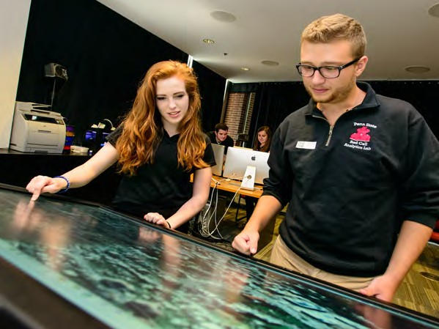

12
FOR-CREDIT INTERNSHIPS

N O N - C R E D I T
I N T E R N S H I P S

Non-credit internships do not award academic credit to the student but do offer a valuable learning experience. These types of internships are held to the same standards as for-credit internships in terms of the level of experience the student receives. Non-credit internships can be paid or unpaid. Due to student financial responsibilities, students tend to apply first to paid opportunities.

Non-credit internships are not supervised by a student’s academic advisor and are set up by the student applying to the internship or through the student’s Career Services office. It is recommended that all internship experiences be posted on
Nittany Lion Careers, Penn State’s job posting portal with access to all Penn State students and alumni.

Non-credit internships can be unpaid. If unpaid, the employer must be able to show that the benefit of the experience is with the student. An unpaid internship should not include responsibilities that would replace a paid employee.
- There are strict qualifications that must be met to legally provide an unpaid internship. Review the legal issues section of the guide for more details.
U N P A I D I N T E R N S H I P S

13
NON-CREDIT INTERNSHIPS

V I R T U A L
If a virtual internship is proposed by a student or offered by a prospective internship site, the following components should be

I N T E R N S H I P S considered prior to final approval.

O R G A N I Z A T I O N
L E G I T I M A C Y A P P R O V A L
The organization must be an established, legitimate business or non-profit, as evidenced by considerations such as a physical location, website, history of offering paid employment, listed telephone number, tax ID number, etc. The organization
must agree to offer an internship that meets the criteria of a legitimate internship as outlined by the
National Association of Colleges and Employers:

- The experience must be an extension of the classroom: a learning experience that provides for applying the knowledge gained in the classroom. It must not be simply to advance the operations of the employer or be the work that a regular employee would routinely perform.
- The skill or knowledge learned must be transferable to other employment settings.
- The experience has a defined beginning and end, and a job description with desired qualifications.
- There are clearly defined learning objectives related to the student’s professional goals.
- There is supervision by a professional with expertise and educational and/or professional background in the field of the experience.
- There is routine feedback by the experienced supervisor.

- There are resources, equipment, and facilities provided by the host employer that support learning/objectives goals.

U N I V E R S I T Y A P P R O V A L
The organization must agree to a potential site visit from a representative of the University. The organization and student (with advisor approval) need to agree on a clear, detailed position description, which covers all expectations and outlines what will constitute a successful internship. The organization’s internship site mentor must provide the student with regular supervision, mentoring, and feedback. In a virtual internship, this will include:
- Use of company intranet or virtual workspace on a server, or an online project management or document sharing tool, such as Office 365, Google Docs, or a similar program. This will allow the supervisor to go online and monitor the work which is to be completed. The work is stored in the “cloud” and not a single PC, so it is always available to those who need it.
- A regularly scheduled email report in which the student provides information to the internship site mentor and academic advisor, such as hours worked, challenges
or problems encountered, progress toward learning objectives, and any questions they may have.
- A weekly virtual meeting of Skype, Zoom, Gmail video chat or a similar technology. This meeting will be used to provide more personalized feedback to the student and correct any issues. This meeting is a time for project planning, review of progress made, feedback, and mentoring.

The organization should make the virtual intern a part of regular operations as much as possible; for example, including them in face-to-face opportunities such as a company meetings or client visits when feasible.
The student must provide the faculty advisor or internship professor with the outputs of the internship
(i.e., written materials produced, analysis completed).
14

I N T E R N S H I P
C O M P E N S A T I O N

Penn State encourages all internship providers to compensate their interns. A recent internship survey from the National Association of Colleges and Employers (NACE) offers some insight into what employers are paying interns for their work. The average hourly wage rate for a bachelor’s degree intern is
$16.26*. Generally, the closer to the terminal degree, the higher the internship wage.

A college senior, for example, averages 20.2 percent more than a student who just completed the freshman year: $17.47 versus
$14.53 per hour. Similarly, the higher the level of the degree, the higher the wage. In fact, according to NACE’s latest intern compensation report, the average hourly wage for a master’s
degree candidate is 35 percent more than the average wage rate for an intern earning a bachelor’s degree: $21.90 compared to
$16.26.

Salaries also vary by major and industry. In addition to wages, many employers add benefits to their internship compensation packages. The most popular benefit: relocation assistance, with roughly three out five employers giving their interns something in terms of moving assistance or a housing stipend. Also popular, with approximately half of employers offering them, are social activities for interns and holiday pay.

*Please note this average hourly wage may not be representative in all geographic locations or industries.

The above information is provided by the National Association of Colleges and Employers and is reprinted with permission of the National Association of Colleges and Employers, copyright holder.
INTERNSHIP COMPENSATION
15

I N T E R N S H I P
D E S C R I P T I O N S :
W H A T T O I N C L U D E

P O S T I N G A N I N T E R N S H I P

NAME OF COMPANY:
Include company name and, if applicable, any parent companies or divisions that may impact the internship.

TITLE OF INTERNSHIP

COMPENSATION:
Include a rate and if academic credit is possible

DATES:
Clearly list the expected start and end date of the internship. You can indicate if there is flexibility or include that listed dates are estimates. Please note most internship dates should coincide with semester start and end dates.

COMPANY DESCRIPTION:
Talk about your company and clearly explain what your organization does. Include goals and how the internship will allow the student to contribute to company success.

INTERNSHIP SUPERVISOR:
Include the internship supervisor or point of contact with contact details. Phone and email are best to include.

REQUIREMENTS:
Outline what candidate requirements you are seeking. Include grade level(s), desired majors or backgrounds, and experience or skills needed to succeed.

OBJECTIVES:
Clearly list expectations of the internship. Include daily tasks and larger projects that you have planned. Consider adding in other elements like learning about company culture.

TO APPLY:
VIRTUAL INTERNSHIPS
Set an application deadline and include instructions for interested candidates. Do they need to email materials to a contact or apply on a company website? List what materials you are looking for like resume, cover letter, or any other samples of work.
Penn State offers Nittany Lion Careers, a single-system recruiting platform for all students, alumni, and employers.

Nittany Lion Careers offers employers the ability to post jobs and internships, register for career fairs, schedule interviews with students, and more.

Creating a free account within Nittany Lion Careers gives you access to over 80,000 current Penn State students as well as Penn State alumni.

C R E A T E A N A C C O U N T
Creating an account within Nittany Lion Careers is free for employers and provides the best avenue for accessing a wide pool of Penn State talent.

- Visit nittanylioncareers.psu.edu

- Click the ‘Employers’ button to access the system and submit an account registration.
- Our employer relations team vets all employer accounts prior to allowing system access. Once your account has been approved you will receive a welcome email with steps on posting positions.
- All jobs and internships posted are reviewed by the employer relations team and approved within 3 business days.
- Receive customized account support and assistance by contacting a Penn State career office. Visit studentaffairs.psu.edu/career/career-offices

16

S A M P L E I N T E R N S H I P D E S C R I P T I O N

NAME OF C OMP ANY | Acme Company
TITLE OF INTERNSHIP | Social Media Marketing Intern
C OMPENSA TION | $XX per hour (with or without academic credit)
D A TES | MM-DD-YYYY to MM-DD-YYYY

C OMP ANY DESCRIP TION
Acme Company is a social media marking company located in Arlington Virginia. With a client base of over 500 small and mid-size companies, the Acme Company provides unparalleled one-on-one service in the areas of branding and social media. We are looking for a qualified intern to join our marketing/advertising team. The intern will participate in various stages of print and online marketing campaigns. This intern should be prepared to work in a fast-paced team environment and will finish the internship having gained broad experience in various aspects of marketing. The internship program at Acme Company can be for academic credit and is paid.

INTERN SUPER VISOR & C ONT A C T
Jane Doe
555-123-1234 | jdoe@acmecompany.com

REQUIREMENTS
Company is looking for an undergraduate (junior or senior) student, who is majoring in marketing, advertising, or communications. This person should have excellent verbal and written communication skills, with extensive knowledge of Web and social media.
PowerPoint, Word and Excel experience are a bonus, and will be considered when choosing the best applicant for this internship position.

OBJEC TIVES
- Learn our corporate culture and basic day-to-day communication/work processes.
- Learn how to prepare creative and effective presentations
- Learn how to perform analysis of marketing and sales data
- Client Research: Learn the importance of it, basic expectations, how to present findings
- Contact Reports: Sit in on meetings to observe and take notes. Learn how to format and draft contact reports based on your meeting notes.
SAMPLE INTERNSHIP DESCRIPTION
- Assist in the creation of signage, circulars, mock ups, e-mail campaigns, online promotion, etc.
- Seek and analyze competitor marketing and sales materials both on and offline
- Enter contact information into contact management systems
- Provide support to social media efforts
- Maintain tracking report of public relations activities

T O APP LY
Email your resume and cover letter by MM-DD-YYYY to jdoe@acmecompany.com
17

L E G A L
K N O W L E D G E

P A Y I N G
I N T E R N S

PAYING INTERNS
The Department of Labor’s Fact Sheet #71: Internship Programs Under the Fair Labor Standards Act provides general information to help determine whether interns and students working for ‘for-profit’ employers are entitled to minimum wages and overtime pay under the Fair Labor Standards Act (FLSA).

The FLSA requires ‘for-profit’ employers to pay employees for their work. Interns and students, however, may not be qualified as ‘employees’ under the FLSA. In this case the FLSA does not require compensation for their work.

T E S T F O R U N P A I D
I N T E R N S A N D S T U D E N T S
Courts have used the ‘primary beneficiary test’ to determine whether an intern or student is, in fact, an employee under FLSA definitions. This test allows courts to examine the ‘economic reality’ of the intern-employer relationship to determine which party is the primary beneficiary of the relationship.

Courts have identified the following seven factors as part of this test:
U N P A I D I N T E R N S H I P Q U I C K T E S T
Use this quick test to give you an idea if your internship qualifies to be unpaid. If ALL boxes are checked you may have an unpaid internship available.
*Please consult your legal council to make a final determination.

- The extent to which the intern and the employer clearly understand that there is no expectation of compensation
- The extent to which the internship provides training that would be similar to that which would be given in an
educational environment, including the clinical and other hands-on training provided by an educational institution
- The extent to which the internship is tied to the intern’s formal education program by integrated coursework or the receipt of academic credit
Employer does not guarantee a job to the student upon completion of the training or completion of schooling
The work is an integral part of the student’s course of study
The student will receive credit for the work or the work is required for graduation
The employer has received a letter or some other form of written documentation from the school stating it sponsors or approved the internship and it is educationally relevant
Learning objectives are clearly identified
The student does not replace an otherwise paid employee
The student is shadowing or learning mode with a mentor in the field of study
The employer provides an opportunity for the student to learn a skill, process, or other business function, or to learn how to operate equipment
There is an educational value of the work performed
(i.e. is related to the course the student is taking in school)
The student is supervised by a staff member (cannot be a fellow intern)
The student does not provide benefit to the employer more than 50 percent of the time

- The extent to which the internship accommodates the intern’s academic commitments by corresponding to the academic calendar
- The extent to which the internship’s duration is limited to the period in which the internship provides the intern with beneficial learning
- The extent to which the intern’s work complements, rather than displaces, the work of paid employees while providing significant educational benefits to the intern
- The extent to which the intern and the employer understand that the internship is conducted without entitlement to
a paid job at the conclusion of
the internship
19

U N D E R S T A N D
L E G A L A S P E C T S

W O R K E R & U N E M P L O Y M E N T C O M P E N S A T I O N
Workers’ compensation boards have found that interns contribute enough to a company to make them employees. It’s wise to cover interns under your workers’ compensation policy even though you aren’t required to do so. Student interns are generally not eligible for unemployment compensation at the end of the internship.

I N C O M E T A X E S
The employer is responsible for withholding all deductions required by federal and state income tax laws from the wages of all student employees. The courts have ruled that compensation for work performed as a student employee is remuneration
for services performed for the benefit of the employer and, therefore, is taxable income. International students on F-1 and J-1 visas are subject to withholding payment of federal, state, and local taxes unless they are exempt by provision of a tax
treaty. In cases where a tax treaty applies, students must provide documentation to the employer on the appropriate IRS form.
Information regarding tax treaties may be found in Internal Revenue Service publications.

A M E R I C A N S W I T H
D I S A B I L I T I E S A C T ( A D A )
Student employees are covered under the Americans with Disabilities Act of 1990. This law protects disabled student employees from discrimination in employment, hiring, transportation, and covers access to public facilities and services, and telecommunications. Employers are required to provide reasonable accommodation to all qualified student employees with known disabilities.
LEGAL CONSIDERATIONS

F R I N G E
B E N E F I T S
The employer may or may not offer a fringe benefits package to student employees. Benefits may include as much as full benefits accrued on an equal basis with other employees in similar personnel categories. Many employers provide some vacation and sick leave benefits. Other benefits such as group life insurance, medical insurance, profit-sharing 401K, and bonuses may or may not be available, depending on company policy.

S O C I A L
S E C U R I T Y T A X
Unless exempt under the Social Security law, employers must deduct Social Security taxes from the wages of all student employees, except those with an F-1 or J-1 visa.

I M M I G R A T I O N R E F O R M & C O N T R O L A C T O F 1 9 8 6
( I R C A )

All student employees, regardless of their citizenship status, must abide by IRCA regulations by providing suitable documentation that will enable the employer to comply with this law. Employers are advised about appropriate documentation to establish both the student employee’s identity and authorization to work.

20

I N T E R N A T I O N A L S T U D E N T S

The most common visa types employers will see on college campuses when recruiting international undergraduate or graduate students for either full-time or internship positions are the F-1 and J-1 visas.

An F-1 visa is granted to a person coming to the United States to attend a college, university, seminary, conservatory, academic high school, elementary school, or other academic institution
or language training program approved by the U.S. Attorney General for study by foreign students. The visa holder plans to return home after completing studies. This is the most common non-immigrant visa for an international student attending undergraduate and graduate school. Students are granted F-1 status until the completion of the academic program and 12 months of post-program practical training.

The purpose of the F-1 visa is to provide an opportunity for study in the United States. Anything outside of study, including employment, is an exception to the visa. Authorization for employment is strictly limited to certain situations. The student holding F-1 status for a full academic year and in good academic standing may work off campus. Such work authorization is granted when the student has sustained unforeseen economic hardship. In addition, the student may not work for more than 20 hours per week when school is in session, but may work full time during holidays and vacations, including breaks between terms,
provided the student intends to register for the next school term.

C U R R I C U L A R
P R A C T I C A L T R A I N I N G
An F-1 student may perform curricular practical training prior to the completion of the educational program as part of his or her educational experience. The INS define this type of training as ‘alternate work/study, internship, cooperative education, or any other type of required internship or practicum that is offered by sponsoring employers through agreements with the school.’

O P T I O N A L
P R A C T I C A L T R A I N I N G
This is temporary employment directly related to the student’s major area of study that takes place after the student completes a full course of study. Authorization for this training may be granted for a maximum of 12 months of full-time or part-time work. Those on a student visa can only gain authorization once for this type of training.

e above information is adapted from the National ociation of Colleges and Employers and
Th A
is N
an
ss
National Association of Colleges and Employers
www.naceweb.org

U.S. Citizenship and Immigration Services
www.uscis.gov

Immigration Support Services
immigrationsupport.com
R E S O U R C E S
INTERNATIONAL STUDENTS
reprinted with permission of the ational Association of Colleges
d Employers, copyright holder.
21

M A N A G I N G
T A L E N T

O N - B O A R D I N G I N T E R N S

The success of an internship depends on the partnership between representatives of the organization, the campus supervisor, and the student. These three parties need to agree on the conditions of the internship, the responsibilities of each party, and the reporting requirements. The site supervisor is the critical link. You guide your interns by providing direction and feedback. If a problem occurs, you will need to counsel the
student and contact the internship coordinator, when necessary.
Develop a thorough orientation and training plan to be implemented when the interns begin work, so they will learn quickly and become productive members of your team. Invest supervisory time to establish an important bond with interns and set a crucial tone for the internship experience. You can help this process by providing important information regarding your organization and the position by creating a thorough on- boarding strategy.

V I T A L
I N F O R M A T I O N T O S H A R E
T H E
F I R S T D A Y

Start your intern off with important information they will need to understand company landscape, culture, and how to succeed. Consider sharing the following:
- Company organization

- Special industry jargon

- Specific work standards and procedures

- Reporting relationships

- Access to supervisor (days, times, duration)

- Tasks to be done with supervisor approval

- Work processing requests and timeliness

- Email, mail, and telephone systems

- Approved form(s) for correspondence

- Safety regulations

- Procedure for signing off completed work

- Security and confidentiality issues, if relevant

- Acceptable dress and appearance

- Maintaining the premises and work station

- Productive interactions with others at the work site

- Personnel who can answer different kinds of questions
- How the organization wants the intern to deal with clients, customers, and vendors
- Share organization’s code of conduct and professional ethics
ON-BOARDING INTERNS
Bringing on an intern is an exciting moment for your company. In order to ensure a smooth transition and successful experience planning is key. Think through the intern’s perspective and try to prepare for common questions in advance.

P R I O R T O T H E F I R S T D A Y
Setting up a usable workspace is the first step in making the intern feel comfortable. Create an organized area with phone, voice mail, internet, email, and other key resources.
Think through the tasks you have stipulated in the internship description and provide all the tools necessary for success.

Formally outline work expectations prior to the intern’s arrival. Prepare forms to be signed, including a confidentiality agreement, if necessary.

C O M M U N I C A T E
Take time to communicate with your intern when they arrive. Use the vital information outline to make sure you cover key points.

Catch your intern up on company culture. Share any newsletters, annual reports, org charts, or memos from high level staff to help them learn company culture. Invite them to participate in professional meetings and schedule regular meetings with them one-on-one.

Encourage your intern to get involved with staff. Suggest spending lunch breaks in common areas, allow them to interview company personnel, and encourage interns to walk around and observe others at work.

23

W H A T
I N T E R N S

N E E D T O S U C C E E D

Real work and responsibility
Internships must provide real work that expands the student s knowledge. While support work is appropriate its important to
provide a wide range of experience for the student.

Honesty and transparency
Do what you say and say what you do. Be honest with your interns about expectations.
Feedback
Remember that interns are students and they may not have the business skills and experience that you take for granted. If your intern makes an oversight, explain how the situation should be handled in
the future.

Inclusion
Is there a staff meeting that interns can attend? Can they tag along to the next project meeting or office luncheon? Include the intern in
your daily life at the office.

Details and explanations
When you assign work make sure to give details and explanations. Patience and a few extra minutes at the beginning will pay off when
your intern can work independently.

Mentorship and time
Make sure you have a mentor or supervisor to provide guidance to the intern. The best mentor is useless if they cannot spend some time with the intern providing guidance. Schedule regular times for meetings.
Preparation
Students do better when they feel that they are a valued part of the team. Prepare for their arrival and make sure to have a workspace, technology, and expectations ready for them. Let your staff know that the intern is coming on board and share expectations and how they can get involved.
PROVIDING SUPPORT & FEEDBACK
Financial support
While internships differ and industries have their own personalities, remember that interns have expenses. Your organization may not be in a position to pay much but anything can help.

P R O V I D I N G F E E D B A C K

Especially if your interns have never done this kind of work before, they will want to know if their work is measuring up to your expectations. No matter what the level of experience, they need you, as a more experienced worker, to let them know if their work is officially “okay.”

Periodically, examine what your intern has produced and make suggestions.

I N F O R M A L F E E D B A C K

Informal feedback is sometimes not perceived by the student as feedback and shows up as comments or a lighthearted nudge. When using informal feedback be clear with your intent. The more direct, the more likely the student will perceive this to be an area of focus.

Positive feedback should be given freely. Areas of growth should be presented in a private setting where the student in not embarrassed. Feedback should be delivered as often as possible to encourage the student.

F O R M A L F E E D B A C K

Formal feedback should be prepared and delivered in a private meeting to discuss the student’s strengths and areas for growth. It should be designed so the manager achieves his/her desired objective.

Students should have clear objectives of what areas of growth need to be addressed. Use specific examples of student behavior whenever possible.

24

This publication is available in alternative media on request. Penn State is an equal opportunity, affirmative action employer, and is committed to providing employment opportunities to all qualified applicants without regard to race, color, religion, age, sex, sexual orientation, gender identity, national origin, disability or protected veteran status. U.Ed. STA 19-387
25

