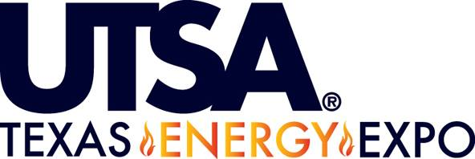

Presented by:
Texas Boomers & Business Student Council
Come and network with leading companies in the energy industry!
When: Thursday, October 6th 9:00 a.m. – 12:00 p.m.
Where: University Center Ballroom II
Companies include, but are not limited to:
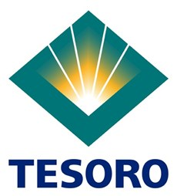
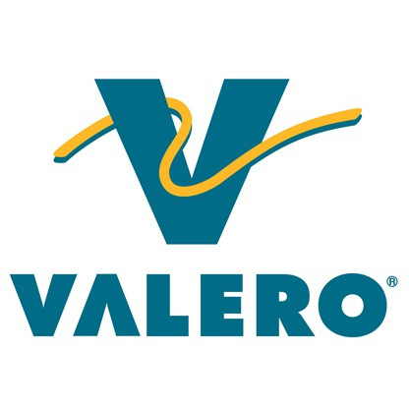

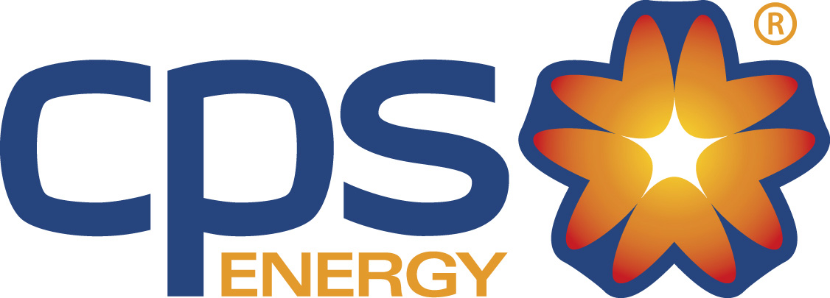
Sponsored by:
University Career Center
Center for Student Professional Development

