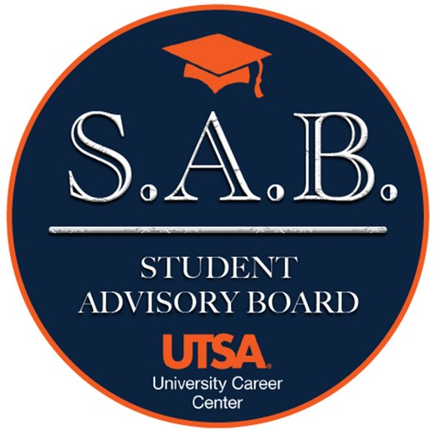

Student Advisory Board Guide
Fall 23 - Spring 24

Acronyms:
- University Career Center: UCC
- Student Advisory Board: SAB
Who can participate?

The University Career Center Student Advisory Board is comprised of any student organization, student group, appointed campus student representative, or individual at the University of Texas at San Antonio, who wants to further the growth of classroom to careers and professional development throughout campus.

Purpose:

The SAB will allow you the opportunity to represent your student organization and the student body to the UCC to help shape the future of career programming and engagement with employers.

What do you have to do?

As a member of the UCC SAB, you will have the opportunity to provide your input on the following:
- Marketing collateral
- Employer/Recruiting activities on campus
- Career programming
- Professional development opportunities
- Feedback on events you’ve attended
- New idea and/or thoughts on better programming
- Share what has/has not worked with you
- Anything else you find related to career/professional development

In addition to all these opportunities, we ask you and your student organization members (if applicable) to assist in cross marketing any upcoming UCC and/or employer events.

Occurrences:

The UCC Student Advisory Board meetings will occur twice a month. One meeting will be held on Main Campus and another meeting will be held on the Downtown campus. You will not be required to attend both meetings, you only need to attend one of the two meetings each month. Each meeting will have a virtual component.

Main Campus:
January 30th at Main Campus from 4 pm to 5 pm or via Zoom
February 13th at Main Campus from 4 pm to 5 pm or via Zoom
March 19th at Main Campus from 4 pm to 5 pm or via Zoom
April 16th at Main Campus from 4 pm to 5 pm or via Zoom

Downtown Campus:
February 1st via Zoom
February 15th via Zoom
March 21st via Zoom
April 18th via Zoom

**Please note these dates and/or format are subject to change due to other events

Point of Contact:

Chianna Knox, Employer Engagement Manager
Email: chianna.knox@utsa.edu
Phone: 210-458-4006

What’s in it for you and/or your student organization/group?

- Priority assistance/guidance on how to build sponsorship packages for your student organization.
- Dedicated resume workshop and resource refresher including how to utilize VMock.
- The opportunity for your student organization to be featured on the University Career Center website.
- A dedicated section showcasing each member of the Student Advisory Board which will include your headshot, a short bio (that you write), your major, and your graduation year.
  - Please note you’re not required to be featured on the website.
- The UCC will assist with promoting your student organization/groups’ professional development, employer, and networking related events. We ask that you provide us with marketing collateral to assist in promoting your events.
- You will be able to add leadership experience to your resume. To simplify verbiage for your resume, please feel free to utilize the lines below.
  - Resume Lines
- Opportunities to attend special events as they arise within the UCC (i.e. ribbon cutting ceremonies, networking events, and luncheons)

What are your requirements for participation?

- To be considered active on the UCC Student Advisory Board, we ask that you attend at least one meeting a month either in-person or virtually
  - If you’re unable to attend, please reach out to the Employer Engagement Manager or send another member on your behalf.
- Please provide the Employer Engagement Manager with a list of your officer team (if applicable) and your general meeting schedule.
- Assist with spreading the information regarding any upcoming events hosted by and/or in conjunction with the UCC through meetings, word of mouth, classes, Canvas, social media platforms, etc.
- Follow the University Career Center on Social Media platforms and encourage other members of your student orgs/groups and friends to follow them as well. See sample posts below.
  - LinkedIn: https://www.linkedin.com/company/utsa-university-career-center/
  - Instagram: https://www.instagram.com/utsacareer/?hl=en
  - Facebook: https://www.facebook.com/UTSACareer
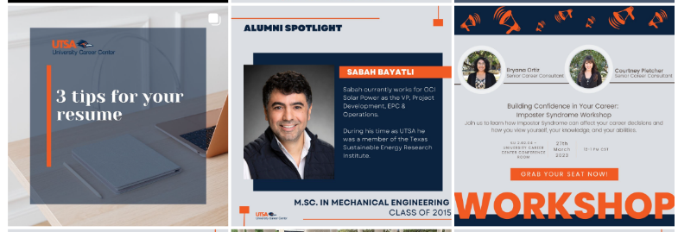
  - Twitter: https://twitter.com/UTSACareer

