L I N K E D I N

A L U M N I T O O L
Tips for Connecting with Alumni on Linked In

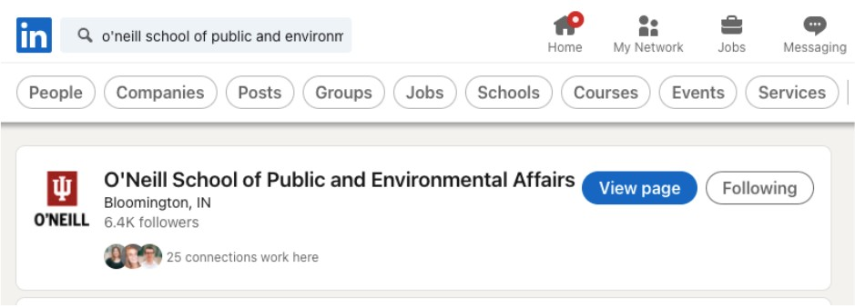

WHY LINKEDIN
LinkedIn is a powerful tool for expanding your professional network and making connections with people of various careers. Social media has so much to offer, so it is important you effectively use the available features. This guide will help you navigate LinkedIn’s ability to connect you with alumni of your school.

HOW DO I GET STARTED?
Connecting with alumni is valuable, because former students at your school can
help you find ways to model their career path. If you’re interested in working at a specific company or as a specific position, a simple search can help to connect
you with relevant alumni. To begin, you can start by looking up your university (Indiana University), or specific college (O’Neill School for Public and
Environmental Affairs) in the LinkedIn search bar.

We encourage you to follow the school you belong to for updates, but that is up to you. Either way, you can go ahead and click the school name/view page.

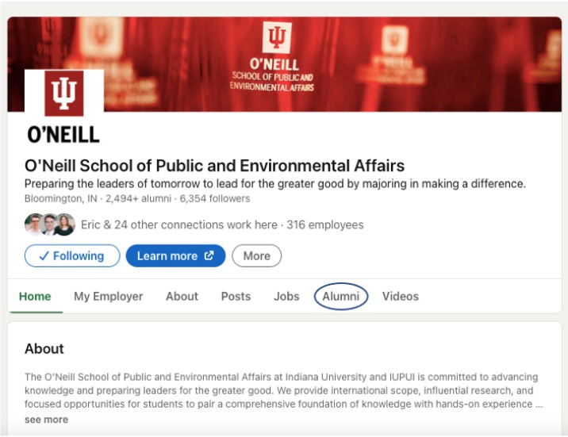
You will land here, at which point you can go to the alumni tool on the menu bar.
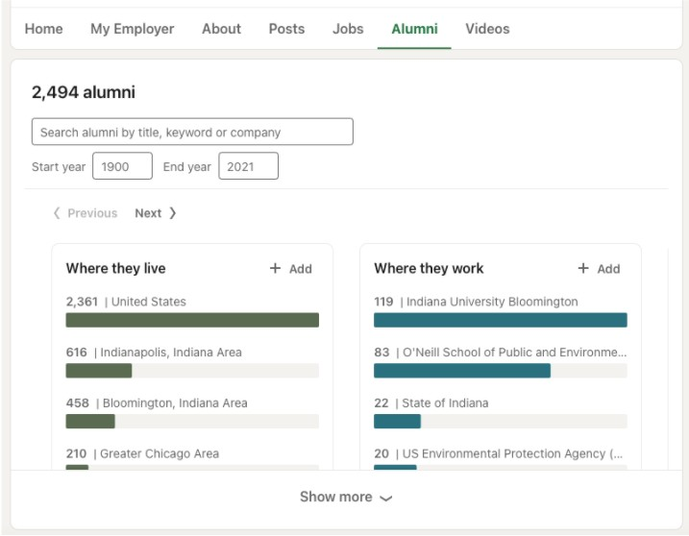

Immediately, you will be greeted with some statistics and demographic
information about your school’s alumni. These are cool, but you are likely more interested in specific individuals who came from your school.

EFFECTIVE SEARCH STRATEGIES
Now is the time to be strategic about your searching techniques. Here are a few search methods to find someone who meets the career path you are looking for:

- Specific companies
- Majors you are interested in
- Job titles
- Specific clubs/organizations of interest
- Location (city, state, or even country)
- Year of graduation

For example, you may be interested in a Health Policy Analyst position. You
could start by searching the specific job title, or the major most common to this
position (Policy Analysis). If you are interested in meeting a recent graduate, you can edit the start and end year to favor the right time period.

Another avenue of search is to look up employers you may know of in the field of interest. For example, you might find looking up “United States Senate” as an
employer will help you find someone who has worked at the Senate, and has a track you are interested in pursuing. If you want to focus on health policy, you
could Google companies related to health policy and look up those companies in the LinkedIn alumni tool.

If you want to connect with someone who was involved in a student organization of your interest, this tool will help you there as well. Just look up the
group/Greek-life organization/project. As a reminder, use general terms to
describe the organization, because not everyone uses specific terminology to list their experiences.

OTHER VALUABLE TOOLS

Once you have found your desired connection, there are numerous paths to getting the information and support you need. We recommend using Mango Email Writing Tool to help you craft a message to reach out to your new
connection. If you are conducting a more thorough network development / job search, check out this Professional Development Tracking Form to keep your
information organized.

