4D Reflective Supervision
Inspired by the University of Iowa’s Guided Reflection on Work (GROW®) program and the NACE Career Competencies, we’ve developed reflective questions to support the 4D Experience. Below is a reflective question bank to use in 1:1s and performance conversations. Sample meeting agendas are included at the end.
The Golden Question & Golden Follow-Up
How can I help?
Tell me more.
Establishing the Supervisory Relationship
Instructions: 1) Supervisor and employee individually reflect and respond to the questions below. 2) Supervisor and employee discuss the questions and responses together in a 1:1.
- Types of communication styles I understand best are:
- The way I like to give feedback is:
- The way I like to receive feedback is:
- When I receive feedback, you can expect me to:
- If I am unclear about something, you can expect me to:
- My “hot” buttons in the workplace are:
- Sometimes I get stressed and overwhelmed, during these times you can expect me to:
- You can help me with stress by:
- The following strengths will help me do well in this position:
- The ways in which I like to be shown appreciation and recognition is:
- The following personal and professional goals are important to me:
- My goals for this position are:
Career Skills Reflection
Instructions: 1) Prior to each 1:1, supervisor sends employee select number of reflective questions below. 2) Supervisor and employee discuss the questions and responses together during 1:1.
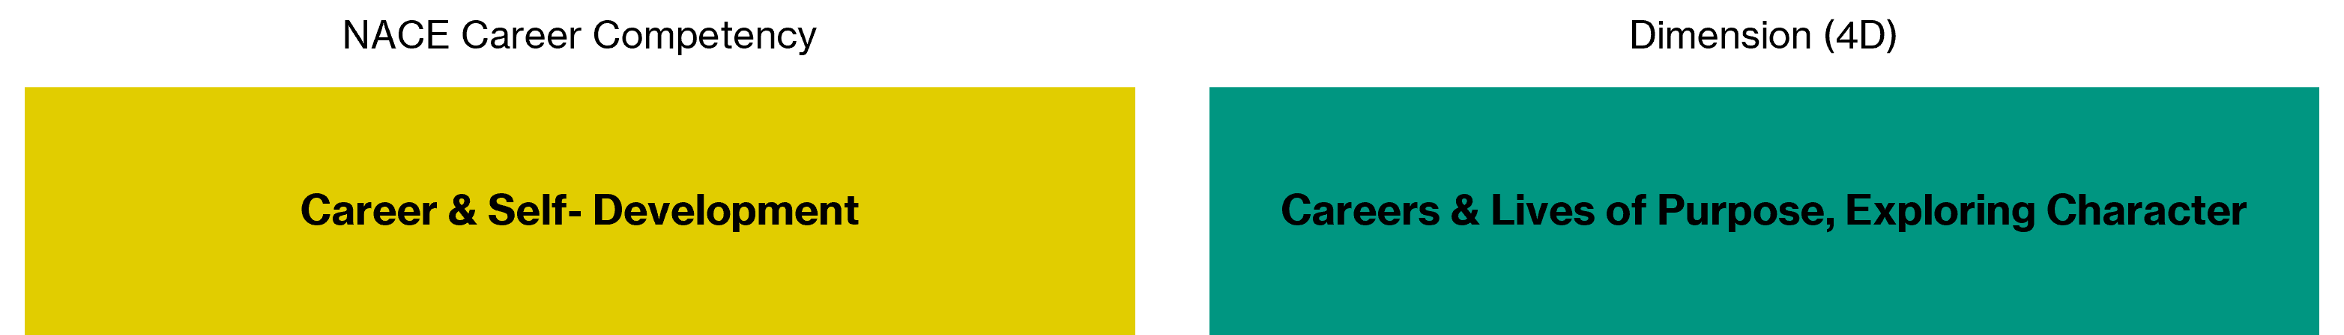
- What internships or jobs are you considering for the future?
- Have you noticed any work values developing for you and if yes, what are these values?
- What projects or tasks can I give you that will help prepare you for your next jobs or career field of interest?
- What are you learning here that's helping you in school?
- What are you learning in class that you can apply here at work?
- What are processes that could use improvement in our office and what ideas can you contribute?
- What have you noticed is effective communication in the workplace?
- What have you noticed to be ineffective communication?
- When you think of communication in the workplace, what aspects of communication would you personally like to develop?
- What social identities have the greatest effect on how you see yourself? How have your social identities affected your career choices, as they exist today, and development so far?
- Which social identities have the greatest effect on how others see you or interact with you?
- How did identity manifest itself within your past work experiences, particularly in your supervisory relationships?
- Do you have any triggers I should be aware of? How can I help you be included as part of the team?
The questions above are recommended from Identity Conscious Supervision by Robert Brown, Shruti Desai, and Craig Elliott. For these questions use this resource to frame social identities for you and your student employee(s).
- What does leadership mean to you and how does this show up in your role?
- Which leaders do you admire most and what qualities stand out to you the most?
- What type of leadership models do you see modeled here?
- What does professionalism mean to you?
- How have you seen professionalism look differently in various work contexts?
- What professional standards have you noticed in our department and are they explicitly stated or are they hidden?
- Which professional standards are most challenging for you and why?
- What technology or software have you used to complete the duties of your role?
- Do you have access to the appropriate technology or software to complete your work?
- What types of technology or software is being used in your current career field of interest?
- Is there a technology or software on-campus that you want to learn more about?
- What does it mean to be part of a team?
- What role do you typically play on a team?
- What do you like most about working in a team?
- What do you find most challenging?
Performance Reflection Questions
- What are 3 of your strengths?
- What are 3 areas for growth?
- What work-related accomplishment are you most proud of?
- How can I as your supervisor help you further develop and grow your skills?
Sample Meeting Agenda
Instructions: 1) Supervisor and employee use a shared document on platform of choice (Office 365, Teams, etc.) 2) Supervisor and employee add items to discuss as they arise between meetings. Supervisor adds reflective questions to consider 3) Supervisor and employee discuss work tasks and reflective questions together in a 1:1. 4) Supervisor and employee act on what was discussed during the meeting.

SAMPLE AGENDA
Employee
- Work Item #1
- Work Item #2
Supervisor
- Work Item #1
- Work Item #2
Career Skills Reflection
Teamwork: Exploring Character Dimension
- What role do you typically play on a team?
Technology: Intellectual Growth Dimension
- Do you have access to the appropriate technology or software to complete your work?
Equity & Inclusion: Exploring Character Dimension, Well-Being Dimension
- What social identities have the greatest effect on how you see yourself? How have your social identities affected your career choices, as they exist today, and development so far?
Sample Performance Agenda
Instructions: 1) Encourage students to add multiple evaluators to help identify trends or themes. 2) Complete their performance review and check they have completed their self-review. 3) Schedule the meeting. 4) Share the completed performance review and performance reflection questions at least 24 hours prior to your meeting.
SAMPLE AGENDA
- Check-in with students for reactions to the performance review. Discuss pieces of the review together.
- Discuss the below performance reflection questions.
Performance Reflection
- What are 3 of your strengths?
- What are 3 areas for growth?
- What work-related accomplishment are you most proud of?
- How can I as your supervisor help you further develop and grow your skills?

