Leading

Multilateral Institutions

Jobs, Internships, Programs

August 2023

Table of Contents

Leading Institutions - Profiles
- Multilateral Institutions
- Development Banks
- Associations Of Member States

Young Professionals and Internship Programs - Timelines

References

Multilateral Institutions

Name | United Nations | Peace, dignity and equality on a healthy planet
About | The United Nations is an international organization founded in 1945. Currently made up of 193 Member States, the UN and its work are guided by the purposes and principles contained in its founding Charter.  The UN has evolved over the years to keep pace with a rapidly changing world.  But one thing has stayed the same: it remains the one place on Earth where all the world’s nations can gather together, discuss common problems, and find shared solutions that benefit all of humanity.  The main bodies of the UN are the General Assembly, the Security Council, the Economic and Social Council, the Trusteeship Council, the International Court of Justice, and the UN Secretariat. The Secretariat carries out the day-to-day work of the UN as mandated by the General Assembly and the Organization's other main bodies.  The United Nations is part of the UN system, which, in addition to the UN itself, comprises many programmes, funds and specialized agencies, each of which have their own area of work, leadership and budget. See The United Nations System pdf  The programmes and funds are financed through voluntary rather than assessed contributions. The Specialized Agencies are independent international organizations funded by both voluntary and assessed contributions. The UN coordinates its work with these separate UN system entities, which cooperate with the Organization to help it achieve its goals.  The Universal Declaration of Human Rights (UDHR) is a milestone document in the history of human rights. Drafted by representatives with different legal and cultural backgrounds from all regions of the world, the Declaration was proclaimed by the United Nations General Assembly in Paris on 10 December 1948 (General Assembly resolution 217 A) as a common standard of achievements for all peoples and all nations. It sets out, for the first time, fundamental human rights to be universally protected and it has been translated into over 500 languages.  17 Goals to Transform Our World The Sustainable Development Goals are a call for action by all countries – poor, rich and middle-income – to promote prosperity while protecting the planet. They recognize that ending poverty must go hand-in-hand with strategies that build economic growth and address a range of social needs including education, health, social protection, and job opportunities, while tackling climate change and environmental protection. More important than ever, the goals provide a critical framework for COVID-19 recovery. Read more here
Careers | United Nations Careers
Career Paths | United Nations Career Paths  There are few clearly marked career paths in the United Nations. The diversity of occupations and multidisciplinary mandates means that you may not only change functions, departments but even organizations or fields of work. While such shifts require learning, time and effort, they also provide valuable experience, broader perspectives and challenging work.  Geographic mobility is yet another way for you to positively affect your career in the United Nations. Career progression to senior levels depends, in part, on evidence of mobility, including service in difficult locations.
Jobs | United Nations Careers Job Openings
Programs | Young Professionals Programme  The UN Young Professionals Programme (YPP) is a recruitment initiative for talented, highly qualified professionals to start a career as an international civil servant with the UN Secretariat.  It consists of an entrance examination process and professional development once those successful start their career with the UN.  The YPP examination is held once a year in different subject areas, depending on the needs of the UN.  YPP is open to nationals of participating countries. The list of participating countries varies from year to year.  The application period typically opens in June each year. Those interested can apply via Inspira. Review Eligibility Criteria.  Watch this brief video to better understand: What is YPP?  Eligibility: National of participating country, be 32 years or younger, fluent in English or French
Junior Professional Officer Programme
If you are a skilled graduate with energy, enthusiasm and an eagerness to join the United Nations, the Junior Professional Officer (JPO) Programme (formerly known as Associate Experts Programme) may be the right route for you.
The main goal of the JPO Programme is to support the 2030 Agenda for Sustainable Development and to offer young professionals an opportunity to get hands-on experience in multilateral international cooperation at the United Nations.
The UN JPO Programme, managed by the Department of Economic and Social Affairs (DESA), recruits and administers JPOs for:
- United Nations Secretariat (Headquarters and Field offices, incl. Peacekeeping Operations and Special Political Missions)
- Secretariat of the United Nations System Chief Executives Board for Coordination (CEB)
- Join Inspection Unit (JIU)
- Regional Commissions (ECA, ECE, ESCWA, ECLAC, ESCAP)
- Office of the High Commissioner for Human Rights (OHCHR)
- International Court of Justice and United Nations Tribunals
- United Nations Secretariat of the Convention to Combat Desertification (UNCCD)
- United Nations Conference on Trade and Development (UNCTAD),
- United Nations Framework Convention on Climate Change (UNFCCC)
- Interregional Crime and Justice Research Institute (UNICRI)
- United Nations International Strategy for Disaster Reduction (UNISDR)
- United Nations Office on Drugs and Crime (UNODC)
- UN Regional Centre for Preventive Diplomacy in Central Asia (UNRCCA)
- United Nations Research Institute for Social Development (UNRISD)
- United Nations System Staff College (UNSSC)

Internships | Internship Programme  Why be a United Nations intern? If you are thinking of entering the world of diplomacy and public policy, an internship at the United Nations could be the ideal start for you.  The objective of the internship is to give you a first-hand impression of the day-to-day working environment of the United Nations. You will be given a real chance to work with our people. As part of our team, working directly with outstanding and inspiring career professionals and senior management, you will be exposed to high-profile conferences, participate in meetings, and contribute to analytical work as well as organizational policy of the United Nations. Initially you will take on the amount of responsibility you can shoulder; the potential for growth, however, is yours to develop. Internships are unpaid.  Keep in mind:  - Duration: The internship programme lasts for at least two months and can be as long as six months. Once selected, you must begin your internship either prior to or within one year of graduation.  Eligibility: enrolled in Master’s, PhD programs, excellent command of English or French
Consultants | Consultants  The United Nations frequently engages experts under individual contracts to work on short-term projects either as a consultant or an individual contractor.  A consultant is a recognized authority or specialist in a specific field, engaged by the Organization in an advisory or consultative capacity. The functions of a consultant are results-oriented and normally involve analysing problems, directing seminars or training courses, preparing documents for conferences and meetings, or writing reports on matters within their area of expertise.  An individual contractor is engaged by the Organization to provide expertise, skills or knowledge for the performance of a specific task or piece of work, which would be short-term by nature. The assignment may involve full-time or part-time functions similar to those of staff members.  How do I apply? Experts with relevant experience who are available for short-term assignments are invited to register in the Consultant Roster through inspira and provide your personal history profile (PHP) so that you are available for consideration when opportunities arise. Please update your PHP regularly because candidates that have not updated their profiles for over three years are less likely to be contacted.
UN System | 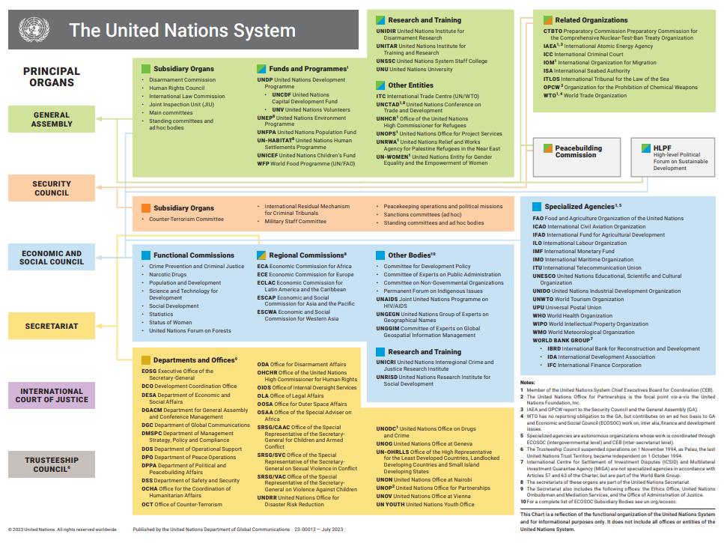
Employment | Generally, nationals of participating countries, review each program for specifics

Name | The World Bank Group IBRD IDA
About | The World Bank Group works in every major area of development. We provide a wide array of financial products and technical assistance, and we help countries share and apply innovative knowledge and solutions to the challenges they face.  World Bank Group staff work with governments, civil society groups, the private sector and others in developing countries around the world, assisting people in all areas of development, from policy and strategic advice to the identification, preparation, appraisal and supervision of development projects.
About  IBRD | International Bank for Reconstruction and Development (IBRD)  The world’s largest development bank, IBRD provides financial products and policy advice to help countries reduce poverty and extend the benefits of sustainable growth to all of their people.  The International Bank for Reconstruction and Development (IBRD) is a global development cooperative owned by 189 member countries. It supports the World Bank Group’s mission by providing loans, guarantees, risk management products, and advisory services to middle-income and creditworthy low-income countries, as well as by coordinating responses to regional and global challenges.  Created in 1944 to help Europe rebuild after World War II, IBRD joins with IDA, our fund for the poorest countries, to form the World Bank. They work closely with all institutions of the World Bank Group and the public and private sectors in developing countries to reduce poverty and build shared prosperity.
About  IFC | International Finance Corporation (IFC)  We work with the private sector in developing countries to create markets that open up opportunities for all. IFC—a sister organization of the World Bank and member of the World Bank Group—is the largest global development institution focused exclusively on the private sector in developing countries. Our Mission: Advance economic development by encouraging the growth of private enterprise in developing countries.  We apply our financial resources, technical expertise, global experience, and innovative thinking to help our partners overcome financial, operational, and other challenges. The IFC advances economic development and improves the lives of people by encouraging the growth of the private sector in developing countries.  We achieve this by creating new markets, mobilizing other investors, and sharing expertise. In doing so, we create jobs and raise living standards, especially for the poor and vulnerable. Our work supports the World Bank Group’s twin goals of ending extreme poverty and boosting shared prosperity.
Careers | Work With Us (worldbank.org)
Jobs | Welcome to the combined listing of current job openings at the World Bank Group, including the World Bank, IFC, ICSID, and MIGA
Employment Policy | The Bank Group's recruitment policy is to hire staff of the highest caliber, on as wide a geographical basis as possible, with preference to nationals of WBG member countries or countries of operations. If the country of your nationality does not appear in the drop-down menu, it is because it is not a member of the World Bank Group, nor a country of operations. Applicants who are not nationals of a member country or country of operations who would like to be considered for World Bank Group employment opportunities may submit a copy of their resume through the Connect with us page on the World Bank Group’s website.
Programs | LCR Inclusive Internship Program The LCR Inclusive Internship Program is designed to introduce a diverse and inclusive group of qualified graduate students to the World Bank (WB) by offering hands-on opportunities to contribute to development work in the Latin American and Caribbean region. It is targeted to highly motivated and qualified individuals from the LAC region, with a special focus on Afro descendants, Indigenous People, persons with disabilities, LGBT+, and other minorities.
Young Professionals Program: The WBG YPP is a two-year leadership development program at the start of a five-year employment contract with the World Bank, IFC or MIGA. Young Professionals (YPs) start the program in Washington, DC, where they engage in intensive training—on-the-job and in the classroom—learning the fundamentals of leadership and development operations across institutions, and how to identify opportunities for joint impact.
For over 50 years, the Young Professionals Program (YPP) has been the preeminent program for developing future leaders across the World Bank Group. Applications for the recently expanded program — now representing the IFC, World Bank and MIGA — will be open from July 3 – July 31 for all profiles and will reopen from August 15 — September 30 for IFC profiles only.
Internships | Internship: The Bank Internship Program (BIP) offers highly motivated individuals an opportunity to be exposed to the mission and work of the World Bank. Internships are available in both development operations and other business units (such as Human Resources, Communications, Accounting, etc.), for a duration of 1-4 months during Winter or Summer terms. Please click here for eligibility, more information and how to apply.  The WB Internship is offered twice a year:  • Summer Internship (May–September): The application period is December 1–January 31 each year.  • Winter Internship (November–March): The application period is October 1-31 each year.  All applications must be submitted online and during the respective application period. (We do not accept applications by email.)  J1 visa holders need to obtain a G4 visa abroad prior to starting employment or unpaid internship at the WB.
Employment | Preference to WBG member countries and countries of operation, review each program

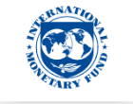

Name | International Monetary Fund (IMF)
About | The International Monetary Fund (IMF) is an organization of 190 countries, working to foster global monetary cooperation, secure financial stability, facilitate international trade, promote high employment and sustainable economic growth, and reduce poverty around the world.  The IMF is governed by and accountable to those 190 countries that make up its near-global membership.  The IMF's resources mainly come from the money that countries pay as their capital subscription (quotas) when they become members. Each member of the IMF is assigned a quota, based broadly on its relative position in the world economy. Countries can then borrow from this pool when they fall into financial difficulty.
Careers | Work with the IMF. Work with the World.
Jobs | Finding the Right IMF Job  The IMF has openings in a variety of fields, including economics, research, legal, information technology, finance, accounting, human resources, and communications.  Search for Jobs
Experienced Professionals
The IMF opportunities for experienced candidates span a range of areas, including economics, finance, legal, accounting, communications, human resources, information technology, library, security, and facilities.
Experienced Economists▸
Short-Term Assignments for Specialized Experts▸
Externally Financed Appointee Program (EFA) And Special Appointee Program (SFA)▸
Specialized Career Stream Professionals▸
Programs | Entry-Level Recruitment Programs  The IMF recruitment programs for entry-level economists, research assistants, and interns offer the opportunity to work in a variety of departments and to make an immediate contribution to our mission while providing a unique platform to launch your career.  Economist Program (EP)▸  Research Assistant Program (RAP)▸  Fund Internship Program (FIP)▸
Support Staff
The IMF recruits regularly for support staff positions across all departments and fields. Other than for the Research Assistant Program, support staff positions are recruited locally in the DC metro area.
Research Assistant Program (Economics)▸
Research Assistants (Economics)▸
Specialized Assistants / Administrative Assistants▸
Fund Internship Program (FIP)
Our summer interns gain an insider’s view of the member-country-focused mandate and critical international work of the IMF. You will build professional networks while you apply your research and analytical skills to help us explore questions of real importance to our member countries and to global economic stability. Whether you see a future for yourself in international organizations or are simply curious about policy and operational work, this is an ideal opportunity to familiarize yourself with both while leveraging your cutting-edge skills and expanding your research experience. Paid internship.
We recruit for the FIP on a global basis with approximately 50 students from around the world joining us each year at IMF headquarters in Washington, D.C. These paid internships take place between June and October and run for 10 to 12 weeks. Active Master’s students, must be below the age of 28 at the commencement of the internship
Follow link – How to Apply & Eligibility
If you are not a citizen or permanent resident of the U.S., and do not have another work authorization that would allow you to work at the IMF, you will need a G4 visa. We will provide the paperwork necessary to facilitate your G4 visa request with U.S. authorities. For those studying in the US who have an F-1 visa, an acceptable work authorization would need to be obtained (e.g. CPT).
Employment | Varies, check job descriptions

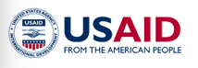

Name | USAID From the American People
About | USAID leads international development and humanitarian efforts to save lives, reduce poverty, strengthen democratic governance and help people progress beyond assistance.  USAID is the world’s premier international development agency and a catalytic actor driving development results. USAID’s work advances U.S. national security and economic prosperity, demonstrates American generosity, and promotes a path to recipient self-reliance and resilience. The purpose of foreign aid should be ending the need for its existence, and we provide development assistance to help partner countries on their own development journey to self-reliance – looking at ways to help lift lives, build communities, and establish self-sufficiency.  Our efforts are both from and for the American people.  USAID demonstrates America’s good will around the world; increases global stability by addressing the root causes of violence; opens new markets and generates opportunity for trade; creates innovative solutions for once unsolvable development challenges; saves lives; and advances democracy, governance, and peace.  - Agriculture and Food Security  - Anti-Corruption  - Conflict Prevention and Stabilization  - Democracy, Human Rights and Governance  - Economic Growth and Trade  - Education  - Environment, Energy, and Infrastructure  - Gender Equality and Women's Empowerment  - Global Health  - Humanitarian Assistance  - Innovation, Technology, and Research  - Nutrition  - Water and Sanitation
Careers | USAID Careers - Employment opportunities and resources are available to the general public interested in development work with USAID, including Veterans and persons with disabilities. We encourage you to create a profile, search for USAID vacancies, and set an alert for notifications on USAJOBs website.  Resources:  - USAID YouTube Channel (link is external)  - Free webinars and events offered by the Office of Personnel Management
Jobs | Vacancy Announcements - USAID fills all vacant Merit Promotion and Competitive positions through the automated application system at the U.S. Office of Personnel Management's (OPM) USAJOBS site.  Civil Service - Civil Service employees remain at the core of USAID/Washington staff and are the prime element in helping to shape programs overseas.  Foreign Service - Foreign Service Officers apply their technical knowledge, program design, management, and evaluation expertise to promote and demonstrate democratic values abroad, and advance a free, peaceful, and prosperous world.  Senior Executive Service - USAID hires managers, supervisors, and public policy leaders with expertise beyond the GS-15 Civil Service level for the Senior Executive Service (SES)
Fellows Programs | Fellows Programs - USAID’s fellowship programs are in a variety of technical areas including global health, democracy promotion, science and technology, and gender equality and women’s empowerment. USAID Fellows generally spend one or two years working in Washington, D.C., or in USAID Missions around the world. They provide technical assistance and advice on USAID programs, write research papers, develop evaluation strategies and methods, and complete other tasks that enhance USAID’s operations in the sector.  Applying for a Fellowship  To apply for a USAID fellowship, follow the links for the particular program on the USAID Fellows Programs homepage:  - Presidential Management Fellows Program  - American Association for the Advancement of Science (link is external)  - Franklin Fellows Program  - Sustaining Technical and Analytic Resources fellowship (link is external)  - Payne Fellowship (link is external)  - Jefferson Science Fellowship (link is external)  - IEEE-USA Engineering & International Development Fellowship (link is external)
Paid  Internships | Pathways for Students and Recent Graduates - Interns and Fellows generally work in one of USAID’s offices in Washington, D.C., supporting program work in economic growth, agriculture, education, health, environment, democracy and governance, conflict prevention, and humanitarian assistance. Internships and Fellowships allow students the opportunity to explore Federal careers and offer valuable work experience.  Paid Internship Opportunities  The Internship Program replaces the Student Career Experience Program (SCEP) and Student Temporary Employment Program (STEP). This Program is designed to provide students enrolled in a wide variety of educational institutions, from high school to graduate level, with opportunities to work in agencies and explore Federal careers while still in school and while getting paid for the work performed. Students who successfully complete the program may be eligible for conversion to a permanent job in the Civil Service.  Recent Graduates Program  The Recent Graduates Program affords developmental experiences in the Federal Government intended to promote possible careers in the Civil Service to individuals who have recently graduated from qualifying educational institutions or programs. To be eligible, applicants must apply within two years of degree or certificate completion (except for veterans precluded from doing so due to their military service obligation, who have up to six years after degree completion to apply). Successful applicants are placed in a dynamic, developmental program with the potential to lead to a Civil Service career in the Federal Government. The program lasts for one year (unless the training requirements of the position warrant a longer and more structured training program). Recent graduates may be converted to a permanent position (or, in some limited circumstances, a term appointment lasting one to four years).  Virtual Student Internships  USAID partners with the Department of State to offer virtual internship opportunities to students regardless of their geographic location through the Virtual Student Federal Service Program.
Eligibility | What are the basic qualifying factors to be eligible? U.S. Citizenship  Can I participate in a Student Program if I am not a U.S. Citizen?  The programs on this site are for students who are U.S. citizens. Non-U.S. citizens may apply for programs available through the Bureau of Educational and Cultural Affairs (ECA), at http://exchanges.state.gov
Employment | US Citizens, Cooperating Country Nationals
Local Employment | Local Employment - Foreign Service Nationals (FSNs) provide unique services in support of foreign policy at USAID missions worldwide, performing vital mission program support functions.  Individuals interested in working at a specific post who are not host country nationals must be legally eligible to work in the country of hire. Each USAID mission is responsible for their local recruitment. Please visit the country page of the mission you are interested in for job listings.

Development Banks

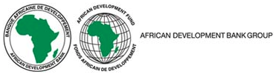
Name | African Development Bank Group (AfDB)
About | The overarching objective of the African Development Bank (AfDB) Group is to spur sustainable economic development and social progress in its regional member countries (RMCs), thus contributing to poverty reduction.  The Bank Group achieves this objective by:  - mobilizing and allocating resources for investment in RMCs; and  - providing policy advice and technical assistance to support development efforts.  Founded 1964  - Constituent Institutions  - The African Development Bank (ADB)  - The African Development Fund (ADF)  - The Nigeria Trust Fund (NTF)  - Shareholders  - 54 African countries (regional member countries)  - 27 non-African countries (non-regional member countries)  - Mission To promote sustainable economic growth and reduce poverty in Africa.
Careers | AfDB Careers
Jobs | Current Vacancies
Programs | Employment of short term staff  The African Development Bank has returned to its Headquarters in Abidjan. From time to time, the Bank needs extra services provided by persons other than its permanent staff in order to assist with additional activities not projected in the normal work programme; replacement of regular personnel who are absent over long periods; and to occupy vacant positions within the time limits set by the Bank.  If you are looking for a short-term opportunity in support functions at the Bank’s headquarters in Abidjan and country office, you may wish to register your CV on (New AfDB Short Term Employment).  Applications submitted are regarded as spontaneous and will be used to populate our database for short term opportunities in the Bank.
 | The Young Professionals Program (YPP) is a three-year leadership opportunity for the development of Bank’s future workforce and leaders. The Bank aims attract highly qualified and motivated professionals from our member countries for a productive and rewarding career path in development. Through the YPP, the Bank ensures continuity and excellence in both the management of its work programs and the provision of policy advice to its regional member countries.
Internship | The primary objectives of the Internship Program at the African Development Bank Group are to deepen the Bank's efforts to advance development within its regional member countries (RMC) through capacity building activities.  The broad objectives of the Program are to provide the opportunity to acquire and develop the ability to work in an international environment, provide the Bank a pool of potential candidates in the future and enhance the visibility of the Bank and its development activities.  Eligibility: 30 years or younger as of 12/31 of intake, enrolled in Master’s, 1 year following Master’s, Citizen of a member country  Selection Cycle: The window for receiving applications for the 2023 Internship Program is from 23rd January to 22nd February 2023. All applicants will receive email notification of the outcome of their application by 24th March 2023.
Employment | Our staff are diverse in many respects, including gender, nationality, race, culture, education and experience and fully represent our member countries. Generally, citizen of a member country

Name | Asian Development Bank (ADB)
About | ADB is committed to achieving a prosperous, inclusive, resilient, and sustainable Asia and the Pacific, while sustaining its efforts to eradicate extreme poverty. Established in 1966, it is owned by 68 members—49 from the region.  ADB supports projects in developing member countries that create economic and development impact, delivered through both public and private sector operations, advisory services, and knowledge support.
Careers | ADB Work with Us  With employees from more than 60 countries, ADB is a place of real diversity. Join us to find fulfillment in sharing your knowledge and skills, and be a part of our vision in achieving a prosperous, inclusive, resilient, and sustainable Asia and the Pacific.
Jobs | Current Opportunities – International Staff Vacancies / Internship Opportunities  ADB Career & Employment System (ACES)
Programs | ADB Young Professionals Program (YPP)  The Young Professionals Program (YPP) is an entry-level recruitment program to attract highly qualified and motivated individuals to ADB. YPP provides the foundation for a challenging and rewarding professional career in an international development environment and offers a wide range of opportunities to develop professional skills and understanding of ADB's operations, policies, and procedures.  Selected Young professionals (YPs) are offered a fixed-term appointment of 3 years. YPs will be initially placed in one of the departments in the Headquarters (Manila) where they can gain foundational experience of ADB’s operations, then assigned to another department/office as a rotational assignment for 12 months. The rotational assignment will be carried out in a field related to the initial placement whereby YPs are expected to broaden their experience and deepen their knowledge on the subject matter.  Selection Cycle: Applications are open from 1 September to 30 September 2023. Applications should be submitted in English no later than 11:59 p.m., Manila time, on the specified closing date.
MIP – ADBI Internship | MIP and ADBI have an understanding, subject to a need for interns, ADBI will make available one or more summer internships to qualified MIP first year students. Applications are due early Winter quarter and are eligible for MIP Summer Funded Internship program stipends.  Asian Development Bank Institute (ADBI) provides intellectual input for policy makers in ADB’s developing member countries (DMCs). It does so by conducting research with a focus on medium- to long-term development issues of strategic importance that affects the region and through capacity building and training (CBT) activities that contribute to ADB’s overarching objective of poverty reduction.  The objectives of ADBI are to identify effective development strategies and improve the capacity for sound development of the agencies and organizations engaged in development work in ADB’s DMCs. ADBI focuses its activities on areas where it has a strategic advantage, such as the analysis of emerging policy issues from regional as well as medium- to long-term perspectives, and the facilitation of policy dialogue among senior DMC policy makers. ADBI also seeks to enhance its visibility, impact, and accessibility through high-quality knowledge products and services. It strives to be a trusted source of insight, knowledge, and information to which policy makers, academics, and others interested in Asia’s development issues turn for guidance.  Eligibility: be a national of one of ADB's members
Internship | ADB Internship Program  The Internship Program is a project-oriented learning opportunity for graduate students to gain experience through research assignments based on ADB’s current operational needs.  ADB advertises internship assignments twice a year and welcomes motivated, open-minded, and self-directed individuals to apply.  The internship program offers the opportunity to:  - work in a major international development organization;  - work collaboratively with experienced professionals from over 50 different countries;  - gain a deeper understanding of development finance and the impact of the work ADB does; and  - contribute to ADB's business through research outputs.  Application period for the 2023 Internship Program:  1st batch: 15 July to 15 September 2022  - On board: January 2023 onwards  2nd batch: 15 December 2022 to 15 February 2023  - On board: June 2023 onwards  Eligibility:  - be enrolled in a Master's- or PhD-level program at a school in one of the ADB member nations, both prior to and after the internship assignment;  - be engaged in academic study in a field directly related to ADB's work;  - be a national of one of ADB's members;  - possess an excellent command of English; and  - have professional experience relevant to the assignment
Employment | National of one of ADB members

Name | European Bank for Reconstruction and Development (EBRD)
About | The European Bank for Reconstruction and Development (EBRD) was founded in 1991 to create a new post-Cold War era in central and eastern Europe. We are now doing more than ever before - across three continents - to further progress towards ‘market-oriented economies and the promotion of private and entrepreneurial initiative’.  The EBRD is owned by 71 countries, the European Union and the European Investment Bank. Each shareholder is represented individually on the Board of Governors of the EBRD which has overall authority over the Bank and is responsible for approving its overall strategic direction. Our operations extend across three continents and almost 40 economies and within a broad range of sectors.
Careers | Working with the EBRD  With staff coming from dozens of countries, our workforce is as diverse as our portfolio.  The EBRD recruits talented and driven individuals to work in our London headquarters and resident offices spread across the countries where we invest.  The EBRD is a unique international financial institution supporting projects across three continents. Investing primarily in private sector clients whose needs cannot be fully met by the market, we promote entrepreneurship and foster transition towards open and sustainable market economies.  We look to recruit people passionate about our values and work. Whether you are a banker, analyst, economist, IT specialist or researcher, there are a number of opportunities to support the EBRD in its operations from client relations to communications.
Jobs | Search and apply for current vacancies at our careers site – set up a Job Alert
Programs | International Professionals Programme (IPP)  Our IPP represents a great chance for a limited number of individuals to join us on a two-year programme that offers experience in one of our Resident Offices and in a variety of teams at our Headquarters in London.  The IPP offers a life-changing experience for ambitious, adventurous postgraduates. It is an intensive 24 month programme that will prepare you for a potential career at the EBRD. It is designed to both invest in your existing talents and expose you to some truly incredible projects.  Starting and finishing the programme in our London headquarters, you will rotate through three placements, including one that provides the opportunity to work with and learn from other cultures with an assignment in one of our 38 countries of operations.
Internships | Internships  The EBRD does not have a formal internship programme, but we do employ interns on a fully-paid basis for positions that arise on an adhoc basis. Internship opportunities may be advertised in our jobs website.  EBRD internship opportunities may arise for students of economics, banking and finance, business administration, law, human resources, communications and the sciences.  Applicants should normally be studying at a post-graduate level, or have just completed their undergraduate programme. Studies should either be in progress or have been completed within the last 12 months.  Internships normally last between three and six months, depending on the requirements of a specific role, but may be extended for up to a maximum of 12 months.  - You must be a national of one of our member countries.  - You must be fluent in both spoken and written English.  - You must be able to obtain the necessary UK visa to allow for Headquarters opportunities.
Employment | The EBRD recruits talented and driven individuals to work in our London headquarters and resident offices spread across the countries where we invest.

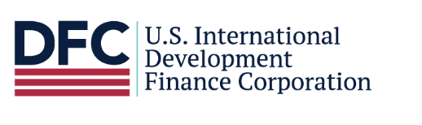
Name | U.S. International Development Finance Corporation
About | U.S. International Development Finance Corporation (DFC) is America’s development finance institution. DFC partners with the private sector to finance solutions to the most critical challenges facing the developing world today. We invest across sectors including energy, healthcare, critical infrastructure, and technology. DFC also provides financing for small businesses and women entrepreneurs in order to create jobs in emerging markets. DFC investments adhere to high standards and respect the environment, human rights, and worker rights. DFC makes America a stronger and more competitive leader on the global development stage with greater ability to partner with allies on transformative projects. Further, we provide the developing world with financially sound alternatives to unsustainable and irresponsible state-directed initiatives.
Careers | DFC is looking to expand its talented workforce with individuals interested in applying their expertise in an innovative, rewarding, and fast-paced environment.  As America's development finance institution, DFC offers many opportunities for young and seasoned professionals looking to broaden and apply their expertise in an innovative, rewarding, and fast-paced environment. We are looking for outstanding candidates from a variety of fields and disciplines to augment our small and talented staff:
Jobs | Search and apply for current vacancies at USAJobs - DFC
Internships | Internships  DFC’s unpaid Student Internship Program offers challenging opportunities to more than one hundred undergraduate and graduate students each year.  DFC internships offer valuable experience that contribute to educational and professional growth, and may be applied in any future employment endeavor, including federal, state, and local governments or in the private sector.  Applicants for DFC's unpaid Student Internship Program must apply via USAJOBS in order to be considered for placement. Applications are accepted year-round; however, if targeting a specific internship period, DFC recommends submitting your application by the following dates:  - Summer - Apply by March 1  - Fall - Apply by July 1  - Winter - Apply by November 1  - Spring - Apply by January 1  You will receive notification if you are referred to a DFC Internship Coordinator for further consideration. Due to the high volume of applications, we are unable to respond individually to application status inquiries.  Please visit USAJOBS to view current internship vacancies, learn about DFC Offices, and review specific qualification requirements for each internship. If you have any questions, please email interns@dfc.gov.
Employment | U.S. Citizens

Name | European Investment Bank (EIB)
About | The European Investment Bank is the lending arm of the European Union. As such, the EIB is a key part of the EU family, contributing to EU policy objectives. We strengthen the European Union’s global influence. We expand its visibility and are active in Member States and around the world. We do so by promoting EU values.  Since its establishment in 1958, the EU bank has invested over a trillion euros. The EIB works closely with other EU institutions to foster European integration, promote the development of the EU and support EU policies in over 160 countries around the world.  Through EIB Global, set up in 2022 to increase the impact of our development finance, we help address global challenges and create growth and opportunity in all continent.
Careers | EIB Work with us  We are a bank with a difference: we all share a passion for helping shape a better future for the European Union and beyond.  We always seek talented professionals for our headquarters in Luxembourg. Our people enjoy a good work-life balance, training opportunities, career advancement and social activities.  We have recently established EIB Global, a dedicated arm for our operations outside the EU, aiming at tackling the great challenges of today. Through technical and financial experts on the ground, we are strengthening our presence worldwide, to maximize our impact and enhance cooperation with regional partners.  For its representative offices in Africa, the Near East and the Western Balkans, EIB Global is currently hiring locally.
Jobs | If you want to make a difference, check our global vacancies here and select the relevant location – set up a Job Alert.
Internships | Internships  We offer opportunities for students in the form of short-term (two-four weeks) summer jobs and longer-term internships, which usually last between three and 12 months, depending on the programme.  We offer a limited number of internships to university students and recent graduates who wish to acquire an understanding of the Bank’s work or gain experience in their field of studies. Internships normally last between three and five months (six months if requested by universities) and cannot be extended beyond the maximum period. Most are based at our headquarters in Luxembourg.  There are two intakes each year, on 1 February and 1 September. We generally publish opportunities between three and four months prior to the start date.  The General Internship Programme is open only to students or recent graduates, with less than one year of relevant experience (since the last degree), who are nationals of EU Member States and Candidate Countries whose membership negotiations have started (currently: Turkey, Serbia and Montenegro).  You must have a degree or be in the final year of a course at an institute of higher education. Generally, successful candidates will have enrolled on a graduate study programme (be pursuing a master’s degree).
Employment | Our headquarters are in Luxembourg, where most of our people are located. We have a network of representative offices in other European capitals, as well as in Africa, America, Asia and Australia, to cover the wide range and geographical scope of our projects.

Name | Inter-American Development Bank (IDB)
About | We work to improve lives in Latin America and the Caribbean. Through financial and technical support for countries working to reduce poverty and inequality, we help improve health and education, and advance infrastructure. Our aim is to achieve development in a sustainable, climate-friendly way. With a history dating back to 1959, today we are the leading source of development financing for Latin America and the Caribbean. We provide loans, grants, and technical assistance; and we conduct extensive research. We maintain a strong commitment to achieving measurable results and the highest standards of integrity, transparency, and accountability.  The IDB prioritizes social inclusion and equality; productivity and innovation; and regional economic integration in its development work across Latin America and the Caribbean. In doing so, it addresses the cross-cutting issues of gender equality and diversity; climate change and environmental sustainability; and institutional capacity and the rule of law. Learn more about the Institutional Strategy here.
Careers | Careers at IDB
Jobs | Current Openings - Work with us! – Sign up for Job Alerts
Internships | Remote Internship Program  We are looking for talented students who seek to gain professional experience in the field of international development. Through our internship program, you will have the opportunity to work with us to improve lives in the region.  Our paid internships provide opportunities across the IDB Group (IDB, IDB Invest and IDB Lab). Positions are available in our headquarters in Washing D.C., in our offices throughout Latin America, the Caribbean, Asia, and Europe, and at the Institute for the Integration of Latin America and the Caribbean (INTAL) in Argentina.  If you would like to know more about our Remote Internship Program, here is a podcast we prepared to answer all your questions.  You can also get a glimpse of what is it like to be at our Headquarters by exploring the IDB Group Virtual Tour, an immersive experience where you will discover who we are and what it is that we do to improve lives in the countries we serve.
Employment | Citizen of one of the IDB’s 48 member countries in order to qualify for any type of employment

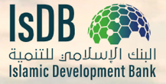

Name | IsDB Islamic Development Bank
About | The Islamic Development Bank is a multilateral development bank (MDB), working to improve the lives of those we serve by promoting social and economic development in Member countries and Muslim communities worldwide, delivering impact at scale.  We provide the infrastructure to enable people to lead better lives and achieve their full potential.
Careers | Think Careers with a Purpose
Jobs | Join Us - Vacancies
Programs | The Young Professional Program (YPP) is an entry level talent development program that equips you with the knowledge, skills, and network for a fulfilling career in international development. You’ll be part of a global network of IsDB professionals who are helping to promote sustainable development in our 57-Member countries & in Muslim communities in non-Member countries.  Eligibility  - Education: pursuing Master’s to be awarded prior to start of program  - Citizenship: Be a citizen of a member-country of the IsDB (however. up to 25% of selected candidates from each cohort can be from Muslim communities in non-member countries).  - Language: Excellent oral and written communication skills in English. Good command over one the Bank’s other operating languages (Arabic or French) will be viewed favorably.  - Age: Not older than 32 years upon joining IsDB, having acquired their Master’s degree less than 4 years from the start of the program.  - Be willing to live in Jeddah (Saudi Arabia) and travel to undertake country assignments as per business requirements (including rotation to an IsDB Regional Hub).  - Display a commitment and passion for IsDB mission and its model of development.
Employment | Citizen of one of the IsDBs member countries (see Job description)

To: Table of Contents

Associations Of Member States

Name | ASEAN Association of Southeast Asian Nations
About | The Association of Southeast Asian Nations, or ASEAN, was established on 8 August 1967 in Bangkok, Thailand, with the signing of the ASEAN Declaration (Bangkok Declaration) by the Founding Fathers of ASEAN, namely Indonesia, Malaysia, Philippines, Singapore and Thailand. Brunei Darussalam then joined on 7 January 1984, Viet Nam on 28 July 1995, Lao PDR and Myanmar on 23 July 1997, and Cambodia on 30 April 1999, making up what is today the ten Member States of ASEAN.  The ASEAN Vision 2020, adopted by the ASEAN Leaders on the 30th Anniversary of ASEAN, agreed on a shared vision of ASEAN as a concert of Southeast Asian nations, outward looking, living in peace, stability and prosperity, bonded together in partnership in dynamic development and in a community of caring societies.
Careers | ASEAN Opportunities
Employment | Check Job Descriptions

Name | European Commission
About | The Commission helps to shape the EU's overall strategy, proposes new EU laws and policies, monitors their implementation and manages the EU budget. It also plays a significant role in supporting international development and delivering aid.  Along with the other main EU institutions, the European Commission develops the overall strategy and political direction of the EU.  Every five years, at the beginning of a new Commission term, the president of the Commission also determines the political priorities for its upcoming term of office.  The Commission turns these priorities into concrete actions on a yearly basis through an annual work programme, which sets out a plan of action for the next twelve months.
Careers | Why a EU Career?
Eligibility | In general, EU National, check specific programs
Jobs | Jobs at the European Commission  Job opportunities  - Open opportunities  - Ongoing selection procedures  - Upcoming opportunities  - Temporary jobs at the European Commission  - Managers at the European Commission  - Jobs at the Joint Research Center  Contract types  - Permanent staff  - Contract staff  - Second National Experts (SNEs)  - Temporary staff  - Interim staff  How to apply
Entry-Level  Graduates | Entry-Level Graduates  If you have recently graduated from university and are looking to work with the EU institutions, you will typically apply for what we call Administrator profiles at grade AD5 to become a permanent official. As an Administrator, you can find yourself playing a key role in the EU’s processes with a high degree of responsibility from an early stage in your career.  Along with your university diploma (at least bachelor degree level) you only need two more things to meet the basics for our graduate selection procedures. You need to be an EU citizen and fluent in one of the official EU languages and proficient in a second (for linguist profiles you will need a third EU language).  The selection procedures for permanent positions with the EU are organised as ‘open competitions’. The most relevant competition for graduates is launched every spring, usually as a generalist competition, for which no particular field of studies is needed.  An open competition includes tests and assessment exercises designed to measure your professional skills and a number of core competencies. Since the number of applicants is very high, this is the fairest and most transparent selection procedure.  Our competitions are published at Job Opportunities and announced by a Notice of Competition, which provides full details of the profile, the eligibility criteria and the selection procedure. The format of the competitions varies depending on the profile being sought. You can find more details on the application procedure at How to Apply.  Registration for competitions begins in the same periods every year (this is what we call cycles), in spring for Graduates and in summer for Translators. The graduate profiles we look for (e.g. Law, Audit) may vary from year to year as well as the language needs for Translators. Other selection procedures such as for Specialists or Assistants are launched in between the cycles.
Employment | Citizen of one of the member states

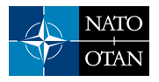

Name | North Atlantic Treaty Organization (NATO)
About | Security in our daily lives is key to our well-being. NATO’s purpose is to guarantee the freedom and security of its members through political and military means.  POLITICAL - NATO promotes democratic values and enables members to consult and cooperate on defence and security-related issues to solve problems, build trust and, in the long run, prevent conflict.  MILITARY - NATO is committed to the peaceful resolution of disputes. If diplomatic efforts fail, it has the military power to undertake crisis-management operations. These are carried out under the collective defence clause of NATO's founding treaty - Article 5 of the Washington Treaty or under a United Nations mandate, alone or in cooperation with other countries and international organisations.  NATO Organization
Careers | Careers at NATO - In Human Resources at NATO, we strive to recruit well-qualified, motivated civilians who can represent the diversity of our member States and who are able to make a difference. We offer employment opportunities in areas ranging from our mission of political-military work, defence, security and diplomacy to functional areas such as engineering, resource management, administration and management or information technology. Learn more about our work areas.
Eligibility | General eligibility: national of a NATO Member State
Jobs | Current Vacancies for international civilian staff positions
Programs | NATO-wide Young Professionals Programme - NATO's Young Professionals Programme (YPP) aims to attract and develop highly talented professionals, who are interested in accelerating their career through entry-level positions at NATO. Successful candidates will have the possibility to work in various areas in different NATO bodies and experience a range of activities across the Alliance.  Successful candidates will be assigned to different NATO bodies for one-year periods, for a total of three NATO bodies over three years. This will provide participants with a broad understanding of NATO and with opportunities to develop many competences in several different work areas within the Organization.  The call for applications for the first edition of the YPP is now closed. Please visit our website and job board in order to receive updated information about the next call for applications.
Internships | INTERNSHIP PROGRAMMES (geared toward undergraduates)  - NATO IS/IMS Internship Programme  - NATO Defense College Internship Programme  - SHAPE Internship Programme  - NSPA Internships  - HQ LC Internship Programme (Izmir)  - CSO Internship Programme
Employment | Nationals of NATO Member States

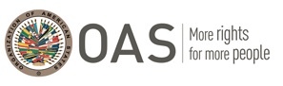

Name | Organization of American States (OAS)
About | The Organization of American States is the world’s oldest regional organization, dating back to the First International Conference of American States, held in Washington, D.C., from October 1889 to April 1890. That meeting approved the establishment of the International Union of American Republics, and the stage was set for the weaving of a web of provisions and institutions that came to be known as the inter-American system, the oldest international institutional system.  The OAS came into being in 1948 with the signing in Bogotá, Colombia, of the Charter of the OAS, which entered into force in December 1951.  Today, the OAS brings together all 35 independent states of the Americas and constitutes the main political, juridical, and social governmental forum in the Hemisphere. In addition, it has granted permanent observer status to 71 states, as well as to the European Union (EU).  The Organization uses a four-pronged approach to effectively implement its essential purposes, based on its main pillars: democracy, human rights, security, and development.
Careers | The Organization of American States has a regional workforce of more than 1,000 people. Its headquarters is located in Washington D.C., USA, and it has coordinating offices in 31 member countries. The Organization of American States is a vibrant, culturally-diverse international organization. In working towards the fulfillment of its statutory mission, the OAS is at the forefront in establishing an order of peace and justice among its Member States, promoting their solidarity, strengthening their collaboration, and defending their sovereignty, territorial integrity, and independence.
Jobs | Employment Opportunities (oas.org)  Search Openings.
Internships | Internships at the OAS  We offer you a unique opportunity to acquire experience in different areas of expertise, in an international and multicultural environment enhancing your networking possibilities. In addition, you will have the chance to acquire significant knowledge of the Organization of American States (OAS), its mission, pillars, structure and projects in the hemisphere.
Employment | Preference to nationals of our Member States, available here

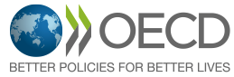

Name | OECD
About | The Organisation for Economic Co-operation and Development (OECD) is an international organisation that works to build better policies for better lives. Our goal is to shape policies that foster prosperity, equality, opportunity and well-being for all. We draw on 60 years of experience and insights to better prepare the world of tomorrow.  Together with governments, policy makers and citizens, we work on establishing evidence-based international standards and finding solutions to a range of social, economic and environmental challenges. From improving economic performance and creating jobs to fostering strong education and fighting international tax evasion, we provide a unique forum and knowledge hub for data and analysis, exchange of experiences, best-practice sharing, and advice on public policies and international standard-setting.
Careers | If you want to help drive change, apply to work at the OECD. OECD Careers
Jobs | Apply to the OECD and Current Vacancies
Eligibility | OECD member country nationals (while also open to non-OECD Member country nationals for specific programmes and projects across OECD affiliated bodies and agencies - check each programme)
Internships | OECD Internship Programme is designed to bring highly qualified and motivated students with diverse backgrounds into the Organisation to work on projects linked to the Strategic Orientations of the Secretary-General and to support the corporate functions of the Organisation. Its main goal is to give successful candidates the opportunity to improve their analytical and technical skills in an international environment.  The Young Associates Programme (YAP) is a two-year programme targeted at recent undergraduates who wish to gain a significant first professional experience in the world of multilateral policymaking, research and analysis. It is designed to act as a springboard for them to target future postgraduate study at top-ranked universities.  The 2023-2025 selection round of the Young Associates Programme is closed for applying.
Employment | National of an OECD member country

Note:

U.S. Government Main Career Websites:
- careers.state.gov
- usajobs.gov
- usda.gov
- trade.gov

US Citizenship and Immigration Services: Green Card for International Organization Employees
There is a provision of immigration law that allows certain long-term international organization employees and their eligible family members to apply for special immigrant status and become permanent residents of the U.S. (get a Green Card) as long as their organization remains recognized.
By statute (INA 101(a)(27)(L)), the North Atlantic Treaty Organization (NATO) is a recognized international organization. Other organizations include the:
- Organization of American States (OAS);
- Inter-American Defense Board (IADB);
- Inter-American Defense College (IADC);
- International Monetary Fund (IMF);
- World Bank;
- International Telecommunications Satellite Organization (INTELSAT); and
- International Telecommunications Satellite Organization (ITSO).
For more information, see 9 FAM 402.3-7.

To: Table of Contents

Young Professionals and Internship Programs - Timelines

 | Program | Application Period | Duration
United Nations | Young Professionals Program | June open, typically  Bookmark for Important Updates | Start your career at the United Nations
United Nations | Internship Programme | Varies, check openings | 2 to 6 months
WB, IFC,  MIGA | Young Professionals Program | July 3 – July 31 (all institutions)  August 15 – September 30 (IFC only) | 2 years (of a 5 year contract)
World Bank | Bank Internship Program | December 1 – January 31 | Summer (May to September)
World Bank | Bank Internship Program | October 1 – October 31 | Winter (November to March)
IMF | Fund Internship Program | Varies, check openings | Min - 10 weeks and max - 12 weeks (June to October)
USAID | Fellows Programs | American Association for the Advancement of Science (link is external)  Franklin Fellows Program  Sustaining Technical and Analytic Resources fellowship (link is external)  Payne Fellowship (link is external)  Jefferson Science Fellowship (link is external)  IEEE-USA Engineering & International Development Fellowship (link is external) | Check each site for specifics
USAID | Presidential Management Fellows Program | Class of 2024 Application opens September 12-25, 2023.  2022 Application: PMF | Entry level for advanced degree candidates
USAID | Internship Program | Check USAJOBS (external link) | Temporary for up to 1 year, indefinite
AfDB | Young Professionals Program (YPP) | Check YPP website | 3 years
AfDB | Internship Programme | Check Selection Cycle | Up to 1 year
ADB | ADB Young Professionals Program (YPP) | Check ADB YPP website | 3 years
ADB | ADB Internship Program | 1st batch: 15 July to 15 September 2022 | On board: January 2023 onwards
ADB | ADB Internship Program | 2nd batch: 15 December 2022 to 15 February 2023 | On board: June 2023 onwards
ABDI | MIP – ADBI Internship | Will be announced January 2023, qualifies for MIP Summer Funding | 10 to 12 weeks
EBRD | International Professionals Programme (IPP) | Watch jobs in this category, set up a job alert | 2 years
EBRD | Internships | Advertises regularly vs recruiting at a specific time of year, set up a job alert | 3 to 6 months, up to 12 months
EIB | Internships | There are two intakes each year, on 1 February and 1 September | 3 to 6 months, up to 12 months
IDB | Internships | Check site: Remote Internships - Washington, D.C.  Check site: Internships in our Country Offices | Check each program for specifics
IsDB | Young Professionals Program | Jan/Feb – Application period for Sep/Oct cohort | 2 year training curriculum
NATO | Young Professionals Program | Check site: YPP Application Process  Review: NATO YPP Programme Overview.pdf | 3 years
OAS | Virtual Internships | 2024 Winter/Spring & Session I | Applications: Aug 21 – Sep 15, 2023 | Sessions: Jan 11 – Apr 26, 2024 | Check program and Calendar
OAS | Virtual Internships | 2023 Fall Session & Session III | Applications: May 15 – June 02, 2023 | Sessions: Sep 07 – Dec 01, 2023 | Check program and Calendar
OECD | Internships Apply: OECD (taleo.net) | Open on an ongoing basis. You can apply anytime via our online application platform. | See job descriptions
OECD | Young Associates Program (YAP) | The 2023-2025 selection round of the Young Associates Programme is closed for applying. The selection process is ongoing. | 2 years

To: Table of Contents

References

Top Multilateral Development Banks - An Overview | Development Aid
22 October 2020

Multilateral Organization | GENI Global Energy Network Institute

Mapping Development Finance Institutions Worldwide: Definitions, Rationales, and Varieties | by Jiajun Xu, Peking University

Making-Global-Impact.pdf (wisc.edu)

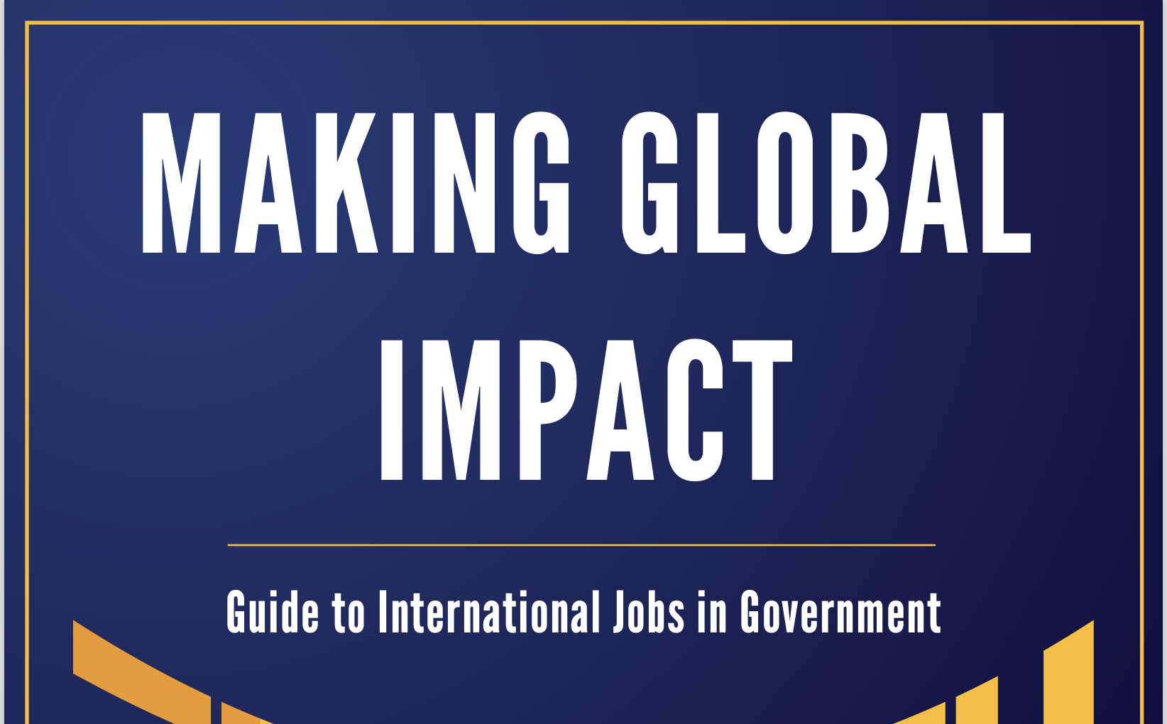

Internships, Fellowships, and Other Work Experience Opportunities in the Federal Government (congress.gov)

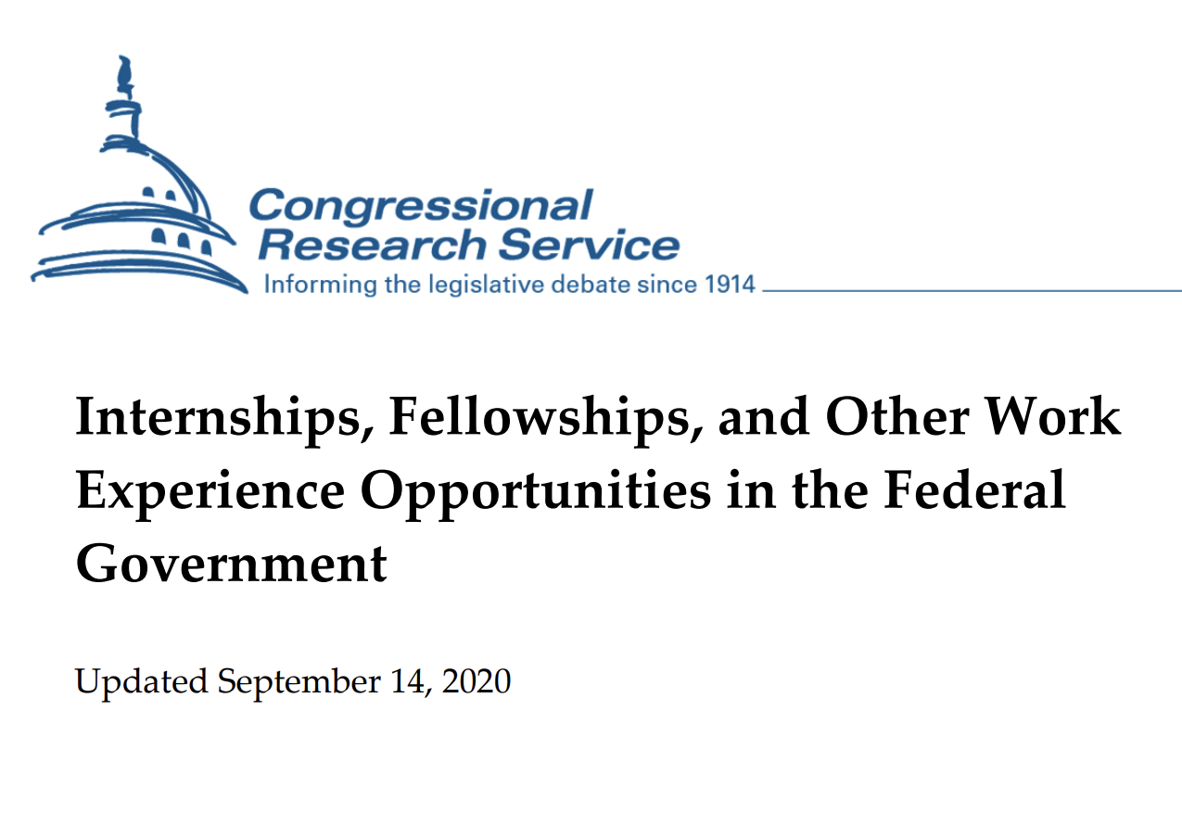
Careers in Global Development | Center for Strategic & International Studies

To: Table of Contents

.

