Schedule an appointment with a Career Coach in Handshake
Check out this step by step guide to schedule an appointment
https://support.joinhandshake.com/hc/en-us/articles/219133257

- Career Center dropdown at the top of your screen and select Appointments.

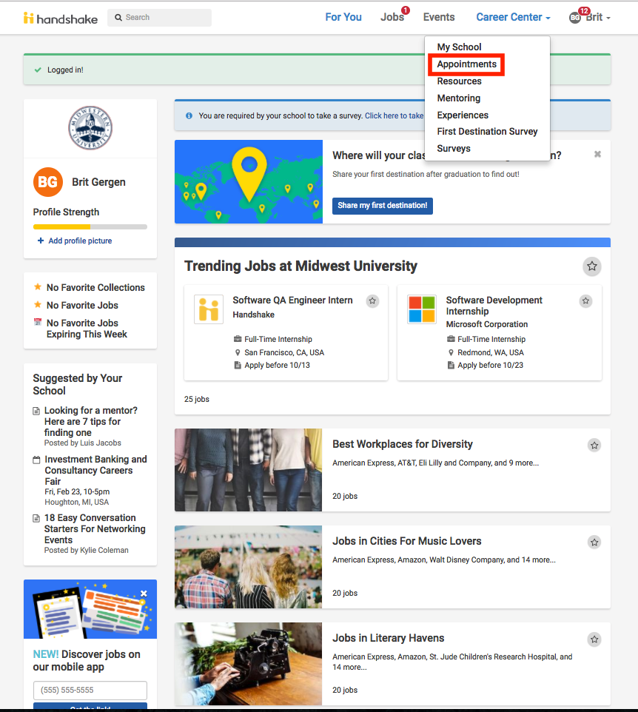

- On the following page, you'll see any past and upcoming appointments you have scheduled. To request a new appointment, click the Schedule a New Appointment button.

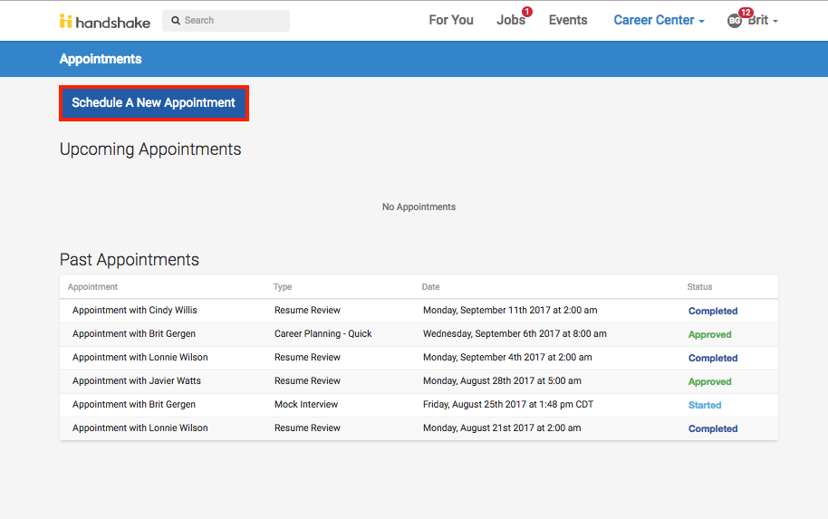
- You will see the option to pick a category and type of appointment.

- ​Select the category and type of appointment you are interested in scheduling.​You will be taken to the next available appointment times once you have selected an appointment category and type.
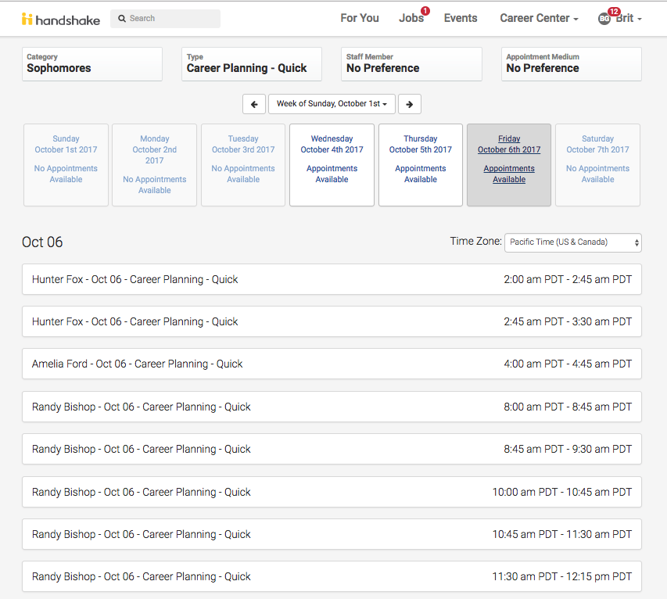
- Click on a time that works for you or click on staff member to see the availability of different staff members.
- Enter details about the appointment in the What can we help you with? section and then click Request at the bottom of the screen. 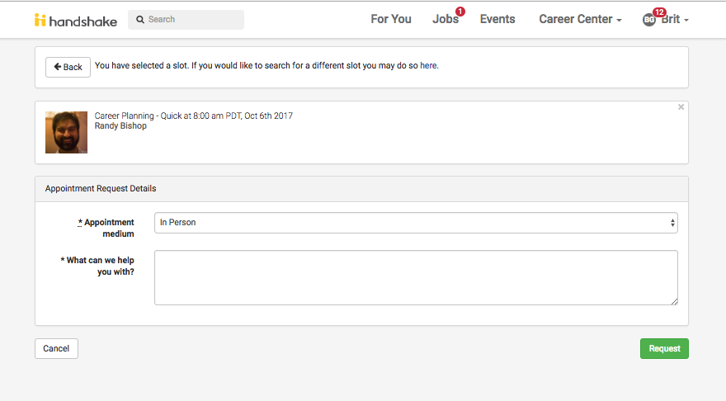
- You will be taken to the overview of the appointment where you can cancel the appointment or add comments before the appointment.
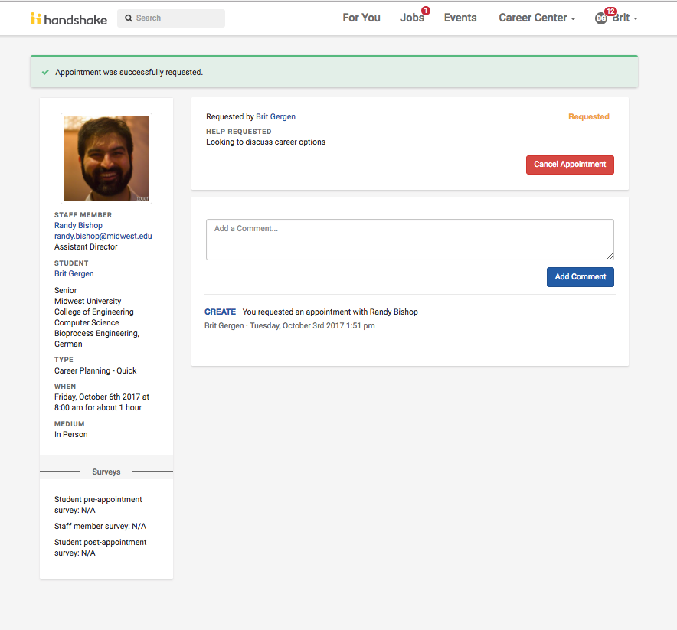
- Make sure that you check your notifications for updates to the status of your appointment.

