Introduction

Welcome to Banner Web Time Entry. Banner Web Time Entry is the timesheet tool Mercy College (the College) employees will use beginning July 1, 2014. Banner Web Time Entry can be accessed via Mercy Connect through Mercy College’s main web page. In general, completing your timesheet under Banner Web Time Entry can be summarized in 4 easy steps:

1. Log into **Mercy Connect**
2. Locate the **Employee** tab
3. Access your **Banner timesheets**
4. Save and submit the timesheet to your supervisor for approval

Please note, when navigating the Web Time Entry tool, don’t use your browser’s “back button” to return to a previous screen. Use the navigation / control buttons in Banner Web Time Entry.

You must submit your timesheet to your approver allowing sufficient time to be approved and processed.

If your timesheet is not approved and submitted to payroll prior to the due date and time, your paycheck may be inaccurate or delayed.

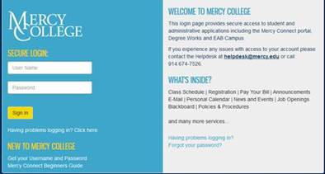

Enter Username & Password

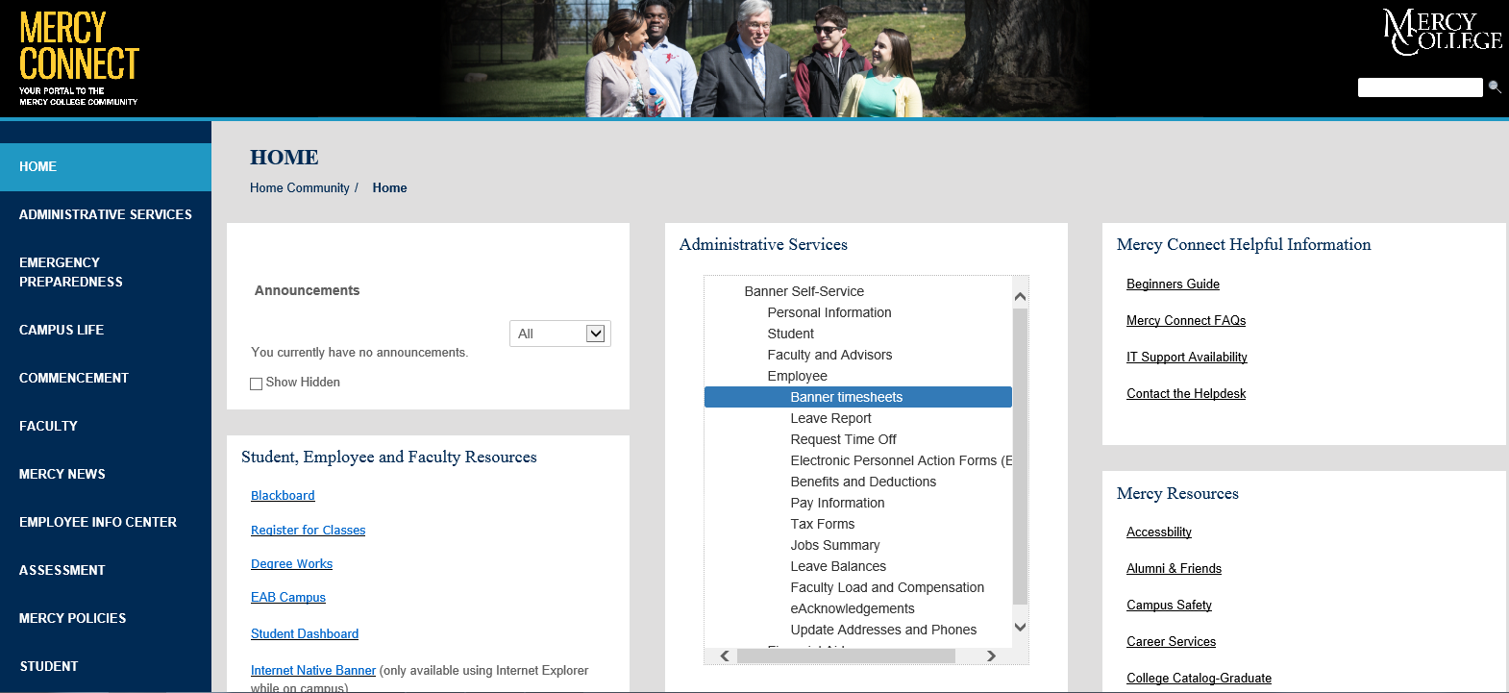

**Click on this Link**

-Using the dropdown menu, select the “Pay Period and Status” to be completed

-Banner Web Time Entry will default to the current active pay period

-Status indicates whether the timesheet is “in progress” or “approved”

-Click the “Time Sheet” box to access the timesheet for the selected pay period



The **Banner timesheet** is divided into three areas, and contains three important blocks of information:

The **first section** includes the:

* Job title and Banner position number
* Home department and account code
* Beginning and end dates for the pay period
* Closing date and time to submit the time sheet

The **center section** summarizes the time entered for the pay period

The **bottom area** provides information about the timesheet’s status, which includes who submitted the timesheet and the name of the assigned approver.

You can also copy hours reported for one day to multiple days on your time sheet, rather than entering the same number of hours for each day.

Select

Timesheet Sample

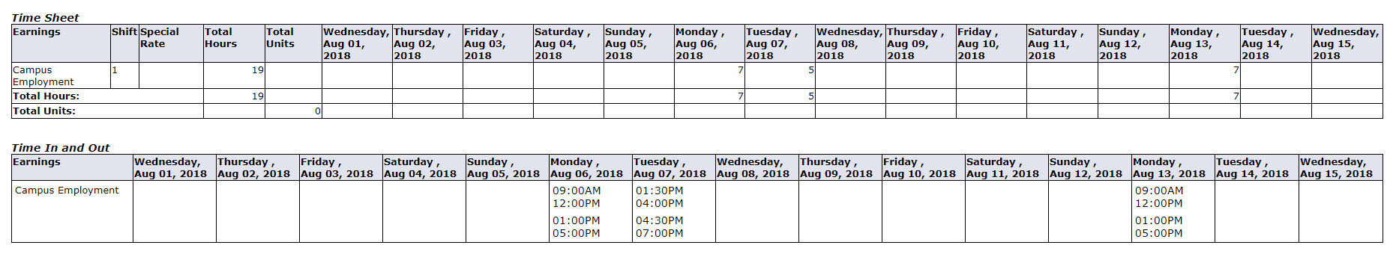

Example

* You can information from day to day if the same work schedule applies to more than one day

**COPY**

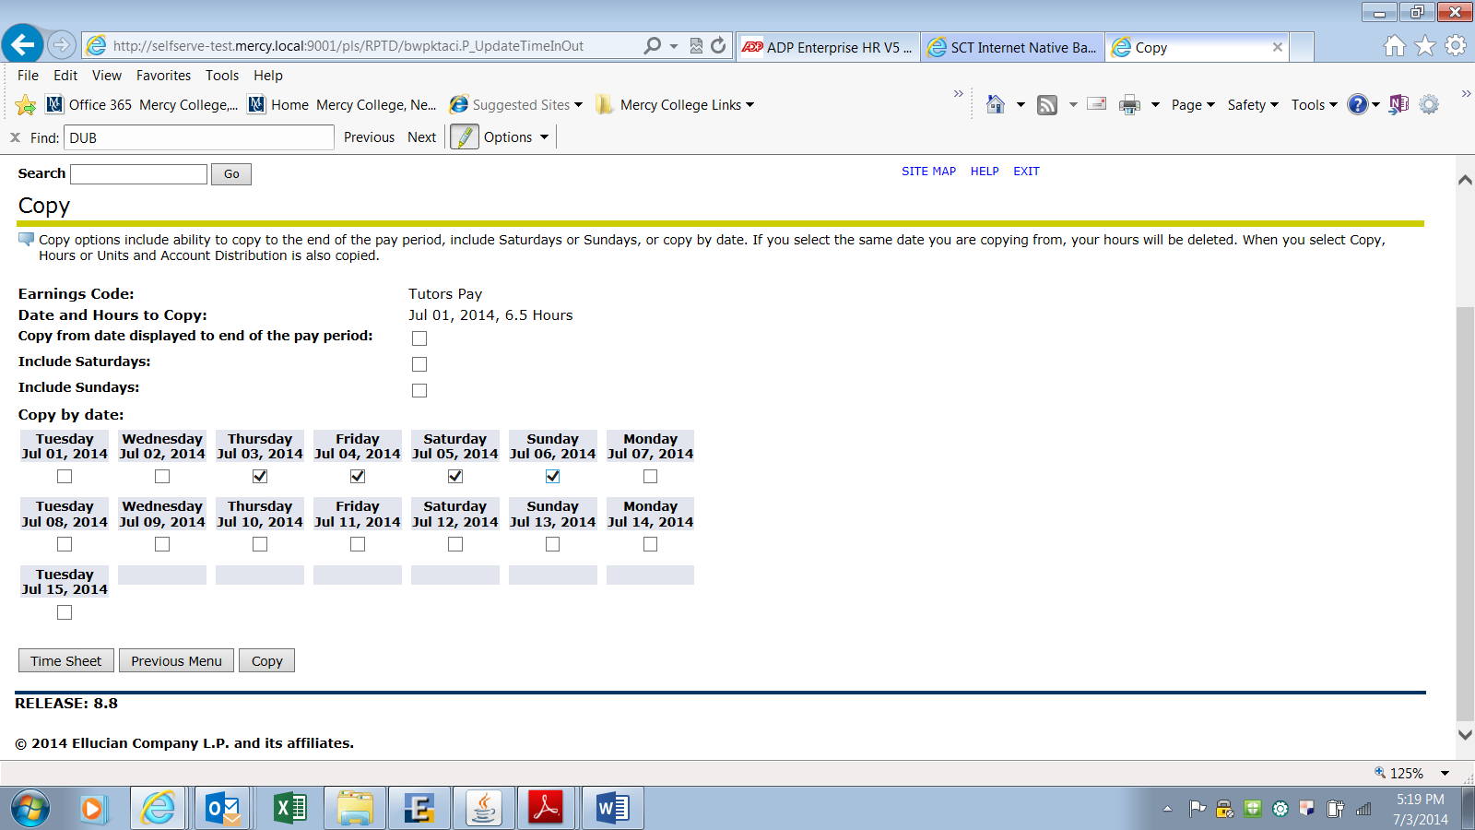

To copy effectively, after the first leave code is entered, save it and copy it to the other dates. If a second leave code is to be used in the same pay period, then enter the second leave type and save it; then copy it to respective dates.

* When the timesheet for the open period opens, it will display earning options: only the highlighted earnings type should be used.

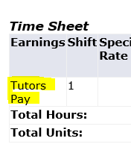

* A lunch break is required after 5 successive worked hours.
* The timesheet displays the period covered; if you have missed reporting your hours for the prior pay period, you can use the any day (you are not scheduled) in current period to report the missed hours; however, a note should be added in the “Comments” sections indicating the actual date worked.
* **Save each** entry then use Tab to scroll to next day worked.

**NEXT DAY**

When you have reported all your time for the first week, select the Next button to go to the second week, on completion, submit for approval

**Note:**

-Once the timesheet is submitted, a message is generated indicating that **“Your timesheet was submitted successfully”** and it will generate an email to your supervisor.

-If the message doesn’t display, it means that your timesheet’s status is **“in progress”** and your supervisor won’t receive the notification to approve it for processing.