UNT CAREER CENTER EMPLOYER GUIDELINES FOR CREATING VIDEOS
The UNT Employer Development Team and the UNT Career Center recognize the value in delivering relevant, virtual content for our students and alumni. We invite all employers who wish to connect with our students virtually to follow these tips and step-by-step guidelines for producing a video to be used on our website or through other mediums. Doing so will ensure the video meets the necessary requirements for posting and that any required edits can be easily made by the UNT Career Center staff.
Ideas for employer generated content include an information session about your organization, an interview or resume tip presentation, an employer panel discussion, etc. Keep in mind that even a short, three to four-minute informational video about your company or organization can be an effective tool for connecting with the future employees you seek. If you’d like some ideas for creating a video, you’re welcome to view our UNT Career Center Video library, which includes videos created by employers and the Career Center staff.
If you have general questions concerning videos, feel free to contact Amy Ferman, Associate Director for Employer Development & Outreach in the UNT Career Center, at Amy.Ferman@unt.edu. For technical questions related to video production, contact Brandon Salazar, Video & Photo Assistant for the UNT Career Center, at Brandon.Salazar@unt.edu.

Recording Etiquette
- Phone on silent, vibration mode off
- Computer notifications off and silent
- Find a quiet, private, well-lit place, free from interruptions, if possible.
- If possible, try testing the video and audio quality of your computer before recording.
- Dress according to your organization’s dress code. If possible, avoid bright colors such as yellow, neon or white. This will help improve the video quality when editing.
- Create an outline or script of everything that will be said during the recording. This will ensure a clear and concise recording.
- While writing the script, make sure to plan an effective wrap-up at the end of your video. A quick recap and a sincere signoff is the most effective.
- While recording, close all unnecessary tabs and disable the favorites bar to ensure privacy.
- If recording with multiple people over a long period of time, make sure each person states their name and position or organization regularly to keep the viewer engaged. This will also help when we are editing the video. For example: “Lakeitria from Service King here."

Video Production
Below are some suggestions for how you can use tools you may already have access to for producing a video and delivering it to the UNT Career Center. These tools do not require any technical knowledge or video expertise. By following these guidelines, you can produce a quality video that meets the requirements necessary to post it on our website and other media. If you have any questions about recording or any other technical issue, feel free to email Brandon Salazar, Video & Photo Assistant for the UNT Career Center, at Brandon.Salazar@unt.edu.
  - Option 1: Zoom
If you have access to Zoom, it’s a great choice because it can provide an automatic transcription with your recording. Just follow these tips on how to record with Zoom, enable transcription, and deliver the necessary files.
Step 1: Settings & Cloud Recording
Check your settings on Zoom and make sure that Cloud Recording is enabled. Local Recording will automatically download your video onto your laptop and only that. Local Recording will not save your recordings to the cloud which means you will not be able to create an automatic transcription.
Make sure that Audio Transcript is enabled in the Settings section. This will allow Zoom to automatically transcribe the video you are recording. The file it creates will capture every word that is said during the recording which is why the best and most efficient recording will create the best automatic transcription.
The image below will show where you can enable Cloud Recording & Audio Transcript on Zoom and the many benefits of Cloud Recording. Local Recording will “allow hosts and participants to record the meeting to a local file” while Cloud Recording will “allow hosts to record and save the meeting/webinar in the cloud”. Local Recording will not create an audio transcript while Cloud Recordings will.
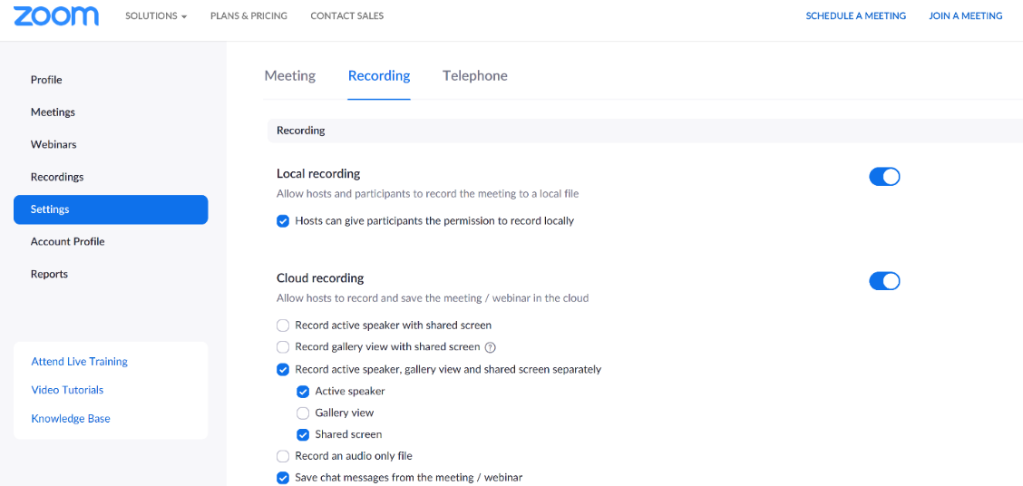

Step 2: Recording with Zoom
When recording with Zoom, you have the option to either record a live video between multiple participants conversing or a “shared screen” video that records what you are saying and what is shown on your computer screen
Here are some quick how-to videos on YouTube about Zoom recording. Feel free to reach out to us if there are any issues with navigating Zoom.
- https://www.youtube.com/watch?v=YA6SGQlVmcA
- https://www.youtube.com/watch?v=bTSJ0YDoF7o
Step 3: Processing the Transcription
After you have recorded your video, you will get two emails once your video is done processing and the audio transcript is available for download. The cloud recording will be available a few minutes after the recording is finished, but the audio transcript may take up to 30 minutes depending on how long your recording is.
The example below on the left is the email you will receive once your cloud recording is available to view, download, and share. The first link will be only for yourself; it cannot be shared. The second link is for you to share with others who only want to view the video you have created on Zoom.
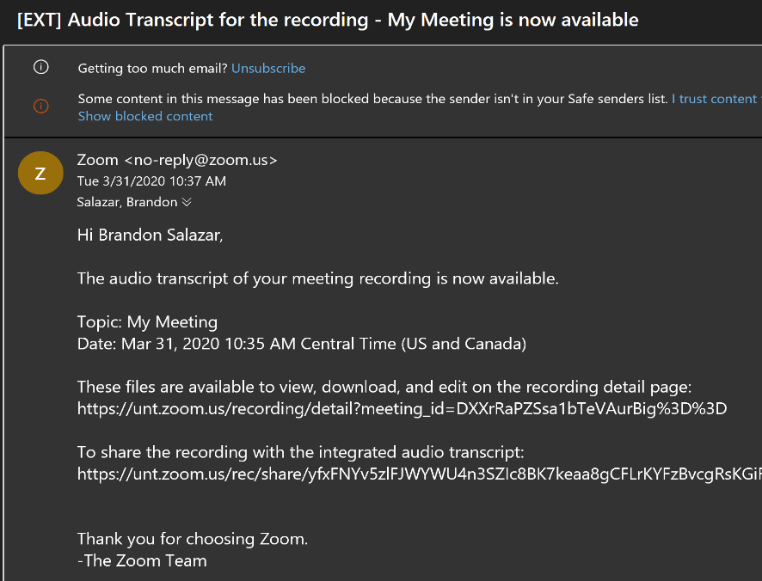
The example below on the right is the email you will receive once the audio transcript of your cloud recording is available. The second link is for you to share the video with an integrated audio transcript for viewing only. The first link will take you automatically to the Zoom Recordings page where you will be able to download the video and audio files. The next step will go more into detail.
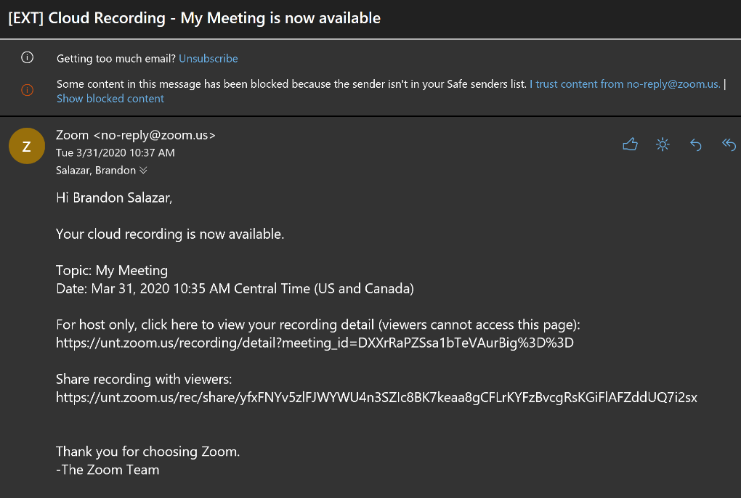

Step 4: Downloading the Files
If you click the first link on the audio transcript email, you should be able to view and download your files immediately.
If you want to find the files manually, go to the Recordings Section in Zoom. You should be able to see all your cloud recordings listed like the first example.
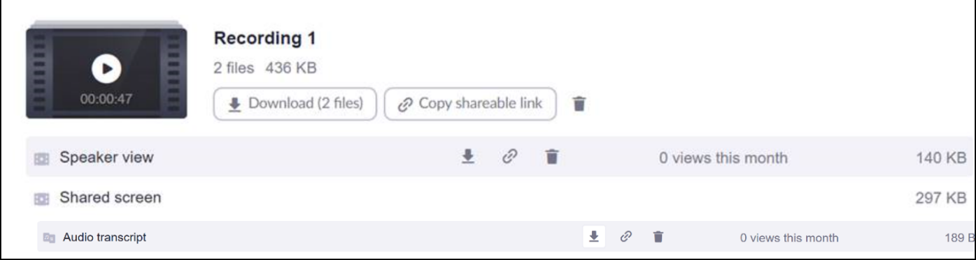
If you click the topic you are currently working on (My Meeting on the first example) or the File Size link, it will take you to the same page where it shows your Speaker View, Shared Screen, and Audio Transcript files. Make sure to click Download which will download all three files to your computer.
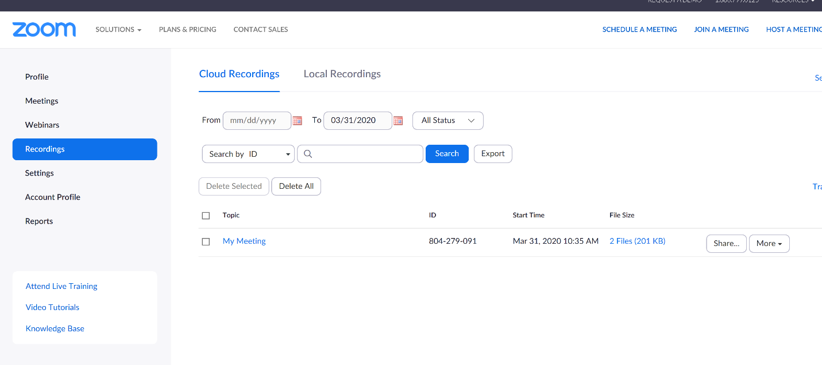
Step 5: Delivering the Files
Once all three files are downloaded onto your computer, you can deliver the files through 2 different outlets:
If your files are small enough, they can be attached and delivered through email.
If they are too large, they can be added to google drive and can be sent through a shareable link.
Option 2: PowerPoint
PowerPoint is a free and easily accessible tool for screen recording.
Here is a quick how-to video on YouTube about PowerPoint recording. Feel free to reach out to us if there are any issues with navigating PowerPoint.
- https://www.youtube.com/watch?v=6T020-TI_3U&feature=youtu.be

Employer Video Examples
- International Work Experience in Spain - https://youtu.be/lfEgUOFkwdM
- COVID-19 Employer Panel - https://youtu.be/XYD6MgHqFUo
- How to Tie a Tie - https://youtu.be/bR1Ct_tl_D8
- How-to Series: Virtual Networking - https://youtu.be/6BdfZAFsZtg
- Virtual Professionalism 101 - https://youtu.be/DS95-WiojmY
- Prepare for an Interview, like you do for a Date! - https://youtu.be/5WagR9Ioius

