Becoming your best financial self as you graduate:

- COVID relation federal loan updates
  - 0% interest and no payments required through 9/30/2020 on all federally held loans
  - https://studentaid.gov/announcements-events/coronavirus#:~:text=To%20provide%20relief%20to%20student,making%20your%20monthly%20loan%20payment.
- Know your federal student loans
  - Visit this government site to track and manage your federal loans
  - https://studentaid.gov/fsa-id/sign-in/landing
- Know your federal student loan servicer
  - Developing good creditor relationships is critical to your success!
  - https://studentaid.gov/manage-loans/repayment/servicers
- Know your repayment options
  - There are “income based” and several other options to meet everyone’s long term needs
  - https://studentaid.gov/manage-loans/repayment/plans
- Deferment & forbearance options:
  - Going back to school, in between jobs, having financial challenges…
  - https://studentaid.gov/manage-loans/lower-payments/get-temporary-relief
- Know your private educational loans
  - Contact your lender or loan servicer directly
  - OR: Check your credit report: www.annualcreditreport.com
- Protecting your credit
  - “Multiplicity”: One delinquent payment, that covers multiple loans, can mean many credit hits
  - www.annualcreditreport.com
- Create a budget that supports your goals
  - Learn how to pay yourself first
  - www.miami.edu/moneymgmt
- Loan term financial planning
  - Get educated and consult a financial planner as needed
  - https://finaid.miami.edu/resources/fiscal-fitness/saving-and-investing/index.html
- Do you have an age specific financial “Life Plan” in place?
  - We all need this so that we can ensure a more secure financial future
  - See the next pages for goal setting examples

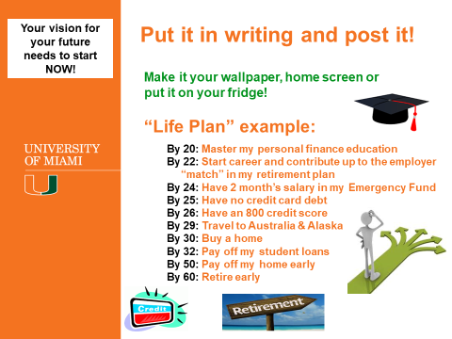

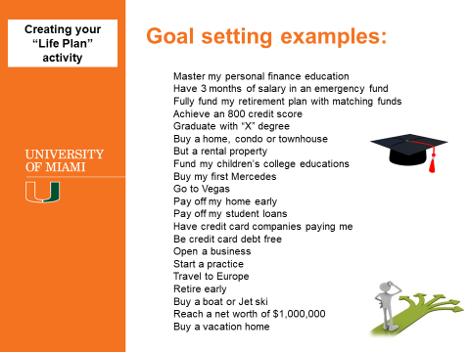

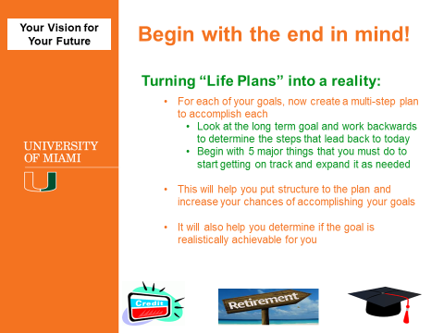

Financial “Life Plan” goal setting:
What will be your future financial accomplishments? Created: ____/____/______
- By age _____ I want to ______________________________________________________________

- By age _____ I want to ______________________________________________________________

- By age _____ I want to ______________________________________________________________

- By age _____ I want to ______________________________________________________________

- By age _____ I want to ______________________________________________________________

- By age _____ I want to ______________________________________________________________

- By age _____ I want to ______________________________________________________________

Attaining Goal # 1: _______________________________________________________________________
- By age ________ I have to ___________________________________________________________________

- By age ________ I have to ___________________________________________________________________

- By age ________ I have to ___________________________________________________________________

- By age ________ I have to ___________________________________________________________________

- By age ________ I have to ___________________________________________________________________

Attaining Goal # 2: _______________________________________________________________________
- By age ________ I have to ___________________________________________________________________

- By age ________ I have to ___________________________________________________________________

- By age ________ I have to ___________________________________________________________________

- By age ________ I have to ___________________________________________________________________

- By age ________ I have to ___________________________________________________________________

Attaining Goal # 3: ______________________________________________________________________
- By age ________ I have to ___________________________________________________________________

- By age ________ I have to ___________________________________________________________________

- By age ________ I have to ___________________________________________________________________
Continued on reverse side
- By age ________ I have to ___________________________________________________________________

- By age ________ I have to ___________________________________________________________________

Attaining Goal # 4: _______________________________________________________________________
- By age ________ I have to ___________________________________________________________________

- By age ________ I have to ___________________________________________________________________

- By age ________ I have to ___________________________________________________________________

- By age ________ I have to ___________________________________________________________________

- By age ________ I have to ___________________________________________________________________

Attaining Goal # 5: _______________________________________________________________________
- By age ________ I have to ___________________________________________________________________

- By age ________ I have to ___________________________________________________________________

- By age ________ I have to ___________________________________________________________________

- By age ________ I have to ___________________________________________________________________

- By age ________ I have to ___________________________________________________________________

Attaining Goal # 6: ______________________________________________________________________
- By age ________ I have to ___________________________________________________________________

- By age ________ I have to ___________________________________________________________________

- By age ________ I have to ___________________________________________________________________

- By age ________ I have to ___________________________________________________________________

- By age ________ I have to ___________________________________________________________________

Attaining Goal # 7: ______________________________________________________________________
- By age ________ I have to ___________________________________________________________________

- By age ________ I have to ___________________________________________________________________

- By age ________ I have to ___________________________________________________________________

- By age ________ I have to ___________________________________________________________________

- By age ________ I have to ___________________________________________________________________

