Sarah Gronningsater, PhD (she/her/hers)
Assistant Professor of History, University of Pennsylvania
Dr. Sarah Gronningsater is an Assistant Professor of History at the University of Pennsylvania. She is an historian of the eighteenth- and nineteenth-century United States, with a particular interest in slavery and abolition. She works at the intersections of legal, political, constitutional, and social history. She received an A.B. from Harvard University, an M.St. from the University of Oxford, and a Ph.D. from the University of Chicago. Prior to joining the faculty at Penn, she was the recipient of the Hanna Holborn Gray Advanced Fellowship at the University of Chicago from 2014 to 2016. From 2014 to 2016, she was a Barra Postdoctoral Fellow at the McNeil Center for Early American Studies at the University of Pennsylvania. In 2017-2018, she was an Andrew W. Mellon Foundation Fellow at the New-York Historical Society. Her current book project is The Arc of Abolition: The Children of Gradual Emancipation and the Origins of National Freedom (under contract with the University of Pennsylvania Press). Gronningsater loves teaching both undergraduate and graduate students. She offers courses in early American history, the long nineteenth century, the American Revolution, slavery and abolition in the Atlantic World, the politics of reform movements, legal and constitutional history, the Civil War, women’s history, and the history of American baseball. In 2020, she was awarded the Richard S. Dunn Award for Distinguished Teaching.
Jordan Kodner, PhD (he/him/his)
Assistant Professor of Linguistics, Stony Brook University (Linguistics,) 2020

Jordan Kodner is an Assistant Professor at Stony Brook University. His research takes a computational approach to language acquisition, acquisition’s impact on language variation and change, and its relationship to low-resource natural language processing, with an interest in how small, variable, and unreliable input affect the morphological, syntactic, and phonological learning. His acquisition work has touched on several areas and varieties of English, and on Latin, Spanish, and Korean, among others, and his work in low-resource NLP aims to include a wide range of world languages, both well-studied and underserved. In addition to earning a dual Bachelor of Arts in Linguistics and a BEW in Computer and Information Science from Penn, he also received his MSE in Computer and Information Science and a PhD in Linguistics at Penn.

Riley McGuire, PhD (he/him/his)
Assistant Professor of English, Worcester State University (English, 2020)

Riley McGuire is an Assistant Professor of English at Worcester State University where he specializes in nineteenth-century literature, queer theory, and disability studies. Prior to joining the faculty at WSU, he completed his Ph.D. in English at the University of Pennsylvania. He is currently working on a book-length project exploring how vocal disability influenced nineteenth-century Anglophone culture. His most recent pieces can be found in Victorian Literature and Culture, the Journal of Interdisciplinary Voice Studies, and Disability Studies Quarterly. His teaching—formerly at Penn and Bryn Mawr College, and now at WSU—aims to cultivate accessibility for all students.

Fernanda Rosa, PhD (she/her/hers)
Assistant Professor, Science, Technology & Society, Virginia Tech (Annenberg, 2021)

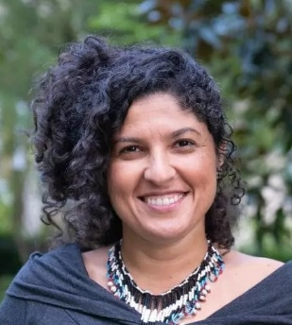
Fernanda R. Rosa is a Postdoctoral Fellow at the University of Pennsylvania’s Annenberg School for Communication at the Center for Advanced Research in Global Communication. She is a sociologist, graduated from the University of Sao Paulo, with a Ph.D. in Communication (American University, Washington DC), and a master’s in Public Policy and Management (Fundacao Getulio Vargas, Brazil). Dr. Rosa is interested in understanding how unbalanced relations of power emerge in underlying layers of the internet, and the consequent social, political and economic implications for the global South. Her work has received several awards. She is currently working on her second book project under the title “The Internet from the South: An Ethnography of Code and Infrastructure,” and is going to join Virginia Tech’s Department of Science, Technology, and Society as Assistant Professor this Fall.

Brooke Stanley, PhD (they/them)
Assistant Professor, English, University of Delaware (English, 2018)

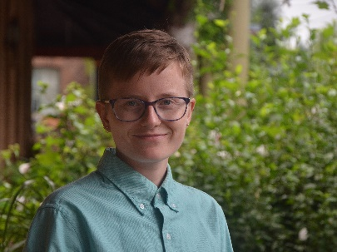
Dr. Brooke Stanley is an Assistant Professor of English at the University of Delaware. Their fields of interest include environmental humanities, postcolonial studies, contemporary literature, food studies, indigeneity, and gender and sexuality. Brooke completed their graduate work in English at the University of Pennsylvania, earning their doctorate in 2018. They worked at Stockton University as a Visiting Assistant Professor of Literature before joining Delaware's faculty in 2019. At Delaware, they teach courses on environmental literature, global and postcolonial literatures, and the interdisciplinary environmental humanities and postcolonial studies, as well as fundamentals of literary studies and writing about literature. Their current book manuscript, Consumption Fiction, explores the politics of food and globalization in contemporary environmental novels from South Africa and South Asia. Brooke is also working on article projects on postcolonial and Indigenous apocalyptic narratives, Afrofuturist film, and teaching climate fiction in ways that recenter the Global South.

