Ana Almeyda-Cohen, PhD, Assistant Professor of Spanish, Colby College (Spanish and Portuguese ’20)
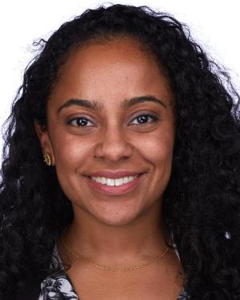
Ana Almeyda-Cohen is an Assistant Professor of Spanish at Colby College, where she teaches courses on Latin American cinema and culture. Her work analyzes representations of popular cultural figures within Mexican culture and media. Her research takes an interdisciplinary approach that draws from critical theories of race and gender, eco-criticism, Mexican visual studies, anthropology, border studies, and Latino/a studies.

Andrea Contigiani, PhD, Assistant Professor of Management, Ohio State University (Management ’19)
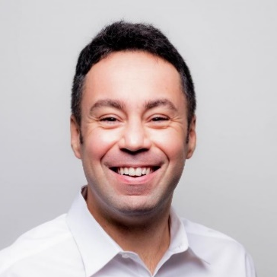
Andrea Contigiani is an Assistant Professor of Management at the Fisher College of Business at the Ohio State University. He received his PhD from the Wharton School at the University of Pennsylvania in May 2019. He studies entrepreneurship using observational techniques and experimental methods. His current work examines the impact of experimentation and “lean startup” techniques in early-stage ventures. He is also interested in the role of entrepreneurship in society, especially in the context of migration.

Aaron Hagler, PhD, Associate Professor of History, Troy University (Near Eastern Languages & Civilizations ’11)
Aaron M. Hagler is an associate professor of history at TROY University. He received his Ph.D. from the University of Pennsylvania in 2011. Before coming to TROY, he was a Mellon Postdoctoral Fellow at Cornell College, in Iowa. He is currently conducting research on the evolving meaning of the narrative of the first fitna, or Muslim Civil War, to medieval historians whose accounts are motivated by sectarian concerns.

Emily Steinlight, PhD, Associate Professor of English, University of Pennsylvania
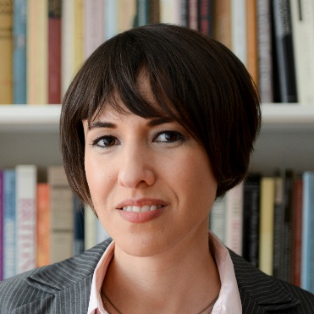
Emily Steinlight specializes in nineteenth-century British literature, with a focus on the relationship between political thought and literary form, as well as the history and theory of the novel, mass politics, the Victorian natural and social sciences, and critical theory. She received her Ph.D. from Brown University, where she held a Graduate Fellowship at the Cogut Center for the Humanities and the Roland G. D. Richardson Fellowship in the Department of English. Prior to joining the Penn faculty, she taught at Trinity University and, before that, at the University of Chicago, where she was a Harper-Schmidt Fellow and Collegiate Assistant Professor in the Humanities.

