Michael Arcaro, PhD, Assistant Professor of Psychology, University of Pennsylvania
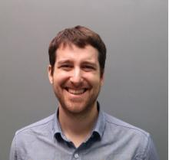
Dr. Michael Arcaro is an assistant professor in the Department of Psychology at the University of Pennsylvania. His research combines neuroimaging, psychophysics, and electrophysiology to understand how intrinsic and experience-driven processes interact throughout development to shape brain organization and behavior. His current research focus is on neural development supporting visual object recognition across mammalian species. Dr. Arcaro received his B.A. in Psychology and Philosophy from Boston University and Ph.D. in Psychology and Neuroscience from Princeton University.

Cynthia Hsu, PhD, Visiting Assistant Professor at Bryn Mawr College (Fall 2021)
Dr. Cynthia Hsu is currently a postdoc at the University of Pennsylvania. In fall of 2021, Cynthia will begin as a Visiting Assistant Professor in the Department of Biology at Bryn Mawr. In her current postdoctoral research at Penn, she is characterizing how inputs into a sleep promoting region of the Drosophila brain change with respect to the circadian day. Dr. Hsu received her B.A. from the University of California, Berkeley and Ph.D. in Neurobiology from Duke University.

Yumeng Ou, Assistant Professor of Mathematics, University of Pennsylvania
Dr. Yumeng Ou is an assistant professor in the Department of Mathematics at the University of Pennsylvania. She researches problems related to Harmonic Analysis, which is a field of pure mathematics concerned with representing functions in terms of simpler components and using information about this decomposition to infer properties about the original function. Dr. Ou received her B.S. in Mathematics from Peking University and Ph.D. in Mathematics from Brown University.

Audrey L. Blewer, PhD, MPH, Assistant Professor of Family and Community Health, Duke University School of Medicine (PhD, 2018 University of Pennsylvania)
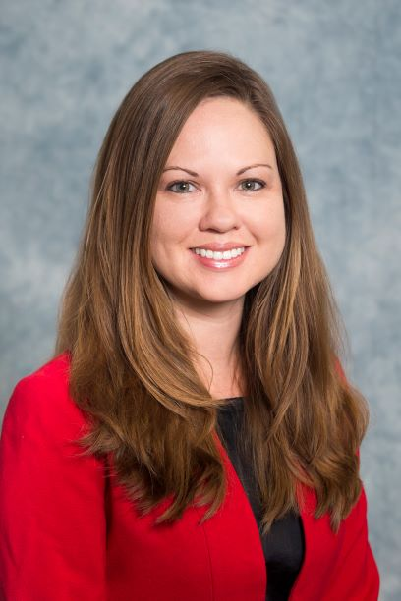
Dr. Audrey Blewer is an Assistant Professor in Family and Community Health with a secondary appointment in Population Health Sciences at the Duke University School of Medicine. Her research interests lie at the intersection of resuscitation science, epidemiology, and implementation science with a focus on improving bystander cardiopulmonary resuscitation and out-of-hospital cardiac arrest. Dr. Blewer earned her Master of Public Health in Social and Behavioral Sciences from the University of Florida and her PhD in Epidemiology in 2018 from the Department of Biostatistics, Epidemiology, and Informatics from the University of Pennsylvania.

