Sarah Connolly, PhD, Associate Professor, DePaul University (CAMB ’03)

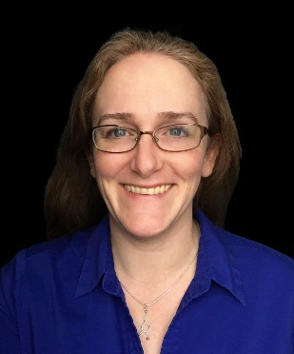
Dr. Sarah Connolly is an Associate Professor of Microbiology at DePaul University, with a joint appointment in the Department of Health Sciences and the Department of Biological Sciences in the College of Science and Health. She began studying herpesvirus entry into cells while pursuing a PhD with Gary Cohen and Roselyn Eisenberg at the University of Pennsylvania in Philadelphia. After her PhD, Sarah began a postdoctoral fellowship with Robert Lamb at Northwestern University in Evanston, studying paramyxovirus entry into cells. Using these approaches, she returned to the herpesvirus entry field in a second postdoctoral fellowship with Richard Longnecker at the Northwestern University Feinberg School of Medicine in Chicago. Sarah began studying the protein responsible for herpesvirus membrane fusion and continued these studies when she joined the DePaul faculty in 2012.

Shivon Robinson, PhD, Assistant Professor, Williams College (Neuroscience ’16)

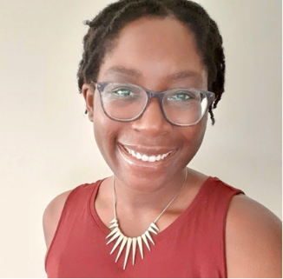
Dr. Shivon Robinson is an Assistant Professor in the Psychology Department at Williams College. She received her bachelor's degrees in Biology and Psychology from Williams College in 2011. She completed her graduate work in the lab of Irwin Lucki at the University of Pennsylvania and earned her doctorate in Neuroscience in 2016. Subsequently, she completed a NIH sponsored Institutional Research and Academic Career Development Award (IRACDA) postdoctoral fellowship in the lab of Julie Blendy, which combined a traditional mentored research experience with extensive training in college level teaching.

Fang Liu, PhD, Assistant Professor, Stanford University (Physical Chemistry ’15)

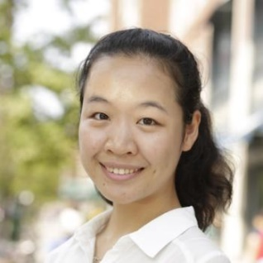
Fang Liu is an assistant professor of chemistry at Stanford University. Her research is focused on the light induced dynamics of solid low dimensional materials and construction of low dimensional artificial structures. Prior to her current position, she was a DOE Office of Energy Efficiency and Renewable Energy (EERE) postdoctoral fellow in the group of Prof. Xiaoyang Zhu at Columbia University. Her postdoctoral research focused on using femtosecond extreme UV in probing time and angle resolved photoemission spectroscopy of 2D materials. Prior to working in Columbia, she worked under the direction of Prof. Marsha I Lester at University of Pennsylvania. She received her Ph.D. in 2015 and worked as a postdoc in the same group in 2016. At UPenn, she used time resolved spectroscopic techniques to study spectroscopy and photochemistry of Criegee intermediates. She received her B.S. in chemistry at Peking University in 2010.

Ekta Khurana, PhD, Assistant Professor, Weill Cornell Medical College (Computational Biophysics ’08)
Ekta Khurana is an Assistant Professor of Computational Genomics at Weill Cornell Medical College. She is also the Associate Director of the Tri-Institutional PhD Program in Computational Biology & Medicine, and a WorldQuant Foundation Research Scholar since 2021. Dr. Khurana's research expertise is in Computational Biology/Bioinformatics, Genomics, Cancer Genomics and Systems Biology.

Alice Huang, PhD, Associate Professor, Columbia University (Bioengineering ’10)

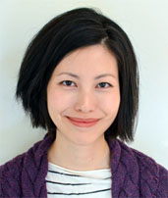
Dr. Alice Huang is an Associate Professor in the Department of Orthopedic Surgery at Columbia University. Dr. Huang graduated from Barnard College and the School of Engineering and Applied Science at Columbia University with a B.A. in Asian/Middle Eastern Studies and a B.S. in Biomedical Engineering. She then completed her PhD in Bioengineering at the University of Pennsylvania. Dr. Huang's graduate research was devoted to the mechanobiology of mesenchymal stem cell differentiation for cartilage tissue engineering. Dr. Huang then conducted postdoctoral research at Shriners Hospital for Children, where she investigated mechanisms of musculoskeletal development and integration. In 2014, Dr. Huang joined the faculty at Mount Sinai as an Assistant Professor in the Department of Orthopaedics and recently moved to Columbia University in 2021. Her research focuses on the regeneration and engineering of dense connective tissues.

