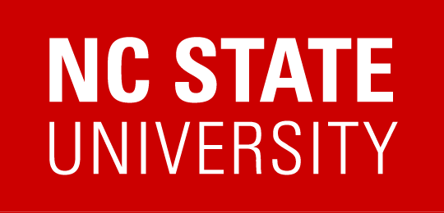ENGAGE EFFECTIVE FOLLOW UP SKILLS

End the Interview with Closing Questions

As your interview draws to a close you will certainly want to end the meeting with another nice firm handshake, thank them for their time and express your continued interest. This is the time to ask questions about what you might expect next and to make sure all of their questions have been answered to their satisfaction.
Some possible closing questions include:
- What is the projected timing on your search?
- When can I expect to hear from you?
- Where do we go from here?
- Do you have any further questions?
- Are there further interviews that will be needed for this position and when will they take place?
- Who will contact me and when will I be contacted for further meetings, if I am selected to progress to the next round?
- If I am not selected for the job, will I be notified?

Get Business Cards

Do not forget to ask for a business card from everyone you meet. You will need this information for immediate and on-going follow up.

Provide Yourself with Immediate Feedback
Before you leave the meeting location, provide yourself with immediate feedback about the interview while it is fresh in your mind. Write down what went well and what did not go well. What were their primary needs? What were they most interested in about you? What were their areas of concern? You will address these items in your thank you note.

Write a Thank You Note
Write and send out thank you notes as soon as possible. A thank you note sent by email is acceptable in today’s job market. Sending a thank you note is proper business etiquette and a critical step in the process. Only seven out of ten job seekers follow up with a thank you note. Sending one can provide you leverage as a candidate. Refrain from the niceties about meeting everyone and concentrate your note on summarizing your qualifications for the position and how you can contribute solutions to the needs and priorities of the organization.

