Use the CAR Model when creating bullets for your jobs, internships and activities on your resume.
C A R
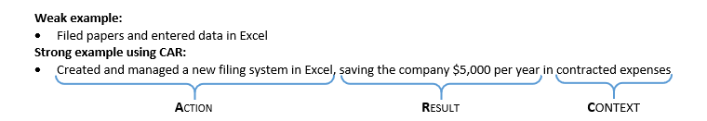
Result
Action
Context
Match the wording on your resume to the job description to which you’re applying!

Example job description, Restaurant Management:
- Management functions such as scheduling employees, managing labor/food costs, inventory, ordering, and oversight of various projects
- Management of the day to day operations of a client account in either food, facilities, sales or a functional area
- Oversight of safety and sanitation as well as client/customer satisfaction
- Leadership/supervisory responsibility of a team of supervisors and/or hourly associates
- Adherence and oversight of contract requirements
- Assisting with recruitment of supervisors and associates as well as involvement in disciplinary/coaching conversations

Requirements:
- Bachelor's Degree required
Flexibility for event-based hours, which may include nights and weekends
- The ability to communicate effectively with clients, client's customers, and support staff
- Strong organizational, time management and leadership skills are required
- The ability to respond effectively to changing demands
- Experience with and knowledge of all Microsoft Office applications
- P&L accountability and/or contract managed service experience is desirable

Resume example excerpt specifically tailored to the above job description:

Wildcats Restaurant, Lexington, KY
Head Cashier, May 2017 – present
- Scheduled 6 employees around peak times to minimize labor costs
- Managed time by completing 30+ hours a week and worked nights and weekends
- Communicated with over 200 clients daily; awarded Employee of the Month (August 2016) for excellent customer service
- Ensured safety and sanitation requirements were met; 0 accidents during shifts worked

Financial Accounting Course Project, University of Kentucky
Team Member, Fall 2017
- Led team of 4 to complete project on time earning an ‘A’
Analyzed P&L statements for 4 major corporations and prepared presentation in Microsoft Office

